BEFORE I GO… by Sabine Hofmann 10.5.2021

Time, like an ever-rolling stream
Bears all its sons away.
They fly forgotten, as a dream
Dies at the op’ning day.

Gather ye rosebuds while ye may, Then be not coy, but use your time,
Old time is still a-flying, And while ye may, go marry,
And the same flower that smiles today For, having lost but once your prime
Tomorrow will be dying. You may for ever tarry.

The words echo down the decades, the first verse from ‘O God, our help in ages past’, and the other two from a folk song we often sang at Primary School.
I tarried…not that it was planned so, but that’s how it turned out, and since I have no children to succeed/remember me, this oeuvre is to be ‘my Baby ’. I do not want to be just a dead end on the family tree leaving no account of myself; my life has been far too interesting and eventful for that. I hasten to add that my intention is not for publication, only for family consumption, especially for future generations, and perhaps for a few friends. - I propose to ‘tell it as it really was…’ I need to do that.

Early Life in Berlin
I was born on 26th January 1943 in the Trautenauklinik in Berlin’s Wilmersdorf. Fortunately my mother Annemarie, née Eckhardt, had by then recovered from the sepsis she had had when my sister Ellen was born on 11th May 1941, and I was a heavy and robust baby thought by many to be a boy! I continued robust all my life, being one of those individuals who hardly ever missed a day from school/work. - I feel we owed our survival in the midst of all the bombing and destruction to the fact that we lived out in Berlin-Gatow, right on the western edge of the city, to the west of a belt of lakes and forest separating us from the centre (Berlin-Mitte). Visiting the Trautenauklinik 22 years later, I was informed by one old man that this was the only building in its street which survived the war intact, so it seems I was meant to survive, and I recall our mother telling me that when the sirens went, all the babies were put on to a huge trolley and wheeled to the nearest lift to shelter in the cellar. The clinic is still there, but is now used as a public administrative building.
In Gatow I remember the flat Im Eulengrund 8, which was my parents’ address, but later, when Mutti was in England getting married and setting up a house, Ellie and I lived for a year or two on the ground floor of the next block. The road was at a lower level with steps going up an embankment to the flats, No. 8 on the left and No.6 on the right, with a T-shaped path dividing off to each ‘front’ door; these were at the back. I have very early memories of playing with the neighbours in the garden of No. 8, and breaking a precious egg in our own.

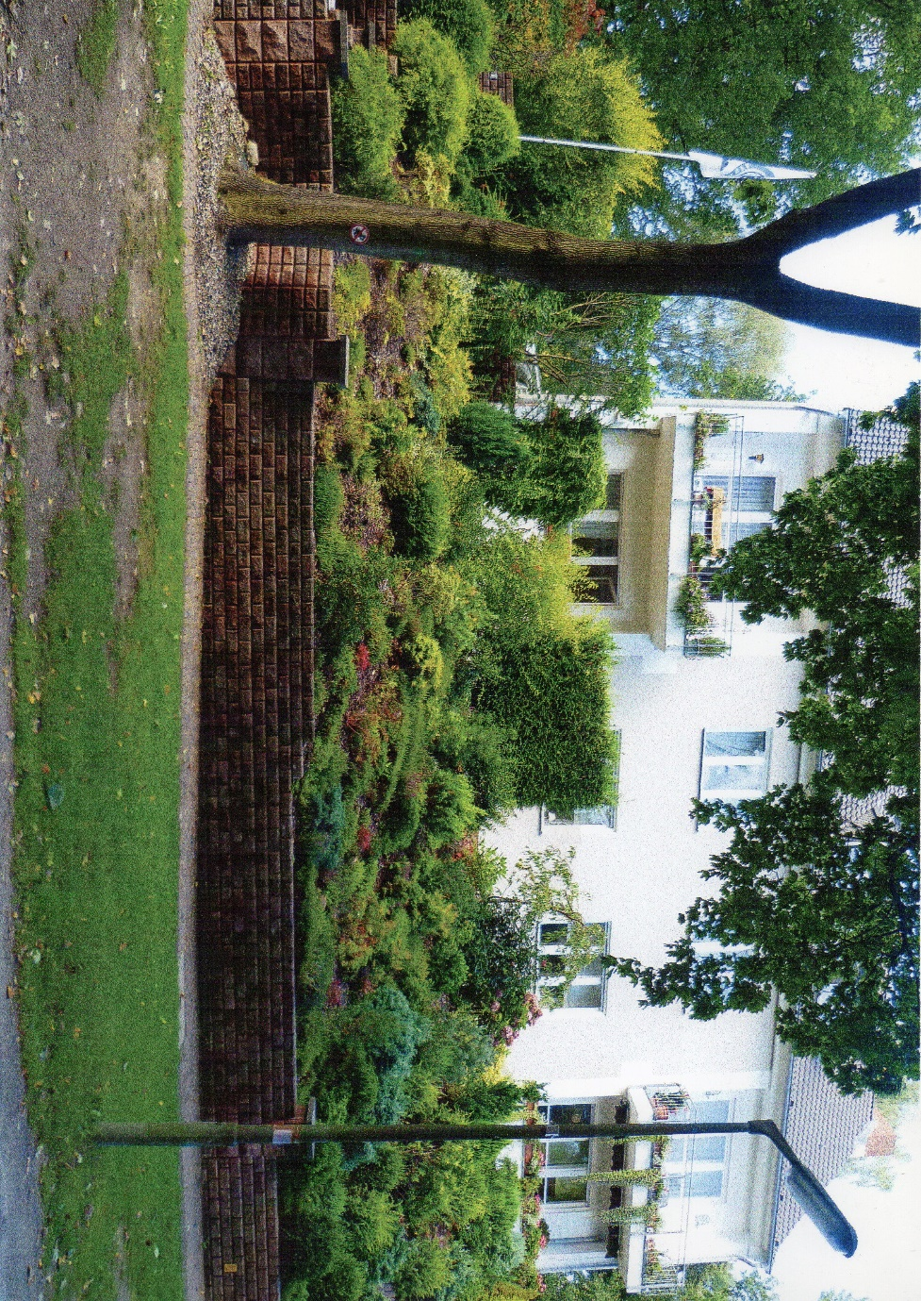
Im Eulengrund 6 was on the left side of the ground floor. This was taken when we visited in 2010, when the 4 flats had been converted into one large dwelling and beautifully renovated. It was in the roof space of this building that my mother and I hid from the Russians in 1945. The steps going up from the road were just off to the left of the picture, but have now been replaced by garages.

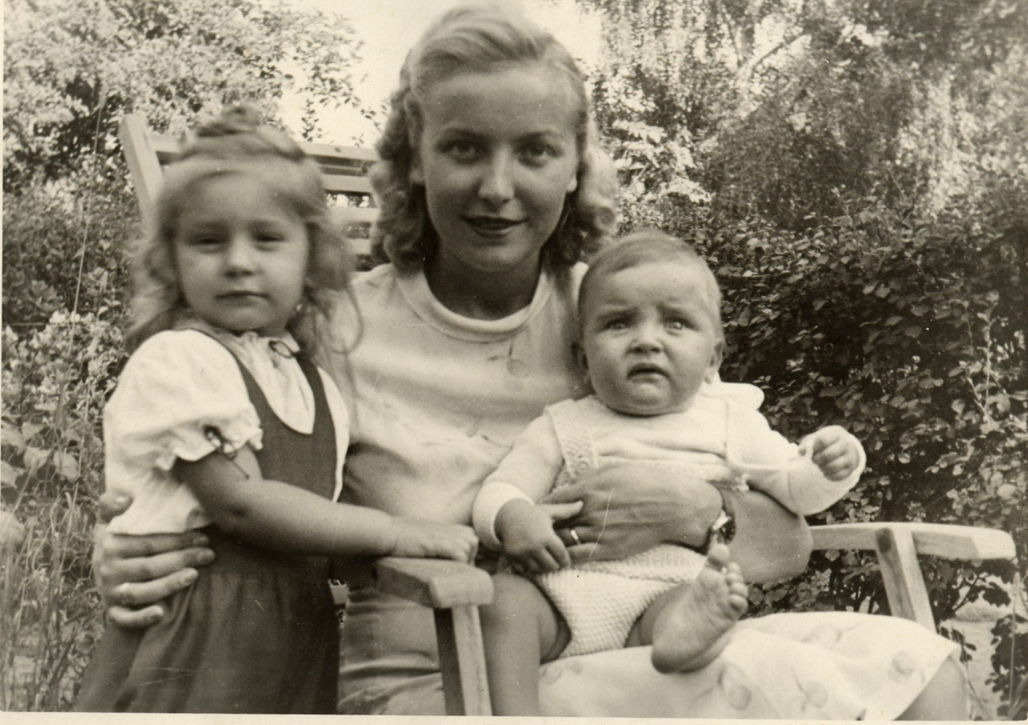
Mutti, Ellie & me in the garden of Im Eulengrund 6, Summer 1943. Had I known what was coming to me, I’d have looked even more worried!

Our father Paul Gerhardt Hofmann had been a flying instructor in the Luftwaffe, and was shot down over Nettuno, near Anzio, Italy, on my first birthday. Ellie was old enough to remember him, but I did not know him at all, and understand that he only saw me a couple of times. As a widow, our mother eventually got a job after the war as a receptionist in the British Officers’ Club in Gatow, which was the location of the British airfield. There she met the man who was to become our stepfather in 1947, Jack Myers, a Captain in the British Army, and in that year they left us in the care of 2 honorary aunts next door, one of them my godmother, while they came to Britain to get married and then to look for a house and get it ready for us. Before they left, I recall meeting our new Dad, who bought us a toffee apple each and took us for a spin in his jeep, ‘um die Ecke ‘rum’, as he later so often recalled. He also became my godfather, as there were hardly any German men left to fulfil this function in 1946. I remember that day in September, as I was given a circlet of flowers to wear on my head, but found it scratchy, and was told I could take it off for now but must put it on when we got to the church, the Dorfkirche in Gatow. (Here many years later the staff located our documentation). Ellie had a white dress of broderie anglaise, and mine was white linen with dark blue embroidery on it.
My other recollections of that time are very sketchy; we had no idea of the enormity of what was happening around us, but I do remember food being scarce and seeing a couple returning from the local shop with just one cabbage in a shopping net. Near us was a large notice board telling everyone what was available that day in the shop, which was some way off. In winter I distinctly remember seeing a fish frozen in the ice in a local stream, and once in summer, playing on the Havel, I fell into deep water and was pulled out by a boy who had seen me disappear – I can still remember the green water closing in on me, and had instinctively put my arm up. - Sometimes we went to pick blackberries, and used to pop all the white berries which grew everywhere. Once we hid in the bushes when a soldier came by on a motorbike. He discovered us, but let us continue. At that time, everyone was terrified of soldiers – of any kind. My mother told me that when the Russians came into the city, they spared nobody, and since she was an attractive young woman and the widow of a German officer, they would have made her really suffer. She took me up into the loft to hide from them when they came calling; heaven knows how she kept me quiet at the age of 2. Later I heard that she had buried our father’s medals in the garden and never dug them up again, and many years later still, when we called at the flat while on holiday, the then occupant told us he had had the garden landscaped but never found any medals…perhaps they remain buried there to this day. - Gradually, time slipped by. When the other children were discussing their ‘Zuckertüten’ (large conical containers filled with goodies of various kinds, and traditionally taken to school on the first day), I knew I would not have one, as ‘I was going to school in England.’
Our parents were married in Leeds in February of 1947, and our mother did not collect us from Berlin until September of that year. Much later, I realised what a long time those 7 months were. On the day she came back, I was standing at the main door of No. 6 when a plane flew over. ‘I wonder if your Mutti is on it?’ an old man said to me. He knew she was coming to fetch us and take us back to Britain.
Before we set off, we had some photos taken in the lounge of the flat we were living in. (By now No. 8 must have been relinquished). I was bewildered and tearful. I still recall the journey from Berlin to Hoek of Holland on the train. We both had grey coats sewn from some rough woollen cloth and both clutched a teddy bear. Our compartment was one of those without any corridor, and I recall travelling through all the fields of the flat north German plain. As we got to Hoek in the dark, all the lights were twinkling. On the boat I was eating a half-rotten pear, and was told I must not eat it, and the next thing I recall was entering a bedroom, with 2 twin beds…this was in the prefab, so I must have slept all the way from Harwich.
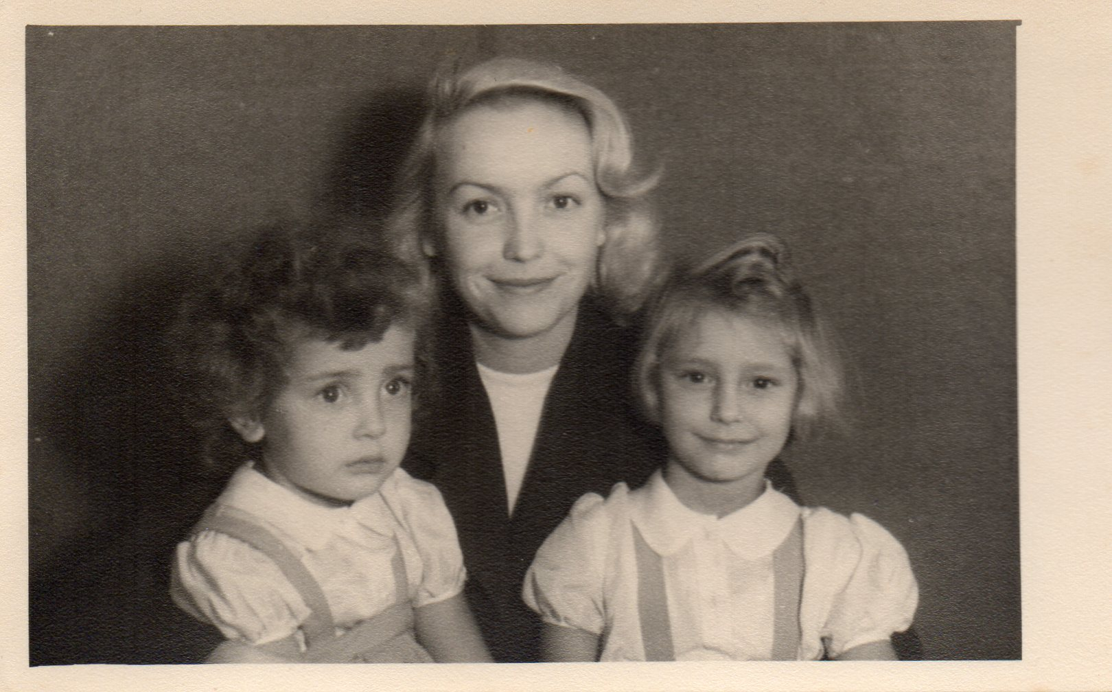
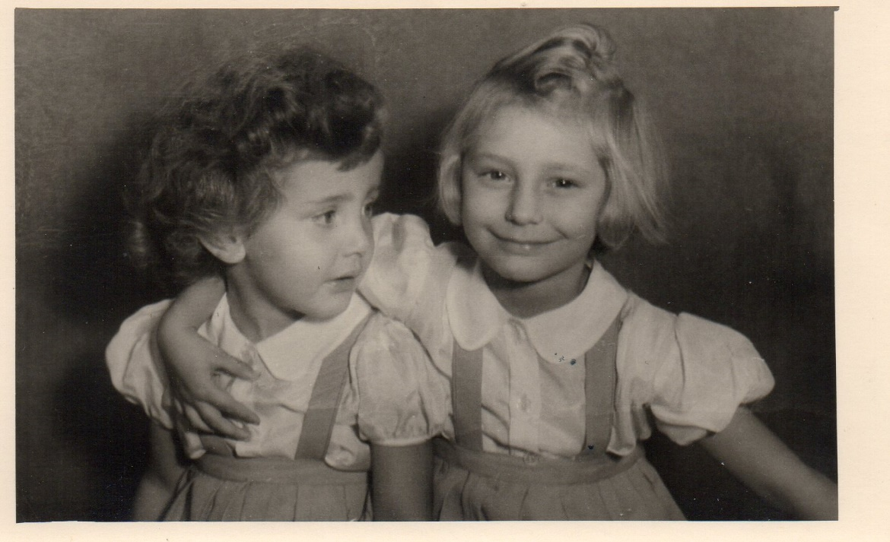
Im Eulengrund 6, just before departure to England.

Lindsworth and the Prefab
Prefabs were temporary houses put up to counteract the housing shortage after the War, and were intended to last about 10 years. In fact they were so popular that some still survive to the present day (2021). The joke was that when Mum & Dad chose to move in, he asked her: ’You don’t mind living in one of these for 6 months, do you?’ and we were there for 26 ½ years…as we all know, there is nothing so permanent as a temporary arrangement. It was convenient for our Dad, as it was only a stone’s throw from his job at St. Francis’ Residential School, in those days designated ‘E.S.N.’ (Educationally Sub-Normal), and attached to Monyhull Colony with its Hospital. Later it broke these ties and is known today as Lindsworth School, and our Dad remained there all his working life. The Colony and Hospital have long since disappeared, as ‘Care in the Community’ took over.
The prefab was, as I later found out, an Arcon V, and there is an exact replica of it at Avoncroft Buildings Museum near Bromsgrove. This was surreal when I visited it long after the demise of both parents; I felt they were going to come round the corner at any moment. All the fittings and fixtures were identical to those we had had in ours, and the furniture was authentically post-war. These units were very well-designed, with warm air ducted into the bedrooms and the water heated by the coal fire in the sitting room, plus an electric immersion heater. There were plenty of built-in cupboards and a semi-fitted kitchen, with a fridge, which seemed to be the envy of lots of people who lived in ‘proper’ houses. The windows were Crittell, as it was long before double glazing was heard of. There were only 2 bedrooms, so Ellie and I were condemned (yes!) to share as we were growing up. I always felt we would have been much better friends if we had each had our own room.
Our house, No. 166, Monyhull Hall Road, was on the Lindsworth Approach end of the row of six, opposite the big Tudor House, with a big oak tree separating us from our neighbours, the Gilberts. On our other side was a big private detached house, where the Holyhead family lived. In the hedge was a beautiful laburnum tree, which can still be seen between the new houses and the flats on the other side of the hedge. In the early days our Dad made an effort to cultivate the garden to some extent, but this was of short duration, as his music increasingly took over his life alongside the job, so we looked out mostly on to rough waste ground, with a few surviving flowers here and there, and rose bay willow herb outside our bedroom window. At the back there were large fields, one flat and the other beyond rising to Bells Lane and Druids Heath, where there were also prefabs, but of a different design. These have long since been replaced by new houses and tower blocks.
On the way to the Cartland Arms, now a McDonald’s, there was a stile after the last prefab, with a narrow path leading towards Bells Lane; this is now Keynell Covert, where the local doctor moved when the new houses were built, from his previous premises in the big house on the left of Lindsworth Approach. The site now occupied by Broadmeadow Primary School was for a long time a mere cabbage field, along with that opposite, now with houses on it.
Memories of the prefab at this time include romping in the garden with Mum and Sybil, one of her girlfriends who came to stay - I have a film of this on my pc/on disc - and the odd birthday party with Mary and Susan, the children of Jack Shaw, our Dad’s best friend with whom he grew up (‘the 2 Jacks’). I also recall having photos taken with our favourite dolls, and growing tall enough to look out of the windows. - Much later, the prefab became quite a trial, as we had a slot meter for the electricity taking only shillings, which were for ever running out, and suddenly everything would be plunged into darkness. If no shilling were to hand, we’d have to go out and buy something and be sure there was one at least in the change, but often we had no money…. If the parents were out, we’d just have to go to bed, and then they discovered on their return that they would be in Stygian darkness until they fumbled for the necessary coin. - Sometimes the meter would get so full that no more coins would go in no matter how hard we banged it, and we had to get the Electricity Board out to come and empty it and were stuck in the dark until they came…. Later they changed it to 2-shilling pieces, but that filled up even faster, so they devised a monthly payment scheme, as they also did for the rent. It was all so hopelessly primitive. - In church, when in the service it got to ‘Give light to them that sit in darkness’, Ellie once nudged me and said: “That’s us at home.” And it was… It all seems quite comical now.
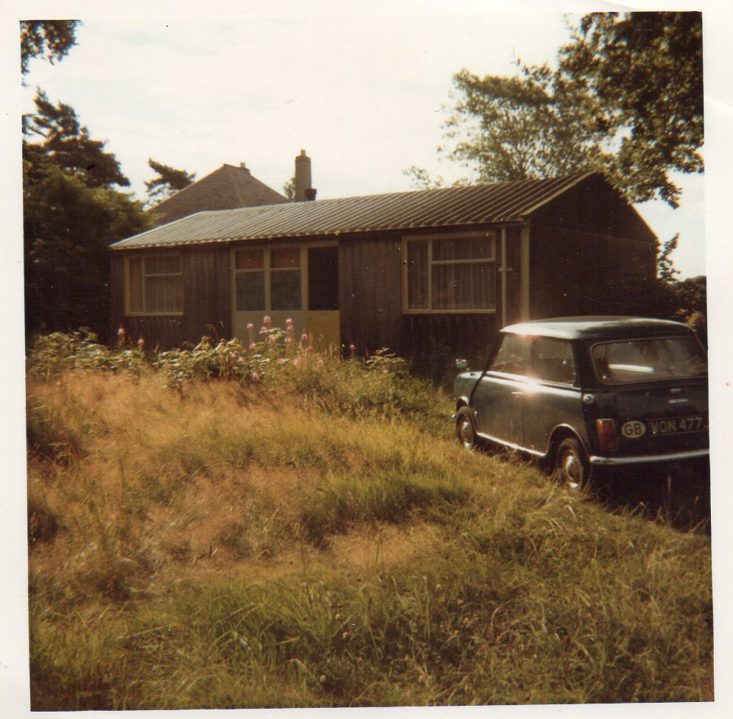
The Prefab…..photographed somewhat later in the early 70s. This was demolished in 1974, but there are still some prefabs left, as many occupants were so fond of them.

King’s Norton Primary School
As our Dad spoke only a little British Army German (Ein Bier, bitte…) and we had soon to go to school, we had to learn English quite intensively; Ellie was already over reception age, and she had not been to school at all in Berlin, German children only beginning at age 6. Unfortunately our Mutti did not keep up our kiddie German, so it gradually slipped away.
In February of 1948 I was just 5 and found myself in a huge classroom with a very tall, rounded window, and a blackboard on one wall, on which Mrs Prince had drawn a picture of a boy and a girl holding hands. I was totally bewildered, and fascinated by the cubby hole under the desk I was sitting at, where I could put my lunch….. soon after that I was moved to Miss Hellberg’s class , where I think I remained for a couple of years. It must have been soon after I started school that one day I decided I’d had enough of it all and walked out of the gate and all the way home (down Wharf Road, over the canal bridge, up Parson’s Hill (I always used the residential side, not the traffic side), across the junction at the top and down Monyhull Hall Road to the prefab). Fortunately in those days there was little traffic…at any rate this 5-year-old must have had training in crossing the road, as I lived to tell the tale. My Mum was obviously not expecting me home and took me straight back to school… We always walked to school in those days, only getting the bus if it was raining. It must have been around this time that Ellie and I won, at the school’s Sports Day in King’s Norton Park, 2nd place in the 3-legged race, for which we were awarded a silver medal, engraved with the year, the school’s name and ‘ 2nd, 3-legged’. Engraved silver, for something so trivial, so soon after the war..? These days it’d be a bar of chocolate. (After consultation with Ellie, we decided to return it to the School for its memorabilia, and I was invited on a tour of the School on 30th November 2020 by Mr Tromans, the present Head).
My teachers at that time had the difficult task of teaching me to read. I only remember once having to read aloud to have my progress assessed. To this day I think Primary teachers have an awesome responsibility in this regard…at any event I wound up able to read and was always good at spelling. I recall a sticker in the rear window of someone’s car: ‘If you can read this, thank a teacher.’ I do, I do! - I moved here into the Juniors, and my next teacher, with whom I stayed for 2 years, was Miss Lyle, who had whiskers on her chin and always kept a pack of glucose on her desk, from which she would take a spoonful every time she had a cup of tea. It was probably around this time that I had my first Library ticket, and I still recall going to borrow my first book, one on birds, which we had discussed in class. I still recall the unique smell in the building, which remains very similar today, and takes me right back. I returned the book the same day, much to the bemusement of the librarian, when I told her I had read it already. Thus began my lifetime love affair with reading, though not always of the books recommended by school! Around this time I recall learning lots of lovely traditional folk songs, like ‘the Lincolnshire Poacher’, ‘All Through the Night’, ‘Men of Harlech’, ‘the Ash Grove’, ‘Barbara Allen’, ‘Sweet Lass of Richmond Hill’ etc. etc., all now replaced with more modern items, largely from musicals like ‘Oliver’ and ‘the Sound of Music’….a great pity.

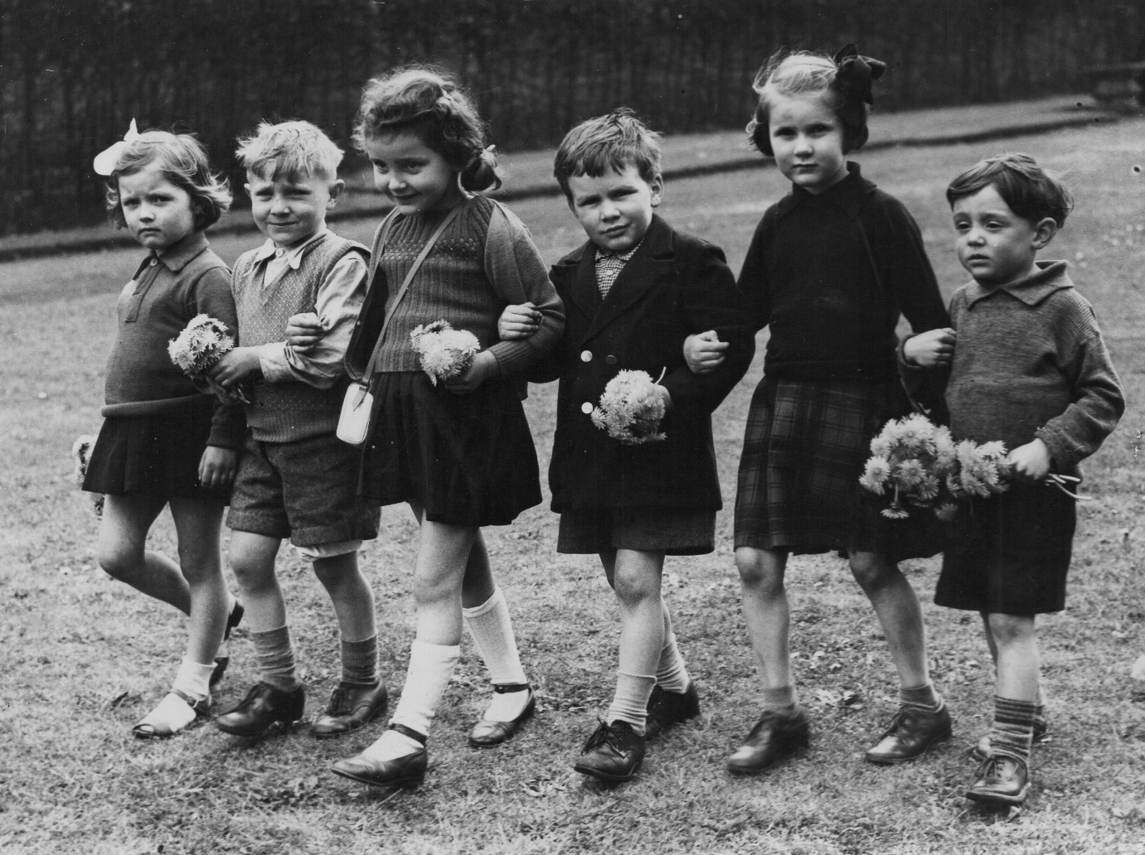
This picture was published in the Birmingham Mail. I am wearing the white knee socks.

I was still in Miss Lyle’s class, in the room which is now used for voting, on 6th February 1952, when the church bell opposite was tolling, tolling… Miss Lyle asked if anyone knew why, and someone knew that King George VI had died in the night. The next year I was in Mr Page’s class, and the country was gripped by Coronation fever. We were in one of the huts at the bottom of the playground, overlooking the red brick wall which gave onto the garden at the back of the Navigation pub, and on the other side of the wall was a gipsy caravan. The huts are no longer there, but I got on very well with Mr Page and remember him doing spelling tests and reading to us, on Friday afternoons, episodes of ‘The Wizard of Oz’. In the summer of 1953 I was invited to a Coronation Gathering in the garden of Margaret Stormes, who lived in Midhurst Road, virtually next door to my friend Hilary Proom, who lived at no. 87, and have still 2 photographs of this occasion, with 7 or 8 of my friends.
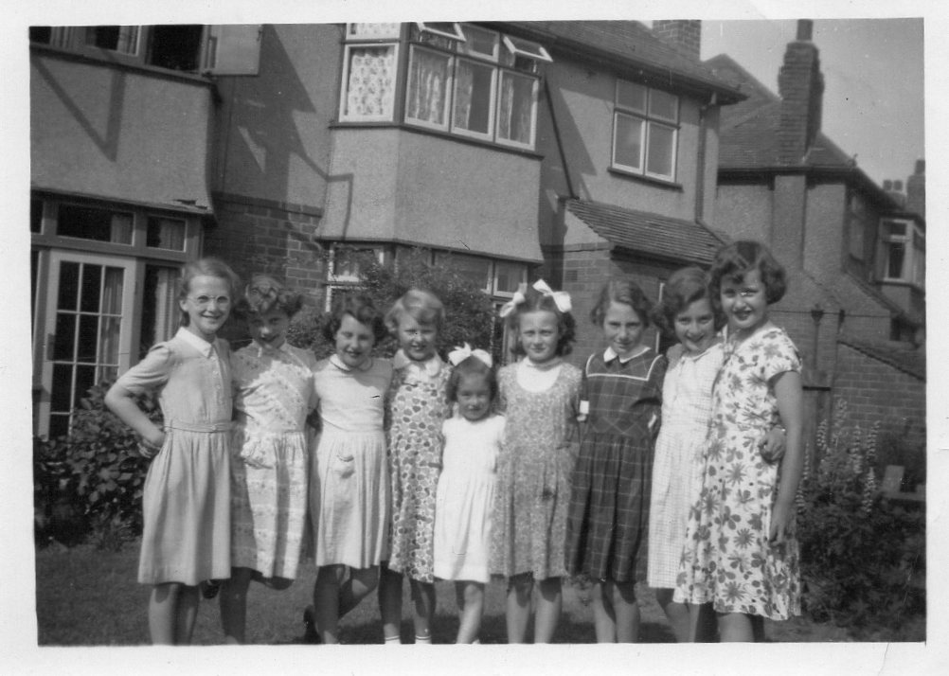

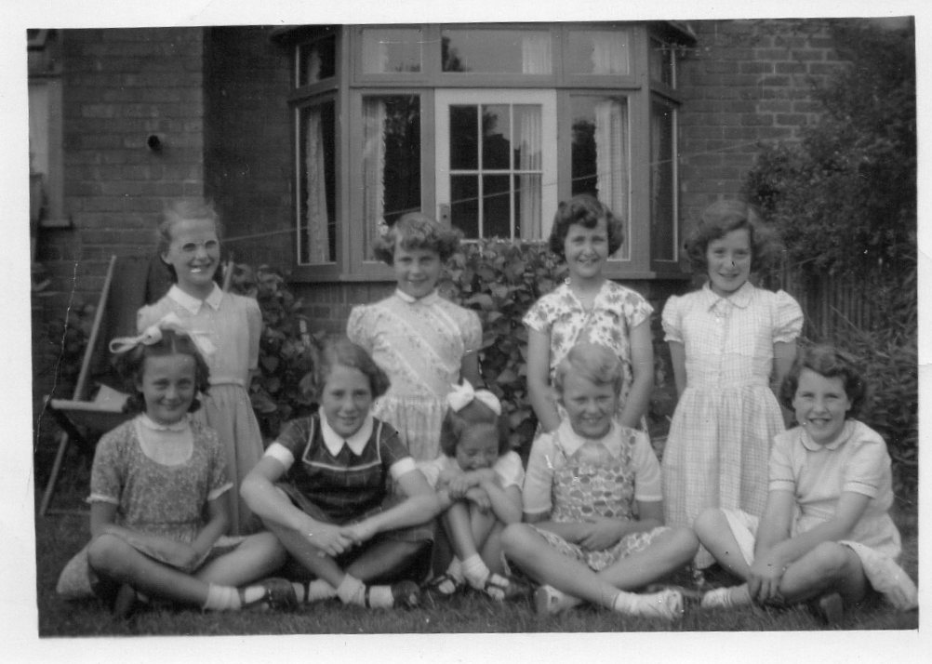
I do not remember exactly when it was, but some boys from St. Joseph’s Catholic School in Station Road used to come for lunch, as they had no canteen. One of them, on arrival in the playground, accidentally caught my left leg on the wing nut of his bike, and tore a small wound in my leg. I was at once spirited away to Selly Oak Hospital to have it stitched, and remember being terrified of the necessary injections. The scar has been with me ever since. – At some stage we went on school coach outings to places like Whipsnade Zoo and New Brighton, very exciting, as we did not break out of our locality very often.
Head at that time was Mr N.G.Roberts, who owned a big square grey box of a car, which he parked on the playground on a spot which is now lost under the new building which was put up to connect the Infant and Junior parts of the School. Occasionally he used to come into lessons of the older pupils to impart wisdom to us. After Mr Page’s class I moved on to Mr Jenkins, whose job it was to prepare us for the 11+ exam. His classroom was one of 2 more huts on the left side looking from the Pershore Road, but the original ones here have since been rebuilt with a slightly different footprint. Behind these 2 classrooms was a kind of electricity substation, and between this and the 2 classrooms was a convenient space, still there, where we used to play ‘Theatre’, a significant preparation for a very prominent part of my adult life. During this year we had 2 crazes: firstly for polishing our desks, and then for collecting all kinds of coloured foil paper, smoothing it out and keeping it between the pages of some book or other.
Around this time came a dental inspection, resulting in my first visit to the clinic in Maas Road, Northfield, a name which would strike terror into my heart for years afterwards. The 4 fillings were torture and enough to put me off from further visits until I was 14 or so and began to worry about my teeth rotting away…I steeled myself and have been to the dentist religiously every 6 months ever since. I’m glad to say that I still have 31 teeth as I write, and that’s the way it’s going to stay. (The one that had to go…? That was the dentist’s fault, not mine….) Taking teeth out at night…? Horrors!! - Today I think modern equipment and techniques have taken much of the fear out of the process.
At the end of the year we got the results of our 11-plus exam; some had taken the Worcestershire exam as well as the Birmingham one. Those who had passed were asked to come and stand out at the front of the class – something which would never happen these days. I was one of them, and passed for King’s Norton Girls’ Grammar School. On leaving, I realised, even at my tender age, how much the Primary School staff had done for me, and that life would never be the same again...it was the summer of 1954. That bewildered little German girl of 1948 had come a long way.

Ellie’s recollections of the Primary School:
“I recall the Annual Sports Day in King’s Norton Park, the 3-legged race in particular. I enjoyed learning how to knit, was good at English and spelling and was allowed to help others in the class with their spelling when writing compositions. This was in my last year before leaving for Turves Green Secondary Modern School. I remember dreading going back to School after my long absence with a mastoid infection and meningitis. I also recall crying a lot after that illness. (I remember Ellie being carried out of the prefab one night by the ambulance men, being very seriously ill. She was in hospital for 4 months. - S.) However, I did manage to recite a poem when the older pupils put on a concert for the parents and pupils. The teacher in charge did not think I was capable of doing this, so I was very pleased not to have made any mistakes! - I remember my favourite teacher in the last year, a very Welsh Mr Davies, who had his legs in callipers after a bout of polio. He drove a 3-wheeled car, which I think was a Reliant Robin or something similar. He was very kind and I think, had a soft spot for me! I can remember always enjoying our singing lessons – and feeling quite emotional when certain songs/tunes occurred. The only other thing which comes to mind was the old gypsy caravan located just on the other side of the school wall.”

Below: Ellie in the late 60s, around the time her 2 children were born. She looked so pretty when we went to see her in hospital.
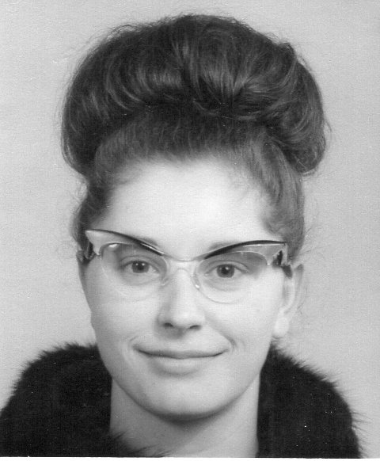

Life at Home
Our Dad Jack Myers had his heart in his music, rather than in his day job at St. Francis’ School, although it has to be said that he had a wonderful touch with the class of senior boys who were allotted to him throughout. For years after they had left, they used to come to the house wanting to visit him and showed great loyalty. The emphasis in the job was not so much on preparing lessons and marking work, but on keeping control in the classroom, and for that he had a great talent, without losing their respect. I never once saw him bring work home, other than perhaps some requisitions or other paperwork he had to do, and school was over by 3.30, leaving him plenty of time for his music. He was the youngest of 6 children, whose father had died of typhoid when he was 2, and his Mum had insisted that as well as their day jobs, the 4 boys should all learn a musical instrument as an alternative source of income. He learnt the piano and clarinet, and later the organ, and for 23 years was deputy organist at King’s Norton Church, avoiding the main post so as to have plenty of time for his operatic activities. He conducted several amateur orchestras, firstly for the Light Opera Section of Bournville Musical Society, then for the Kendall-Bond Operatic Society, in which our mother took a lot of leading parts, and several other local companies including Stratford, Lichfield and Sutton Coldfield Operatic Societies. This meant that there were usually rehearsals with Mum going on in our sitting room, or perhaps church psalms and other items. Operatic societies are notorious for post-performance drinking sessions, and our parents really went to town over this. They were not exactly alcoholics, but quite heavy social drinkers, and tended to spend their money on this rather than on basic essentials…like clothes for us and the roof over our heads, so we rented all our lives until very much later. Their routine also involved putting us to bed at 6.00 and going out to rehearsal without leaving anyone in charge of us, something which today would be considered child neglect, but which was quite widespread at the time. We used to peek at them leaving from behind the curtains, and once the coast was clear, get up again and maybe switch the new telly on or get ourselves something else to eat… I tremble over this today, as there were times when the house’s locks did not work properly and anyone could have got in…. On their return they would usually both be tanked up with alcohol, and we always heard when they got in, as the prefab’s walls were paper-thin. By next morning we had been in bed for so long that we were ready to get up, but they were often badly hung over, and when we made a noise, our Dad used to come and give us a good hiding. The weakness was so strong… Years later when I mentioned this, I could see that it filled him with remorse. But a decade later, there was worse to come…..
As Mum & Dad were at work, we often used to get home from school before they did, and there would be, on the mantelpiece, a bit of paper with 4 items written on it – I can see it now in Dad’s handwriting… Fire, Wash up, Beds, Tidy. In winter this meant arriving home to a cold, dark house, and then having to go out to the shed at the back to break up some coal to light the fire. The coal was delivered in sacks, and was always in lumps far too big to use without breaking up. There was no light in the shed, so we had to open the sitting room curtains so that some light shone outside, and break up enough for the evening; before that, of course, the previous day’s ashes had to be taken out, a dirty job that we all hated. Usually we got the fire going, gradually it warmed up, and when that was done, the other jobs were a relative doddle, though of course not our favourite activities… When the parents finally returned, they did so to a house which Ellie and I would have liked to come back to. Someone once said I seemed like the type who always had everything done for me… Hm.
It was not all bad, however. Mum took us to Weston-super-Mare and Torquay, and Dad took his class of boys to Towyn in mid-Wales several times, with us hitching a holiday as well. In Towyn the Martineau family of Birmingham had bought a house near the beach for disadvantaged children from special schools, such as those of St. Francis’, and here we got our marine education, learning how the sea had to be treated with respect, and about the tides, shells, fish and so on. We went on lots of lovely day trips from there, once almost getting cut off by the tide and having to be rescued. Happy days….we travelled there by coach with plenty of ‘scoff’ to eat en route. Idyllic days… were I not going to spend eternity in St Nicolas’ churchyard, I would happily have my ashes scattered off Towyn beach.
As Dad was my godfather and organist at the church, he arranged for us to go to the Sunday School for little ones in the Saracen’s Head, which we did for years until we graduated to the Junior Church in St Nicolas’. Here at about 14 I became Stamp Monitress, receiving a set of stamps of religious significance for every Sunday in the Church calendar and doling them out to all the other children. I still have my complete booklet with them all stuck in today. We won a few prizes for never missing a week, which were all signed by the Vicar, Edward Ashford, and he also presented us with bibles and communion books at our confirmation course. We thought he was God… We were confirmed on a Saturday in December 1956 by the Bishop of Aston; I was wearing my school uniform, as I had nothing else to wear. - Later after the Junior Church, we moved on to the Bible Class in the Old Grammar School until we left School for employment and in my case, University. While here I arranged several parties for the other members in the Saracen’s Head with my friend Hilary, and we had the occasional day’s outing to local attractions too.
Our Dad was a Yorkshireman from Leeds, and had his Mum and most of his brothers and sisters still there, in Middleton, south of the city. There were no motorways in the early days and the journey took twice as long as it does now, but Dad liked to go and see everyone, and they always made us feel very welcome. It must have been hard for our Mum in 1947 coming as an enemy woman with baggage in the form of 2 children, but they always gave us a good time when we went there. The eldest brother Tom and his wife Gladys lived near Doncaster, so we seldom saw them, and George, the next one down, soon moved to Leicestershire with his wife Cyn to teach clarinet, but Mabel and her husband Bernard lived in Middleton and ran a hairdresser’s and men’s outfitter’s on Middleton Circus; they had a son Eric, Marie was a midwife and her husband Jim a policeman, and they lived on the Ring Road not far away, as did the youngest brother Bob with his wife Peggy, who worked in the dress department in Schofield’s, a prestigious department store in Leeds. Bob worked at Kitchen’s, a musical instrument supplier. We had many a jolly session with them at the Woodman Pub not far away.
Their Mum Anne Eliza sadly died of cancer in 1956, but we had several stays with her in our holidays, and it occurred to me much later how glad she must have been that she got all 4 of her sons back after the war. Dad’s wartime dogtag hangs in my lounge to this day, both parts still attached. He used to say his Mum was ‘the best’, and I still remember how he arrived back from her funeral in Leeds with the car laden with some of her household effects.
Many of my friends joined the Guides, but I did not like what I heard of the silly games they played and had a friend Rita Jackson, who was in the Women’s Junior Air Corps. Daddy let me join, and I was a member for some 2 years before I had to stop for O-level exams. However I had a good time with them and went to camp once in Torquay, and twice up in light aircraft from Elmdon Airport, as it was then. I also still have several training certificates from them for things like Theory of Flight (useful in my later General Studies exam) and Aircraft Recognition.
King’s Norton Grammar School for Girls
In the summer of 1954, Ellie also passed to go to Moseley Art School, which meant our parents had to buy two lots of new school uniforms at once. These were obtainable either from the very expensive Thomas Donne in Corporation Street, where the school blazers had the badge already sewn into the garment, or the much cheaper local Co-Op in Stirchley, where you had to purchase the correct badge and stitch it on yourselves…. For us Donne’s was out of the question, as money was always very tight. Mum budgeted to get the very best value for money, but there was none left for a navy raincoat for me…I was told to wait till Ellie had grown out of hers. ‘What am I supposed to do if it rains?’ I asked. ’ Wear your blazer and go under the umbrella’, was her reply. Grrrrr! By now it was clear to both of us that we were not exactly our mother’s priority. She was her own priority, and kept our Dad poor… A child very quickly realises if someone is selling them short. Our mother was narcissistic, and often concerned with catching the eye of other men. I used to get cross when people in the operatic world said how wonderful she was - all we wanted was a mother who would be there for us when we needed her, but her thoughts were usually elsewhere. We were not read to, nor taught how to cook, nor how to relate to other people, nor to be tactful, to put others first, in short, she did not spend nearly enough time bringing us up, but just left us to fend for ourselves. Thus we blundered on as best we could. Once we were at a performance where she was playing a leading part, and on her appearance she got a round of applause from some in the audience who had seen her several times before. This, for an amateur, was unheard of…it only usually happens to famous professionals. I can only assume it went to her head. While on that subject, she owned a very fashionable red hat, quite unlike any worn by other mums, and once when there was a parents’ evening which she was coming to, I cannot recall whether at the Primary or the Secondary School, I was determined that she was not going to wear it, so I took the precaution of hiding it for the day….
I began at my new school in September 1954, and at first found it hard to settle, even though there were several others there from my Primary School. I dreaded Break in the mornings as I never knew who to hang out with…. This continued until I gradually made friends and slowly settled into the complex new regime. At the end of the first year I came top in French, and was put in a Latin form for 2nd year, when I really wanted to do German, which I had of course spoken as a small child but forgotten. It seemed I would have chance to do it in 4th year, so I settled to Latin, which ultimately was to prove very useful to me...I only wish I had had chance to do Greek as well. But in my first 3 years I was not very motivated, and one end-of-year report stated: ‘Sabine has not worked hard enough this term…’
Thereafter I made more effort, but my record really lifted off when I began with German in year 4 and was properly motivated. At last this was what I really wanted to do. We were put in for O-level after just 4 terms from scratch, as our teacher Freda Kellett felt we were an excellent group with much promise, and she wanted to start us on A-level work in the remaining 2 terms of the 5th year. So then we found ourselves reading Storm’s ‘Immensee’ in Gothic type…..a tall order for us. – I should place on record that in the summer of 1960 Miss Kellett took us to see the very uplifting Passion Play in Oberammergau, followed by a few days on the Rhineland, where we got to see Beethoven’s birthplace in Bonn, which still smelt of smoke after the recent fire, and while there I managed to visit Oma and Opa Hofmann, recently arrived from Bad Kösen.
But the previous summer had been difficult. I had nowhere to work properly without Ellie waltzing into the room, no table, no chair, and had to sit on the bed, and the Latchford boys, David, Robert and Peter, who lived in the 5th prefab along from us, were learning to play football and cricket outside the window, where there was a large patch of waste ground, all with the relevant sporting noises uttered at the tops of their voices and my constant fear of a football or cricket ball coming through the single-glazed window. In those days I had no idea that they would all become professional footballers, and I don’t suppose they did either. Homework was the bane of my life, and how I ever got through any revision for my O-levels I do not know. These days schools have quiet rooms for study, since it is recognised that some pupils do not have quiet facilities at home, but in our day we were given detentions if we were caught doing homework in school.
I took those exams in the summer of 1959, and by then knew that I wanted to go to University, for which it was essential to have either Maths or a Science, if not both. As I was always very weak in Maths, I was pinning my hopes on my General Science, without which I knew I would not get in anywhere, and I thought I had explained this to Mum & Dad… The night of 23rd June 1959 was one of the worst in my life. They had had a rehearsal and came home high on drink, bringing some friends home with them to go on drinking. I was trying to sleep, to be fit for the Science exam next day, on which my future depended, but was driven frantic by the noise, until I could not stand it any more and flung open the sitting room door and said look, I have this exam tomorrow…please let me get some sleep – I made a scene, in other words, but the noise still went on for half the night. I took some tablets in despair, and next day at school told someone, who was quite concerned but could not really do anything. I don’t remember what my parents said when they sobered up, but think they just felt entitled to please themselves in their own home. Our future? Not important. I can forgive my Dad quite a lot, as after all we were not his children, but I find it harder to forgive my Mum. It was as if, once she had us, we were too much Hard Work for her, hence the long 7 months when she palmed us off on her friends in 1947. I have never again had such a feeling that I did not matter as I had that day – it was black despair with nowhere to turn, and I know it damaged my confidence for years afterwards and gave me the feeling that I was somehow inferior to everyone else. It was to be a very long time before I saw this for what it really was. It was not my fault….
Alongside all that, as a teenager I had become acutely aware of how much other girls had that we did not…enough clothes to make a ‘wardrobe’, bicycles, several topcoats where we had none at all, and a change of school blouses and summer dresses where we had one, which had to be laundered at the weekend. Once the Latin class was going on an outing to Chedworth Roman Villa, and I was the only one who did not sign up to go. My teacher tried to discover why, but I never told her the real reason - I had nothing to wear. – We had no washing machine and had to wash our own things from about age 12. Most of our friends’ mothers did their laundry for them, but not ours… she once asked us to wash hers in exchange for some extra pocket money – but we told her we’d rather do without it!
But the thing I felt most self-conscious about was the lack of a proper brick-built house to live in. At that age one is very anxious to fit in with everyone else, but I often felt the odd one out. My ‘house-barrassment’, as it is called in a current TV kitchens ad, grew ever greater, and all the other girls were inviting their friends round when I simply was too ashamed of our place with its corrugated asbestos structure and shabby furniture. Nearby was the bus stop where I used to get on in wet weather, and if I heard a bus coming past, I would stay out of sight until it had gone, as I did not want all the passengers to see me coming down the path from a mere prefab….one day, I thought to myself, I shall have a respectable place of my own where I can invite anyone in at any time of the day or night…..
I passed my General Science, and the other O-levels apart from Maths with moderate marks, having already got French and German the previous winter, so embarked on A-level in both, plus Latin. After 4 terms of Latin, I was getting increasingly frustrated with the teacher, an obese Miss Sanders, who would set us a translation and then fall asleep…today schoolchildren would just not put up with it. I decided to cut my losses and do Scholarship French and German in addition to the A-levels, dropping the Latin at Christmas in the Upper 6th, which I already knew enough of for it to be useful. The exams loomed in the summer of 1961.
As one cannot work all the time, a few of us went to the Saturday night ‘Hops’ in the Students’ Union Building at Birmingham University as we were coming up to the examinations. The first night I went, I was asked to dance by a charming young man who turned out to be German-born, as I was, and with whom I had much in common. His name was Dieter Ritz, he was a first year Mechanical Engineering student and his family had come to the UK from Karlsruhe in Germany to live in Whitley Bay, Northumberland. The following week he was there again, and we began seeing each other on other evenings too. We did our exams, and life suddenly became very intense with the stress of work on the one hand and the fact that I was falling hopelessly in love with him on the other. That summer I began to have some inkling of what Paradise was like...he was going to family in Karlsruhe, and I was planning to go as usual to our family in Bonn. We arranged for him to come up to Bonn for the weekend, and also that I should catch the same train home as him ready for the start of term, with him travelling up from Karlsruhe and me getting on in Bonn, then travelling on together, splitting up in London for me to go home to Birmingham and him to Newcastle and Whitley Bay. This was at the end of September, and I ought to have gone to the Freshers’ Conference in Leeds, my first choice uni where I had secured a place (below, the letter informing me), but there was no contest between that and coming back with Dieter, so I stayed on, much to the consternation of our Dad, who thought I was cutting it all too fine. He came to the station in Birmingham to pick me up, and I still remember the stony silence in the car on the way home...he did not approve of my having boyfriends, who he thought would distract me from my career, and of course we were not of age in those days until we were 21, so he would always clamp down on them, and often made me miserable by insisting that I had to be home by 10.30 from the Hops when it was awkward with the buses, something which spoiled an otherwise magical time. Today he would be regarded as excessively strict, and called Dieter, the man I loved, ‘this cove’…. So I used to say goodnight to Dieter, when he saw me home, a hundred yards from the house, which he did see once or twice, much to my usual embarrassment. However, the relationship went on.

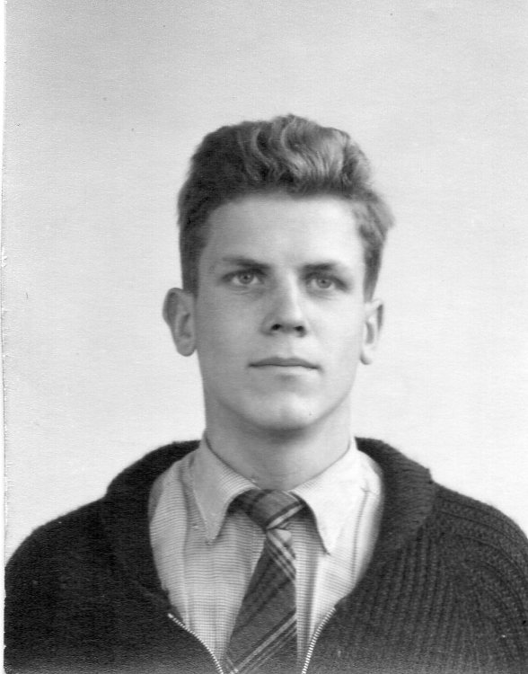
Dieter….

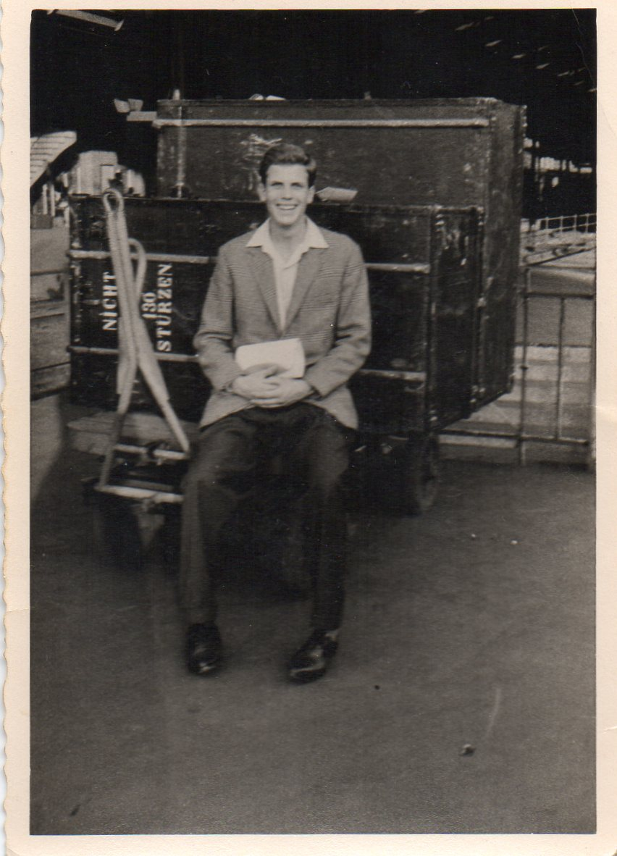

…and on the platform at Bonn Station, following his visit to me
in the summer of 1961, shortly before I was due to start at Leeds.
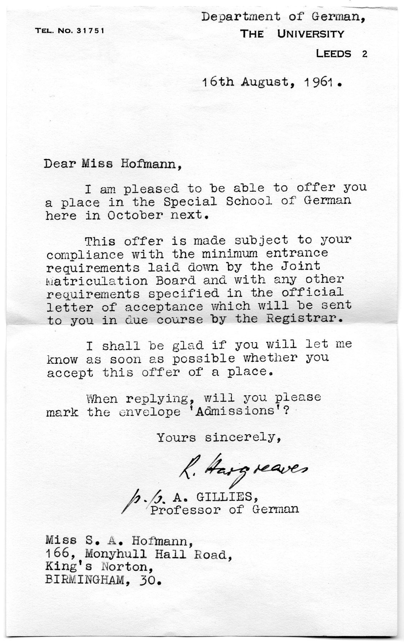
Leeds University (and Manchester)
Here, at long last, I was able to have a single room, though at the cost of having to live in digs rather than a Hall of Residence, since only final year students were allowed them there. After one term in a rather substandard place, I wound up with the Procters in Halton, a couple who had a daughter of my age at Durham Uni, and when she went, I came, and vice versa. I enjoyed the freedom from constant parental scrutiny, and managing my own money. As Mum had decided to train for teaching at this time, we were lucky both to be given the maximum grant. How different things are now….My allowance for the first term was some £86, of which half went straight to the landlady for my accommodation, and the other half was for Everything Else. (Books, clothes, lunches, travel). What on earth was I going to do with all this money…? I had never been so wealthy in all my life, having earned 15/- (15 shillings) for a Saturday job. I remember getting £2 out every time I went to the bank – and it sometimes lasted me over a week! Laughable now.
Leeds had been my first choice of Uni, and I do not think I would have got in without doing French and German at S-level. I was accepted to do the German Honours course, but once I was there…I did not want to be there, I wanted to be back in Birmingham with Dieter….so I frequently came home for weekends and we would have more pleasant evenings out. This continued all through my first year, and over the summer, until, in November of 1962, when I had arrived home as usual for the weekend, a letter came saying: ‘the flame for you has gone…’ and more. I was more than distraught…the bottom fell out of my world and I simply did not know what to do with myself. I often wonder how big a part my Dad’s attitude and home circumstances played in this disaster, because I obviously did not strike Dieter as suitable material to settle with. I think that Saturday night I went out somewhere or other with Mum, but cannot recall where, and I went back to Leeds that weekend in pieces, with no enthusiasm whatsoever for my work nor anything else. - Subsequently I did see Dieter once or twice, he knew how I felt, and told me ‘just because this has happened, don’t think the die is cast for good’. I wanted to believe him, but I realised much later that … it was. I knew I would never find anyone like him again, and I never did. He subsequently got engaged to someone from Whitley Bay that his parents were ‘sold on’, and disappeared from my life, leaving me totally heartbroken. This again undermined my confidence and underlined my feelings of inferiority – and how. Anyone who knew me at this time would probably have said I had the air of someone who was not happy in her own skin…not at peace with herself. - Today all the places we went to in the University here have very bitter-sweet memories, especially the Debating Hall where we met and had our first dance together, to ‘Moon River’. I can still recall the smell of the place, probably down to the disinfectant they used, and there have been times when, invited to a performance or some other function in that Hall, I have felt unable to go.
It was around this time that the Cuba crisis happened – we fully expected to be going up in smoke at any moment, and this went on for several nerve-racking days, until common sense reasserted itself and both sides drew back from the brink. I recalled at this time a conversation I wished I had never heard, some years earlier, when a visiting married couple were talking about whether they should have children. I overheard the wife say: ‘No… they’ll only die in the next war’. This sowed the seeds of a lifelong fear in me, overcome only by the fact that we are all still here some 60 years after Cuba.
The rest of the year dragged on and I did date other people, but was not in the least interested in any of them. Then in the summer term of that year it was envisaged that we should spend a term at a German University. Leeds’ link was with Tübingen, but we did not have to go there…we could choose any place which was approved. I saw this as my opportunity to do some hitch-hiking around southern Germany, Switzerland and Austria, and felt that Freiburg im Breisgau, capital of the Black Forest, was much better placed on a direct railway line than Tübingen, which was tucked away in the ‘back of beyond’. So the summer of 1963 was spent in Freiburg with its hundreds of pink-candled chestnut trees…it was beautiful. We were some half dozen students there from Leeds, all with the same idea, and in the absence of any definite work assignments from Leeds other than just to experience a German uni, went on some wonderful trips…in those days hitch-hiking in twos and threes was still quite possible. Before returning home I was lucky enough to go the ‘Stiftungsfest’ of a student brotherhood in Giessen/Lahn. But despite all this I was still miserable over Dieter, and had I known that this heartbreak would repeat itself 20 years later, I would have been even more so. It’s just as well that we do not know what is going to happen to us. How long did it take me to get over it? It’s difficult to say, as it was such a gradual and painful process…in some ways it has scarred me for life.
That September Ellie was married, and I was her bridesmaid. In the evening of that day Mum & Dad went out to a pub somewhere, but did not tell me where they were going, and I was left high & dry at home. What was I expected to do? This had been a day with a major family event, and we ought to have all been together. I began to feel the way I had on that dreadful night before my Science exam…as if nobody really cared about me and as if I didn’t matter. I recall I went uninvited in desperation to the house of my friend Rosemary to seek some consolation. Heaven knows what her parents must have thought. Later that evening, as so often, there was the usual alcoholic haze to cope with. I knew I just had to be patient until I could establish myself independently and run my own life. - Thereafter, with Ellie living round the corner, I had the bedroom in the prefab to myself…a small step in the right direction, bliss! - The cherry on the cake was that once later when I came back from a summer break in Bonn, Daddy had painted and papered the room with pink and white bandbox wallpaper of my choice…heaven after the battleship grey walls we had always had before. I got matching furniture and curtains and it was a total treat. The one advantage of having nothing is that you really appreciate things when they do come.
I did my final year and got a lower 2nd class degree, good enough to be regarded as a ‘good honours’. I had explained to my Dad the system of marks (first class honours, upper second, lower second, third, pass and fail (yes, some did!)) On hearing my result over the phone, he said: ‘Is that good?’ as if it had not really registered with him. I wondered how interested he was…however, from this point my relationship with him changed…he knew now that I had meant business, and we bonded with each other far more than we had done before. He was thrilled to bits on my graduation day in the Great Hall in July 1964, especially as I did a bob to Princess Mary, sister of the previous monarch George VI, who was Chancellor of the University at that time and lived at Harewood House near Harrogate. The last time he had seen her was when he was in the North African Desert in the War. It did not strike me at the time that some of my contemporaries had stayed an extra year in the 6th Form, or done a year abroad during their courses, and wound up with no better a degree than I had, after 3 years from age 18. Later I wondered whether, if I had had proper support at home, I could have done better, perhaps even got to Oxbridge. I shall never know.

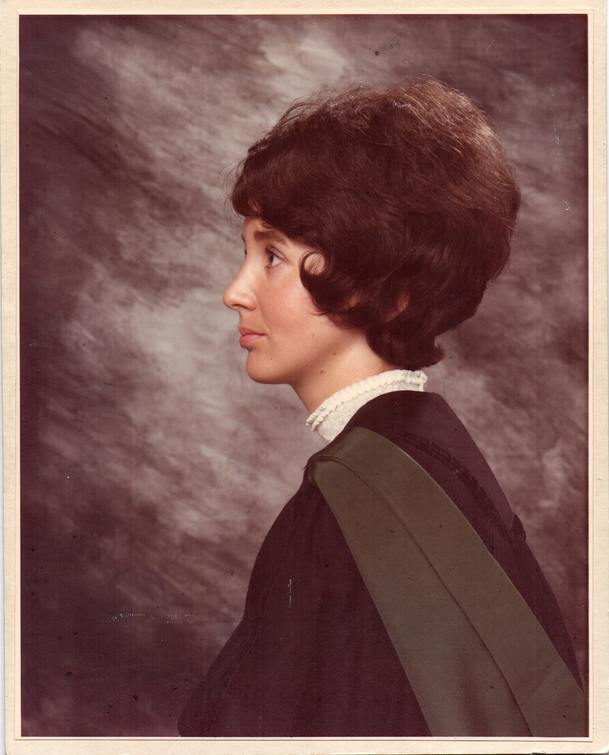
During all 3 years at Leeds it had been the same few people doing the same things, and I felt ready for a change in my postgraduate teacher training year. In Leeds we only did play readings, not a proper performance, and I saw this as my only chance to do a German play proper, so I migrated over the Pennines to Manchester, and took the part of Eva in ‘Der Zerbrochene Krug’ (Heinrich von Kleist). However, teaching did not come easily to me: I did 2 weeks’ preliminary practice at my old Primary School – and hated it, but persevered in Manchester after some difficulties over finance, as I was not British and said I was not sure whether I would teach at the end of the course. But then there was a vacancy in the German Department of my old Grammar School, and Daddy urged me to ‘jump in with both feet’, which I did. After some 2 years of hard slog, things began to get easier.

Holiday Jobs
In these days of so many going to University and having to fund themselves, jobs during term-time are essential, but we were only allowed to work on Saturdays while at school and in the Uni holidays. Over my student years I had numerous such jobs; my first was at Thomas Donne’s in Corporation Street while I was still at school – the idea was that I would earn my own pocket money if my Mum paid for me to go on a school trip to the Passion Play in Oberammergau in 1960. In this post I sold shoes, baby clothes, dresses and school uniforms, and followed the firm to Five Ways when they were taken over by Daniel Neal’s. I worked on the Christmas post and did script checking (totting up the examiners’ marks) for the Union of Educational Institutions and the West Midlands Examinations Board in Norfolk House, Smallbrook Ringway.
In Bonn I packed colour slides and worked in the local Youth Hostel, and following my term in Freiburg, in a skin clinic in Giessen/Lahn. After that I was earning a proper salary in my first teaching job.
I do feel that such jobs are valuable, as they bring us into contact with all sorts of people we would otherwise never meet – particularly important when one is constantly in the cloistered and rarefied atmosphere of school and university.

King’s Norton Girls’ Grammar School – on the Staff
I had been a mere 4 years away from the School when I returned in September of 1965, and was to stay for 5 years, until I was 27. Mum and I both began teaching together, albeit in separate schools, as she had meanwhile also trained for the profession at Wolverhampton Day Training College. We had a photograph together in the Birmingham Mail and a short write-up headed ‘Mother and daughter are both new teachers’.
I enjoyed the exam work, as all the girls were volunteers, but not the younger classes, which were mainly conscripts ‘trying the subject out’ as I hated playing language games and other activities which the inspectors deemed necessary. As well as teaching German from scratch to A-level, I was given one afternoon per week of Social Studies with the Sixth Form, and this was divided into one term each on Law and Order, Public Health (long before the Environment became the huge concern which it did later) and Special Education, since all our girls had come through the normal channels and had little idea therefore of what other services existed for children with various disadvantages. The School Secretary made up a programme of alternate visiting speakers and trips out to see what they had been describing, and my role was simply to chair the sessions and accompany the group out on visits. I enjoyed this, as it was such a change from what I was doing for the rest of the week. I also made a lot of contacts in the city which would come in very useful later.
In the summer of 1968 I led a party to Oberammergau, though not to see the play, which was not due again until 1970. Some teachers thrive on this, but I did not, and was so run down on return that it was the only one I ever went on.
During this time we were still living in the prefab, and I remember once seeing, out of my bedroom window, some girls I taught at school, I guess I could call them ‘my groupies’, who had obviously come to see if they could get a sighting of me at home……they didn’t…I was excruciatingly embarrassed, but had to live it down. - At some stage also, I spotted, coming up the path to the house, an individual from Leeds Uni, who had obviously got hold of my address, and, having some engagement or other in Birmingham, decided to come and seek me out. Horrors!! I quickly told whoever was at home with me at the time to tell him I wasn’t in, and hid until I was sure he had gone….I like to think he eventually learnt that for very good reasons, such unannounced calls were Simply Not Done.
During my years at King’s Norton, both my niece Susie and nephew Stephen were born; I also learnt to drive, and bought my first car, a Mini, 2nd hand from my Mum. Later, when the children were a bit older, we had wonderful days out, and Ellie was very grateful, as she was working, and of course when Sue and Steve were on holiday, so was I, and they lived only just round the corner. I adored them…. Happy days!

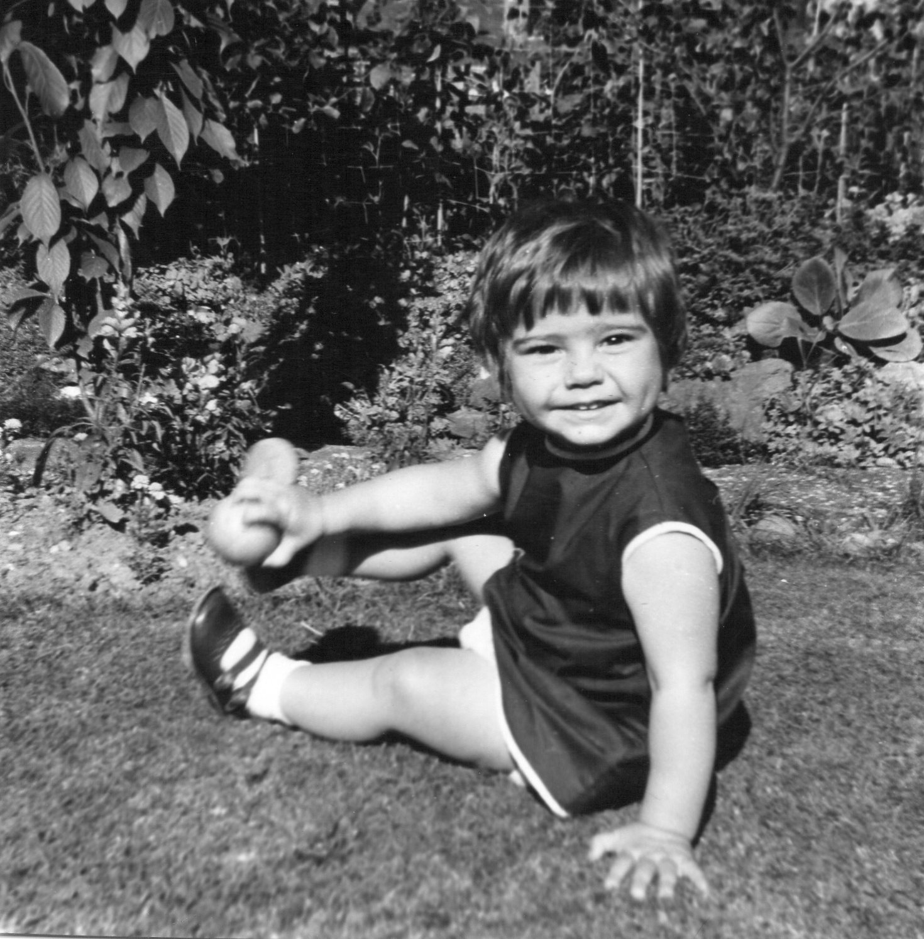
Susie, born in February 1967, in the summer of 1968

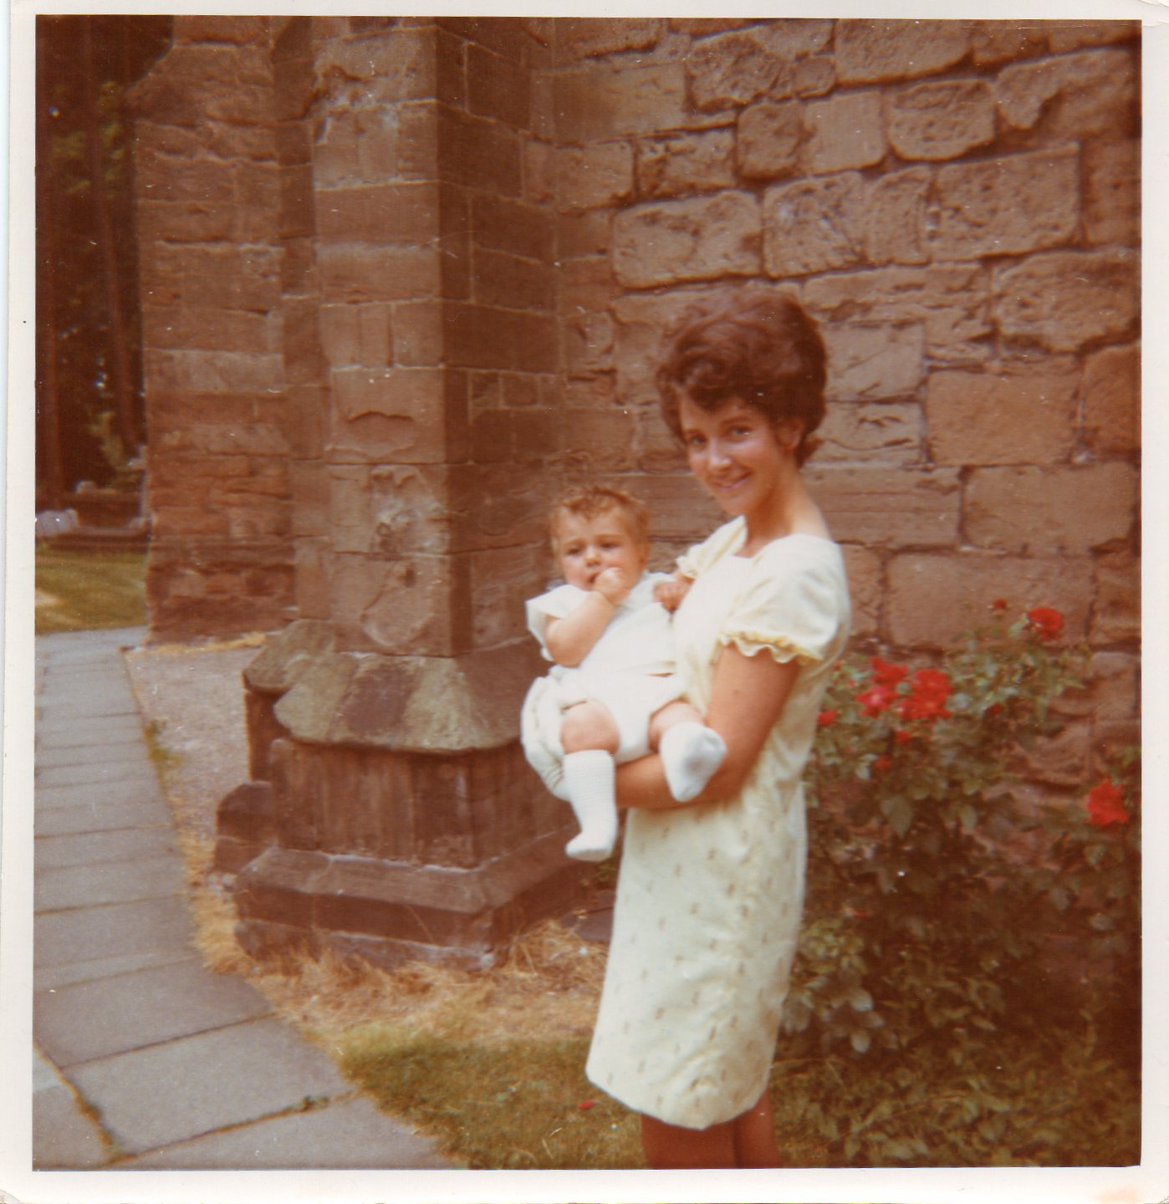
At Steve’s christening, 20th July, 1969

By the time I was 27 I had spent 12 years of my life in that building as a pupil and a teacher, and I got ‘itchy feet’, conscious that I had never spent any time in Germany other than my term in Freiburg. There was a chronic shortage of English teachers in Germany at that time, and a scheme was begun to recruit some from UK. My Dad wanted me to stay at home, but I applied, nevertheless….

Amateur Theatre
Dad had always been musical, like the rest of his family, and played piano and conducted orchestras from an early age. When we were children, as I have already mentioned, he was involved with the Kendall-Bond Operatic Society, and with Mum playing leading parts, there were always rehearsals going on in our sitting room, or he was learning the latest score, whose tunes also wormed their way into our consciousness. He was then asked to be Musical Director for the Light Opera Section of Bournville Musical Society, provided for Cadbury employees, but with some room for ‘outsiders’, without whom they could not have cast their productions. In the early days he did one or two obscure operettas like ‘Tom Jones’ and ‘The Rebel Maid’, but then the company turned to the Gilbert and Sullivan operas, and from 1954 for the next 10 years or so, it was wall-to-wall G.& S. To help him learn the score, we would always have the latest recording from the D’Oyly Carte playing on the gramophone, and of course we always went to see the finished product. The Kendall-Bond continued until its demise for lack of funds in about 1963, and around then, Bournville branched out into other things like ‘The Merry Widow’ and Strauss. This was all a part of our lives as we grew up, and I, at least, knew I wanted to join in with it eventually, as I was hooked on the music, teamwork and general atmosphere in the theatre. However, Dad would not let us join in before we were properly qualified for our careers, so everything had to hang fire until then. There was one exception: when I was 14 and there was a production of ‘The Mikado’ in the offing at Bournville, the Stage Manager broke her ankle and needed a ‘runner’, so I was drafted in despite the homework difficulty…and had a most wonderful week, which made me all the more determined that I was going to sing in these shows too.
Companies over here usually do one main production a year, rehearsing for it on one night a week for some 6-9 months, with extra principal rehearsals, and often there is also a Concert on one evening to raise extra funds. Tension and excitement mounts as the production approaches, we are measured for costumes (Dad sad they spend ages measuring you up then pick out something from the Costume Company which is the worst fit possible…..and often he was right!) There are always extra orchestra rehearsals just prior, tickets to sell, programmes to be compiled and printed and a host of other jobs to be done like Front of House (selling programmes, guiding people to their seats, and so on).
At Bournville the official photos were always taken on the Saturday after we had had our costumes the previous evening, so on that night we all had to frantically sew, alter and iron our stuff so that it looked all right next day. On Monday evening there was the final dress rehearsal, and on Tuesday it was curtain up for the rest of the week. On Saturday some companies did a matinée either at 2.30 or 4.00, so it was quite strenuous with twice in one day. However, adrenaline always carried us through, and lots of fun was had… on that last night we all bought each other small presents, which also had to be got ready and wrapped in time. On arrival one went round the dressing room depositing them on each person’s place, and on return to one’s own, there would be a pile of parcels/flowers or whatever waiting. Most dressing rooms were too small, and we had somehow to muddle our way through the chaos and try to get our slap and costumes on before the tannoy message: ‘Act I beginners, please!’ Even after 49 shows on stage and 57 prompting, I still feel excited when I hear the overture strike up from behind the curtain. Such a show takes over one’s life for about 4 weeks, and I always had the tunes reverberating round my head for much longer. They became a part of me, and I have always got some tune or other going round and round in my head, even if I have not just done a show. Besides that, a host of quotations stick in the mind from the libretto and score, which come out at odd moments when something apposite happens, and we all have a good laugh. - I mainly sang in the chorus as a soprano, but did one or two principal parts too, notably Orlofsky in ‘Die Fledermaus’ twice and the Baroness in Offenbach’s ‘La Vie Parisienne’. On Saturday night there were flowers on the stage following these, and I really felt I had arrived! - In the early days there was no pub on the Bournville site as the Cadbury family are Quakers, but in the early 70s they bowed to pressure and opened the Bournville Club just across the road from the Concert Hall. We certainly sank a good many bottles of Dry Moussec in there when we came off the stage. Over time I worked with several different local companies, as shown on the appended list, which includes every show I have done since my first at Bournville in 1966. Once I was asked to prompt, and this led to dozens more requests, so that today I am a ‘roving prompt’, which I enjoy, as I don’t need to put on make-up, nor dress up; I simply need a lot of black orchestra-pit/backstage garb! I can dodge straight into the bar after the curtain comes down and look for old friends who have been in the audience. - I did 17 shows at Bournville with my Dad as Musical Director altogether, until the company went over to American musicals, which I did not want to do, so I migrated elsewhere. There are plenty of companies operating in the Midlands. - This hobby was what kept me sane during my working life, and stopped me from getting all too wedded to my teaching job. A show is a major project which one can lose oneself in, forgetting everything else, and very social - just what I need to replace the husband and children I never had. Over the years I have built up a very great number of friends this way. One of the things I liked about it was that it brought us all into contact with people of all ages and from many different walks of life…from professional senior management to those in the most humble occupations, the unemployed and everything in between. One lad at Tinkers Farm Opera was Marius from Transylvania. He worked for the Blood Bank, so of course we called him ‘Dracula’. As well as the performances, I also did a stint as Membership Secretary and committee member for Bournville, and much later a year as Company Secretary for Tinkers Farm Opera, a rather onerous position with regular minutes to write up. I think I did 19 lots in my year, which would have been bad enough if we could have stuck to the agenda!!

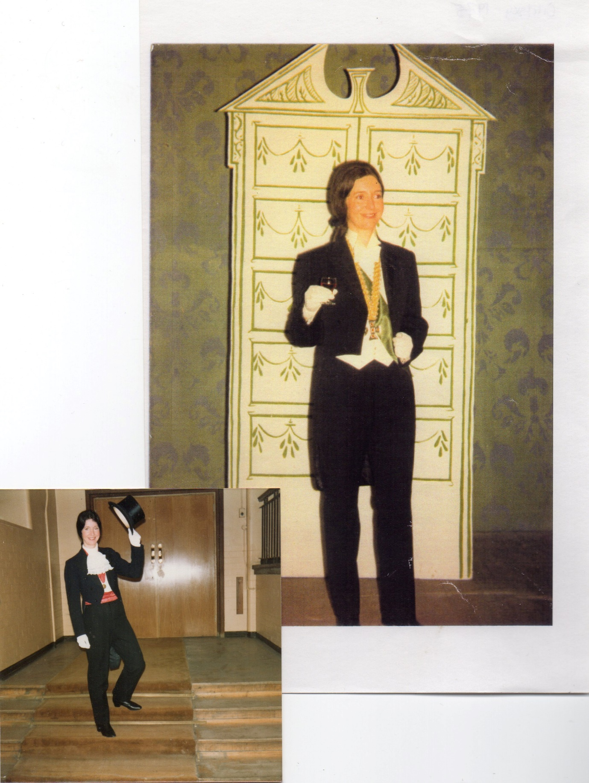
Prince Orlofsky in ‘Die Fledermaus’, Bournville, 1975 (top), and again in 1984. I loved that costume!

Frequently I would dream about doing performances, often having mild nightmares about having to go on stage and not knowing my lines, or being all ready to go on and mislaying my libretto when I needed to check up on something. I had similar dreams about teaching lessons in school and not being prepared properly, or not being in control. These made me double-check that I had given due attention in good time for what I had to do.

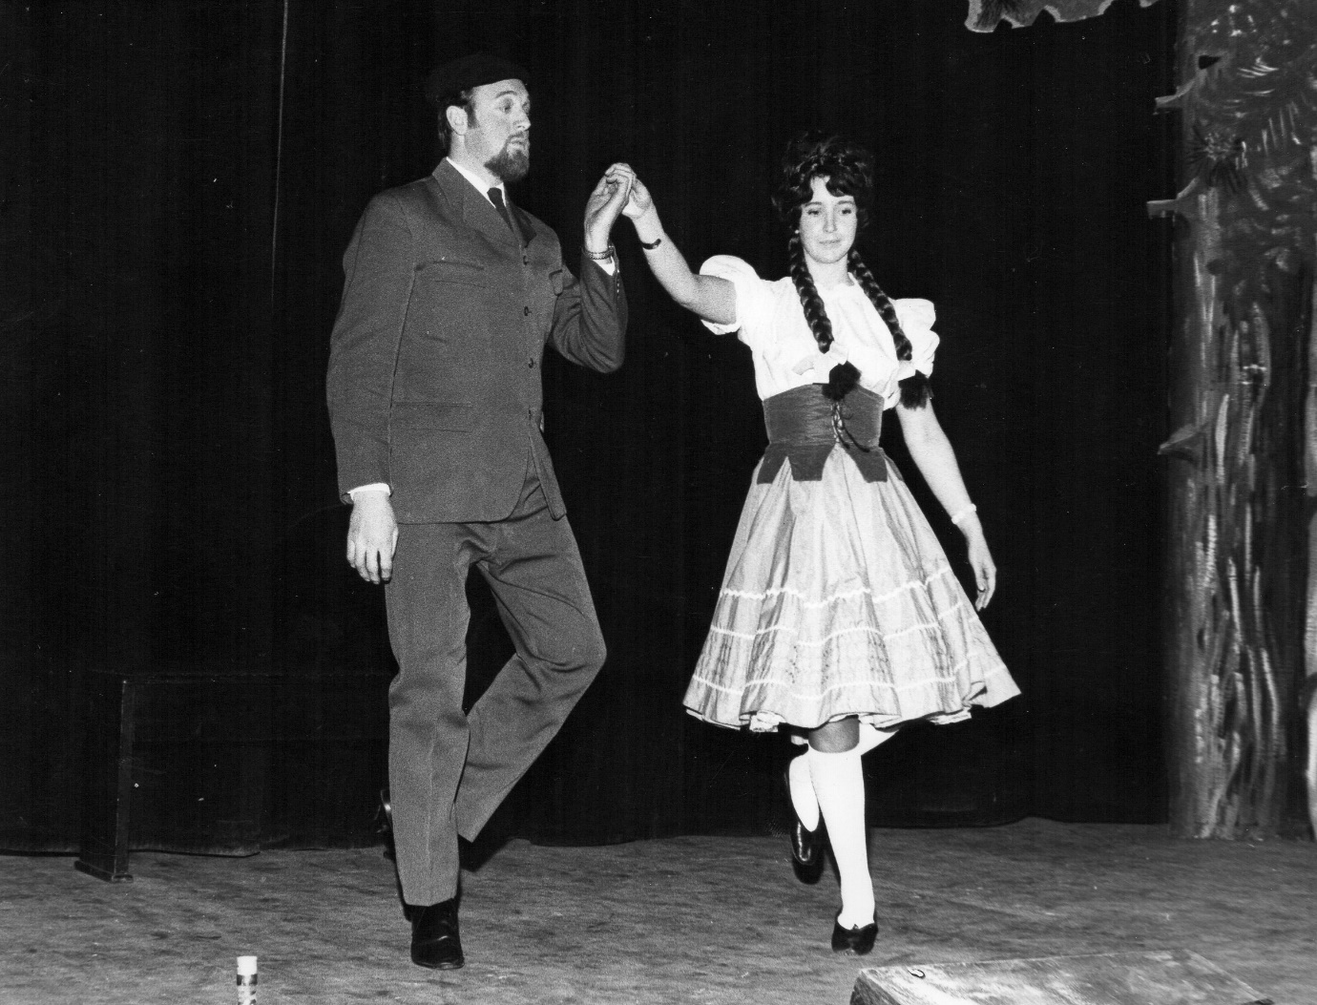
Bournville, 1969. Gretel & Sigismund in ‘White Horse Inn’

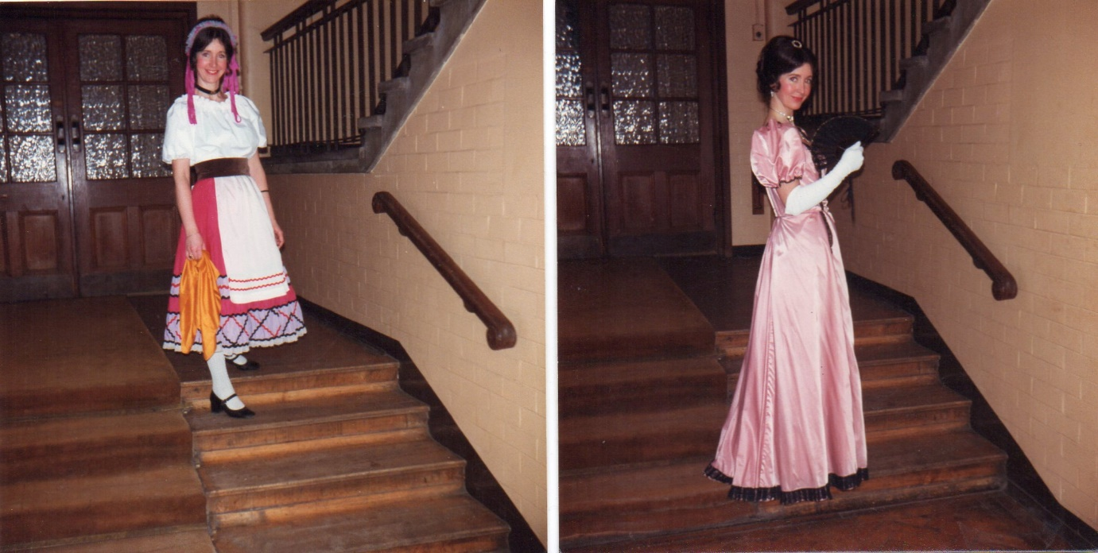
Bournville, 1982 The Merry Widow

For every good photo of me , there are at least 20 which are - terrible!! These a few of the relatively better ones.
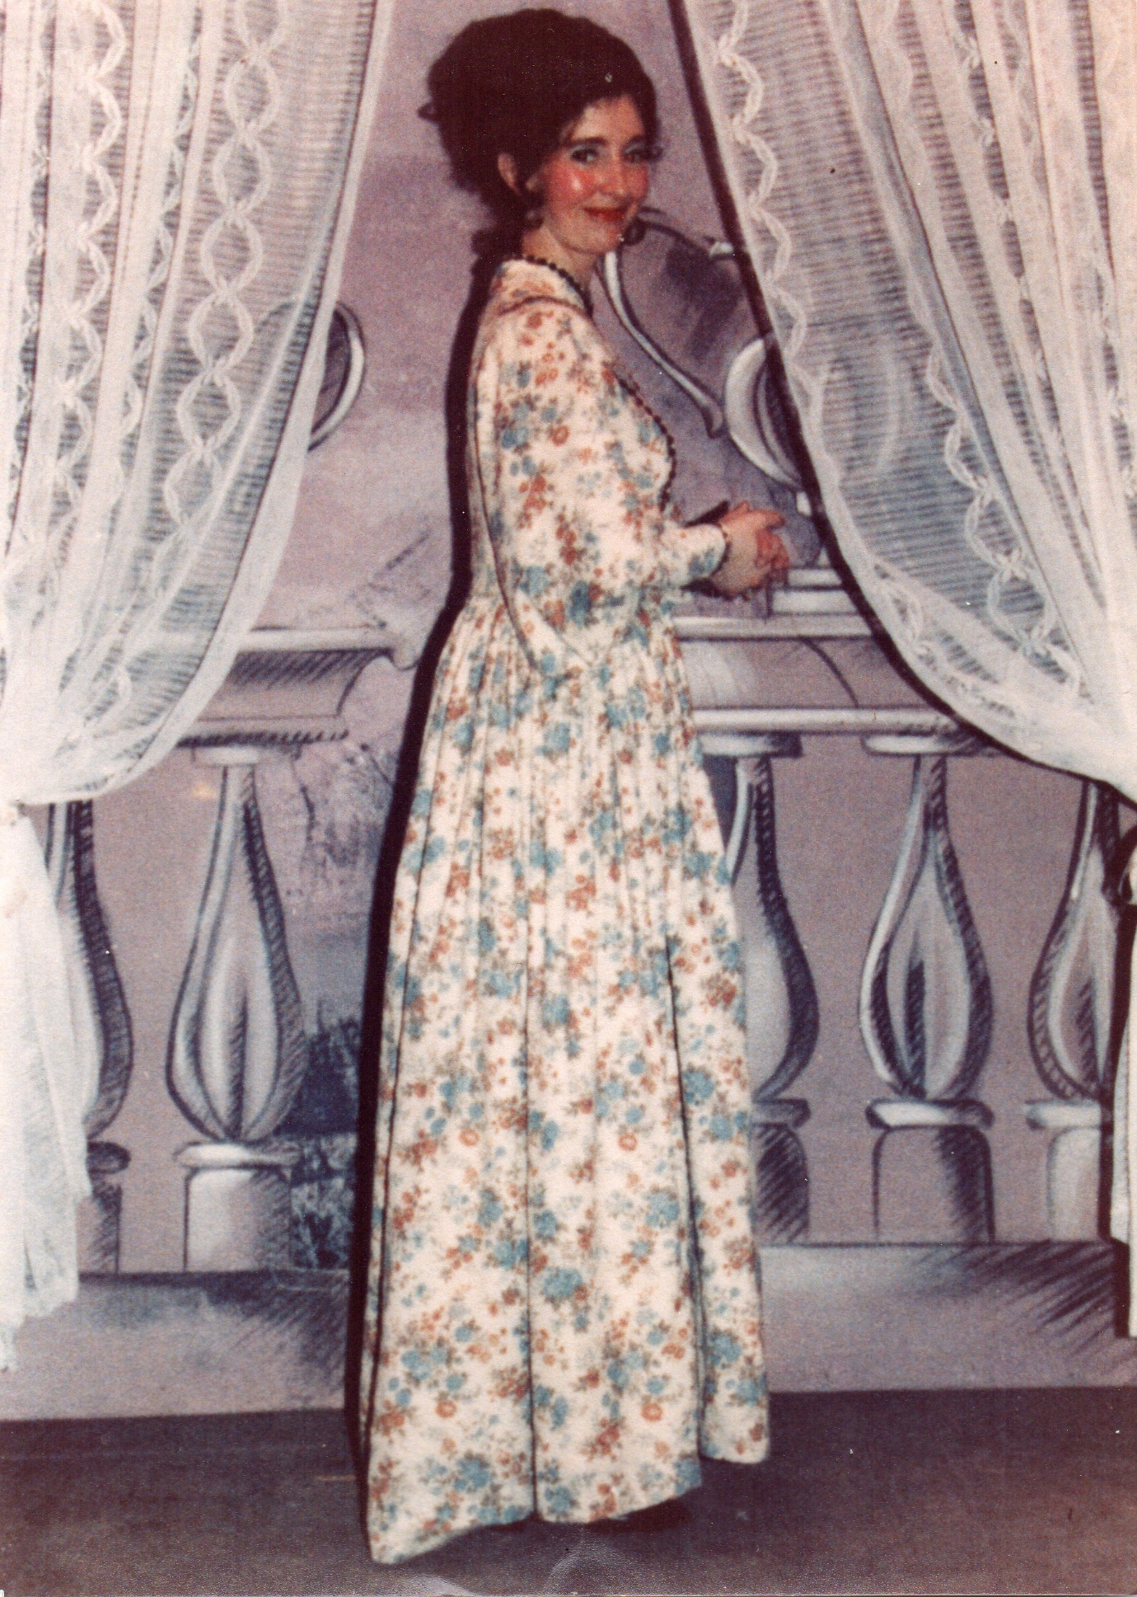
Bournville, 1979 Baroness in ‘La Vie Parisienne’

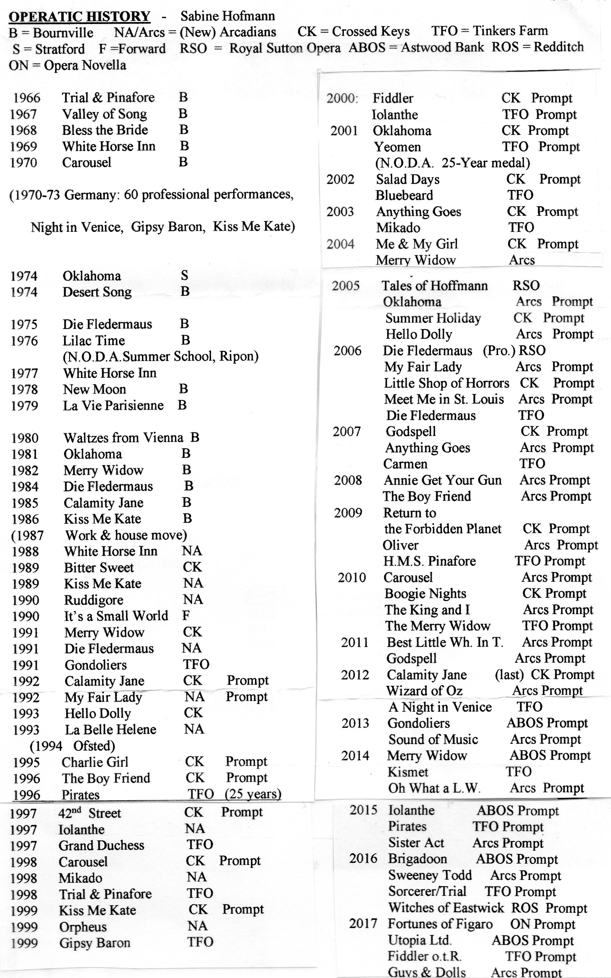
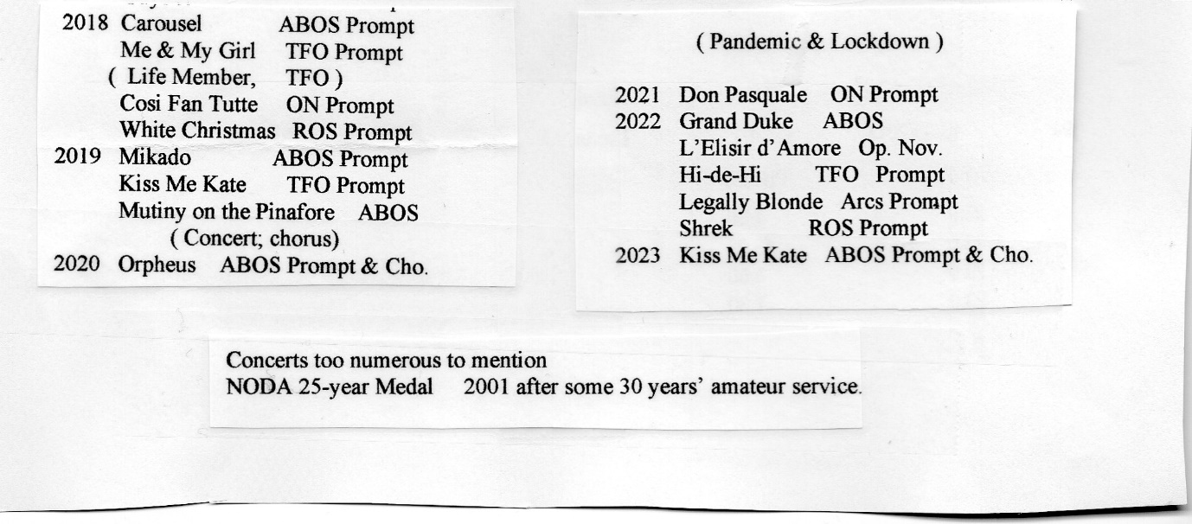

Another main hobby of mine was/is the National Trust. The date and place of my first visit to one of these properties is lost in the mists of time, but I loved to drink in the atmosphere of these lovely old houses and gardens, probably as they were so elegant in comparison to where I lived. Left some money by my German grandfather, I spent some of it on a Life Membership, and have certainly had my money’s worth out of that!
1970 – 3: Germany
I initially took 2 years’ leave of absence from King’s Norton, and was posted to Oberhausen in Nordrhein-Westfalen. The scheme had been devised by Anthony Abrahams, a British businessman who enticed us all over there by giving us 2 years tax-free, with a possibility of a 3rd year, and free car loans. I taught English in the Sophie-Scholl-Gymnasium, in Oberhausen—Sterkrade, and learnt a lot about Britain and America which I did not know. I had a form tutorship which meant I had to lead a Klassenfahrt which turned out to have Amsterdam as its destination, and which was every bit as exhausting as my ill-fated trip to Oberammergau from King’s Norton. I also learnt a lot of legal jargon, since someone drove into my new car, taken out on personal export, damaging it so that I had to manage without it until repairs were completed, and to seek out a German solicitor. As I was due to go on holiday in Switzerland shortly afterwards, I had to go by train and hire a car once there…a left-hand drive, of course, which tested my concentration, but I managed it. In those 3 years I also had some lovely holiday breaks with some of my colleagues, including a first trip to Vienna. - A suggested call on me at home in England by one of my colleagues was gently discouraged, and fortunately never happened……

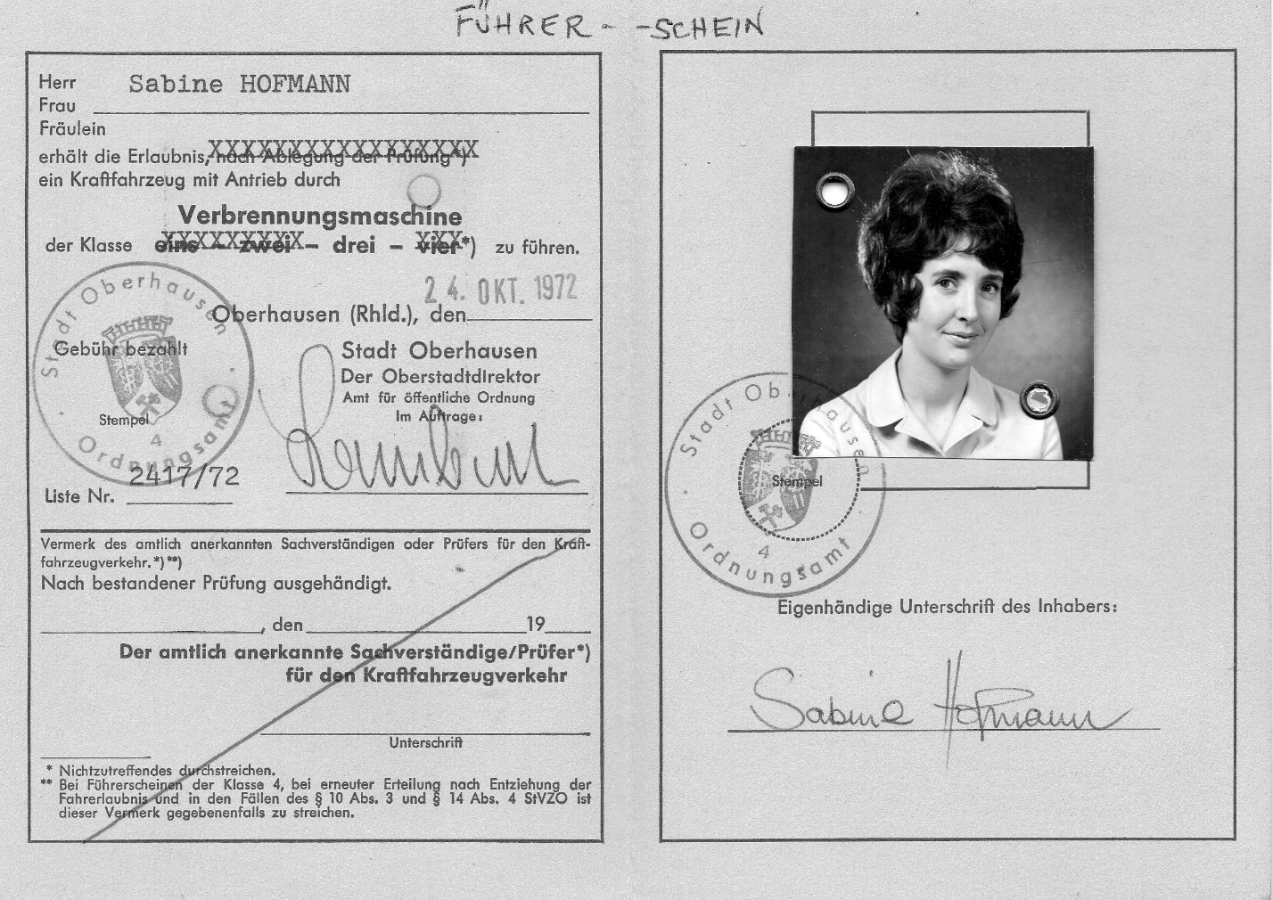
After a year and all the upheaval of moving over there, I loved it, though I missed my Dad and my baby niece and nephew. I looked forward to going home at Christmas and in the summer, but I had by then been accepted to sing with the Extrachor of the Theater Oberhausen, a flourishing concern with lots of sections which also did guest performances in other German towns and in Holland. The Extrachor consisted of a few people like me, not employed by the theatre, for when a bigger chorus was needed. Rehearsals for Strauss’s ‘Nacht in Venedig’ began in May of my first year with the première coming out in September. (In Britain the gala night was always the final Saturday, whereas here it was the opening night, and in Britain one did a week, but here the show concerned ran on the Spielplan for as long as the audiences kept coming, which for two of mine meant 25 performances each over 6 months). I could not believe I was standing on a German professional stage, being paid for rehearsals, performances and mileage away from Oberhausen, and being allowed to go gratis to all other shows in the theatre in which we were not involved. The other advantage was that I learnt a lot of backstage jargon, and did not need to rely on my British colleagues for my social life. As German schools finish at 1.00 or so, it was easy to fit in the theatre alongside my Gymnasium job, even when we had to travel. Inevitably a few girls from my classes found their way into the audiences, so it was not long before my privacy was blown…whether this boosted ticket sales, remains unknown! As well as the ‘Nacht in Venedig’, I did 25 or so performances of Strauss’s ‘Zigeunerbaron’, (which eventually my mother saw in Remscheid), and about 15 of ‘Kiss Me Kate’, which I had already done in Bournville with Daddy, and I wondered how I would get on with learning it in German…but I did it; it was very cleverly translated and went down just as well in Germany as it does here. Overall, having expected to be giving up theatre while I was abroad as I knew they were all professionals, I did far more there than I would have done at home. I had expected perhaps to be able to sing with a choir, but having written to the Kulturamt in Oberhausen explaining what I had done here, I was put in touch with Willi May, the Chorus Director at the theatre, sang an audition for him and the rest was history. While I was waiting for a suitable production to come on the Spielplan, I had singing lessons with his wife. Some things go right!

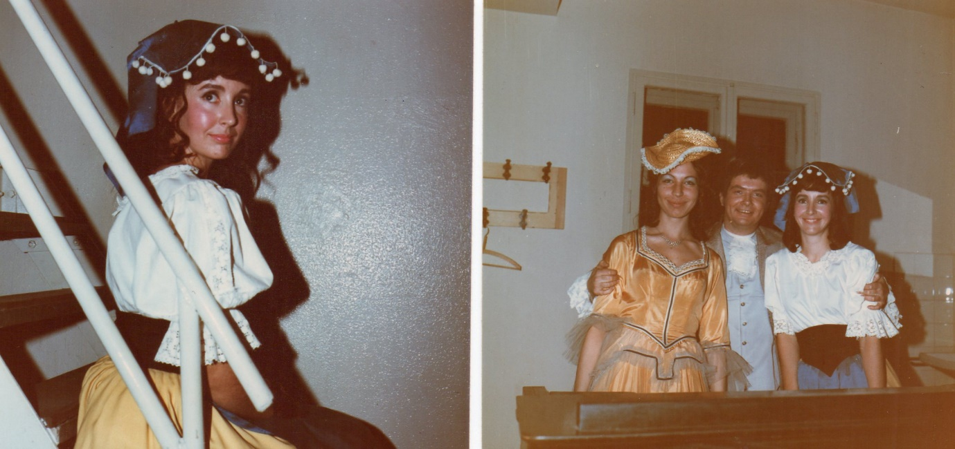
Theater Oberhausen, West Germany, ‘Eine Nacht in Venedig’, 1971/2. Extrachor. My Dad carried the left hand picture round in his wallet for the rest of his life!
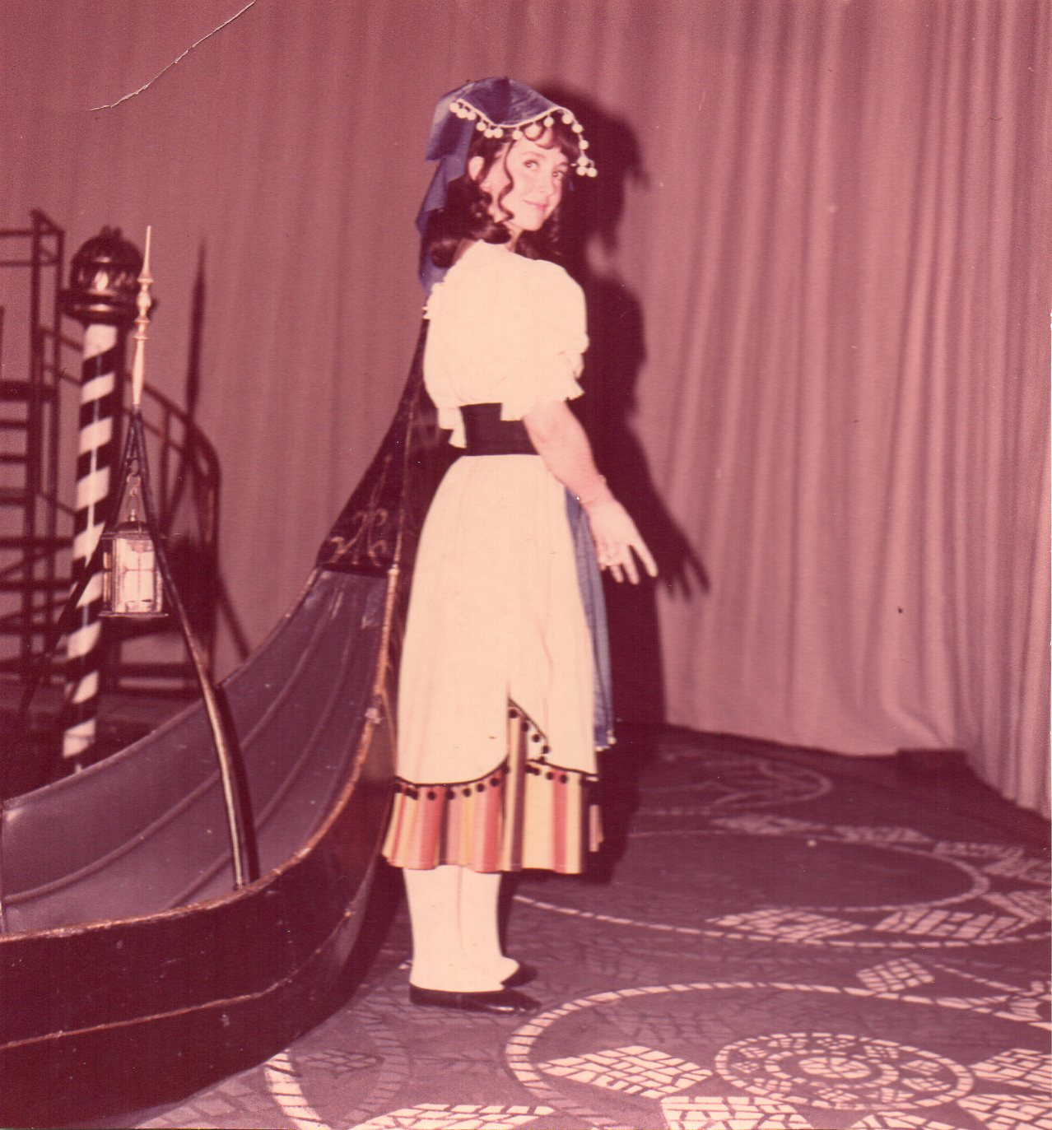
Standing on the ‘Drehscheibe’ in the Theater Oberhausen, which occupied most of the stage. We had to know when it was about to move…. ’Achtung, Scheibe!’

My mother was still teaching back home and became quite envious of me, so decided to apply for the scheme herself. She was, after all, German-born. Dad would never have stopped her, but although he was quite capable domestically, he turned out to be miserable the year we were both over there together, even though he knew it was only temporary. Once he came back with me in my car as far as Harwich and got the train home, but I could see he was not happy. I think he was afraid I would settle over there and never come home. He lost a lot of weight, thought he had cancer and gave up smoking (the silver lining). With hindsight, it would have been better if one of us had stayed with him at home, but eventually it all ‘came out in the wash’ and we were reunited. I subsequently did another 12 shows with him at Bournville, and he often said he would not have had his life any other way. He, the Baby Brother, was ‘our Bübchen’.
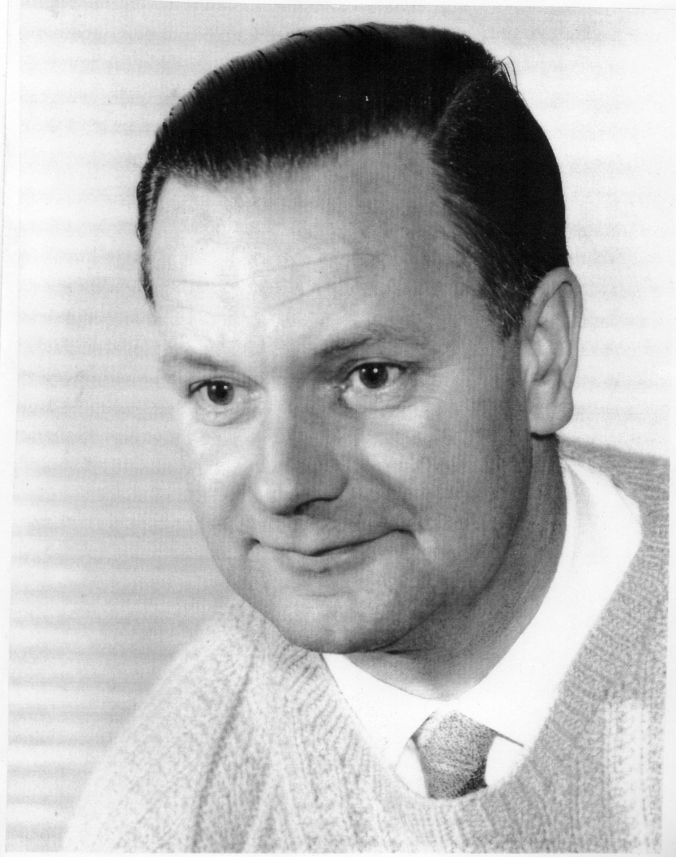

‘Our Daddy’, aged about 40

Summers in Bonn
Our father’s 2 sisters, Doris & Barbara, moved to Bonn at the end of the war, hoping to find office work with the Americans, which they duly did. They settled in Tannenbusch, a newly developed estate, where they found a flat together. In 1960 their parents joined them from Bad Kösen in East Germany as allowed by the regulations, having now both reached the age of 70. Barbara then moved into her own tiny flat in a neighbouring block, vacating her large room for the parents. That summer I was in Germany with my school party to Oberammergau and the Rhineland, and managed to get leave to visit them, the first meeting since I was a baby.
From then on Bonn became my summer home whenever I was not planning anything else in particular. In 1961 Dieter came to stay…. when I was working in the Youth Hostel in 1962 it was easy enough to visit Tannenbusch, and from there I got a holiday job another year in a photographic laboratory, but mostly I simply enjoyed being there, and my numerous visits to the open-air Römerbad. Oma would love cooking and did some fabulous German meals, and enjoyed my company while her 2 daughters were at work. Opa had been a Latin teacher and did not like the fact that I pronounced it the English way….
Doris & Barbara were as different from each other as Ellie and I are. Doris never married, and her favourite activity was…gambling in the Casino. Every holiday destination had to have one, often with disastrous results, not just financially…..one year, possibly 1982, she had an accident on the Autobahn coming home, having slept too little and eaten too much in the night, and as there was nobody else to sort out the mess, it fell to me to do so, picking up the contents of the car from the bottom of an embankment, and visiting her in the hospital in Bad Kreuznach. Even so, she insisted that ‘das Spielen bleibt’ – it was her raison d’être. Barbara had 2 children, Klaus & Gudrun, a couple of years younger than Ellie and me, but they lived elsewhere. Her hobby was drinking and smoking, for which she finally paid with the amputation of both legs and general ill-health. Again, the weakness was so strong….. No role models for me, then, either there or with my Mum; I had to seek them elsewhere. 3 abschreckende Beispiele! I wonder what Paul Gerhardt, our father, would have thought of them. More of Bonn later.
Sometimes I used to visit Hamburg, solo, or with my Mum. Her mother and twin sister lived in Wilhelmsburg, having also migrated from the East, so I got to see a bit of Hamburg, driving through the Lüneburger Heide to get there. We went several times on outings on our own, which were too strenuous for the twins, and one of these was to the harbour (Hamburger Hafen).
At a ‘Fischbude’, the lady serving proudly told us that she had been there for 40 years. My mother, for reasons best known to herself, replied: ‘Yes, you look like it too’. The reply came loud and clear: ‘Alte Kuh!’ with more curses to follow. I wanted the ground to swallow me up….how could my own mother come out with such a gratuitous insult? I have never been so ashamed, and it was good that there were not many people around. - I was in my twenties then, and already knew I did not want to become the type of woman my mother was, but this was the bitter end. I don’t think I ever asked her why she had said that, I just gave her up as a lost cause.

Back in GB: House Move
In the summer of 1973, when I had completed my 3 years in Oberhausen, Mum & I had quite a pleasant holiday on the Bodensee, where my parents had honeymooned in 1940 after their wedding in Elbing. I then left Mum to do her year (in Gummersbach), and went home to my Dad. It was hard to find a job in Birmingham to return to by remote control from Germany, so I had to do this in earnest on my return. I wound up in a post which I knew would be a mere stop-gap until I could find something more suitable, and left at Christmas stressed out and having lost some considerable weight. I had a couple of temporary jobs until Easter, then was lucky to find a German post at Swanshurst School in King’s Heath. It also involved a little junior French. The week of the interview in February we were doing Sigmund Romberg’s ‘The Desert Song’ at Bournville, and on the day it was the dress rehearsal.
Dad had seen me through all the traumas of coming home and getting resettled, so was thrilled to bits when I told him I had the job; furthermore, Monica Ricketts, whom I had met at my autumn term school, had moved there in January and said it was fine. I was offered the job from April, so my worries were over, and we both went to our dress rehearsal with more gay abandon than we had known for a long time, having a few welcome celebratory drinks in the Bournville Club afterwards.

Adding to the upheaval simultaneously, we had had notice that the prefab was to be demolished and we therefore needed to find somewhere else to live. We found a new build house on the Old Golf Course in King’s Norton, which was the first one we were offered, and they wanted us out the week we were doing the show, so we had to pay the rent on both properties for the week to give us time to do it and recover. On the day of the move, we sat ready and waited…and waited…and waited, until finally the removal van came. I recall taking carload after carload of household stuff in my Mini from Lindsworth to Vardon Way, and still remember counting the 6 steps down to the front door so that I could carry stuff in without having to look down… Mum, of course, was still in Germany and so it was just Dad & me doing everything. Here we were, at long last in the brick-built house I had always dreamt of, my only regret being that I had to leave behind my pink-and-white striped bedroom. I suppose I was also a little sad to leave a house with so any memories after over 26 years. For a long time I would dream about it, as if I had the choice of where to sleep, knowing I could always go to the pink room if I so wished, and in my thoughts - I could!
Fitting up the new house, however, was fun, and we also had to reorientate ourselves with the local geography, the bus routes and quickest way to walk to the shops and so on. There was also a rubble-filled garden for Daddy to cultivate, much more manageable in size than the prefab garden had been. Here, one year, he had the company of a magpie, which seemed fond of him and watched him working from the top of a concrete post in the fence, and sometimes, to his amusement, got in his way… (see P. 39 below).
Eventually we grew our own roses, chrysanthemums and more. Now when I see white and rusty-coloured chrysanths, I remember how proud our Daddy was when we could cut some and bring them inside. Bitter -sweet memories…. On the front we had a trellis with an evergreen honeysuckle growing up it, and a small avenue of 4 standard rose bushes leading to the front door. There was a porch with a flat roof, on which we placed boxes of geraniums in summer; they looked a perfect picture. A wrought iron black lantern adorned the front, which I had bought with money from my Oma in Bonn, and we had a doorbell fitted…. All these were things I had dreamt about in the prefab. For a long time the estate was a building site, but gradually as people moved in, it got tidied up with lovely gardens emerging – like ours! My bedroom was again decorated in pink as I still had all the accessories from before. However I missed the built-in cupboards in the prefab, and had to buy some free-standing ones and paint them to match. I should also mention that we were much closer to our neighbours than we had been in the old house; the new one was terraced, which took some getting used to, as we could no longer make noise ad lib late at night. - The day we moved in, Daddy played ‘Bless This House’ on the piano.

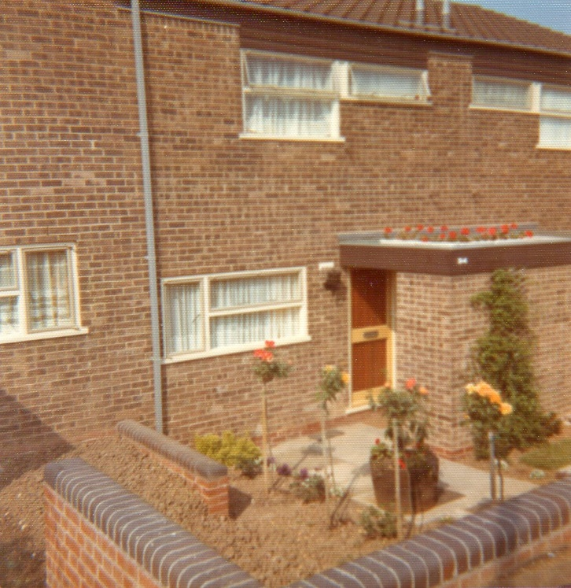
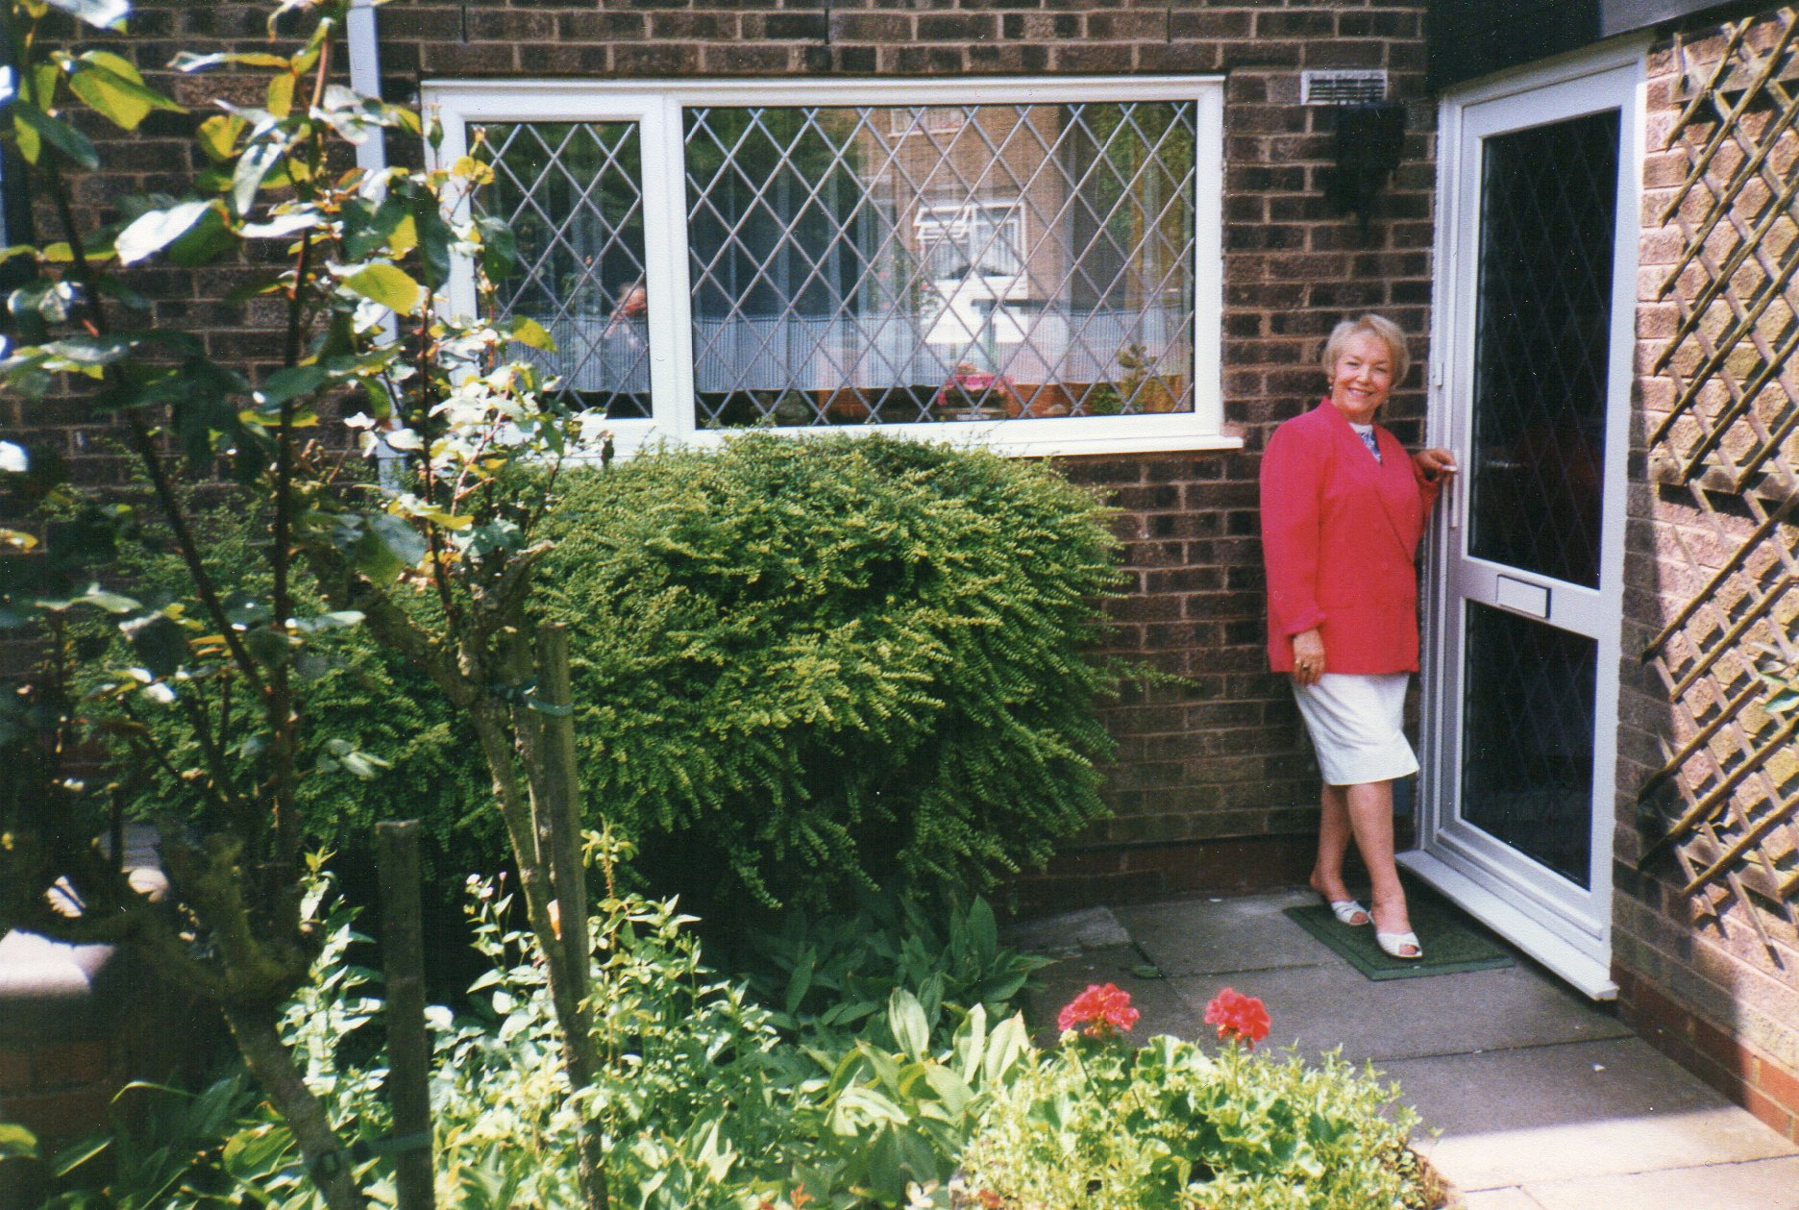

The house at Vardon Way, on the former site of King’s Norton Golf Course. The front, when it was quite new, (the roses and the red geraniums on the flat porch roof were something I had dreamt of during all those years in the prefab), and again later, with Mutti.

He and I had been good pals during this time, as Mum was still in Germany doing a second year; she was slightly disappointed on seeing the new house when she came home for holidays – I don’t know quite what she expected. Dad was aware of her German origins of course, and would never have stood in her way when she wanted to work abroad, and of course she was now no longer in such demand as a theatre principal as she got older, whereas he was very much sought after as a Musical Director. I was also much involved with the operatic scene, and we therefore had that in common and used to go round seeing various shows which were under consideration for Bournville. Other companies he worked with came and went, largely because the travelling distance was too far, but Bournville was basic, his ‘core’ company.
When Mum came back I knew I could not live with her, and was also conscious that I was now getting to the age when I had little more than the 25 years I needed to take out and pay a mortgage before I retired. I had thought I might go over to Germany again, but there was no longer the acute shortage of English teachers, so my way forward was to find property of my own and settle down here permanently.

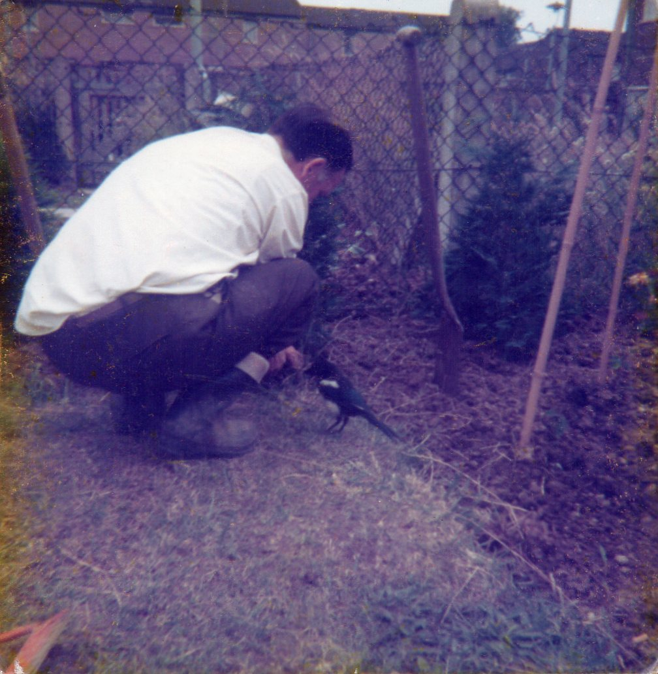
This magpie seemed to be very fond of Our Daddy in the
summer of 1978 and arrived every day for some weeks.

A Woman of Property
Eventually, in early 1976, I found that some new maisonettes were to be built on a site in King’s Norton, not far from the new house in Vardon Way. I made my way to an on-site caravan where the plans were being given out, and also beat a path to Great Barr in north Birmingham, where some similar units had already been built, knocking on a couple of doors and explaining myself, and asking if I might have a look. I liked what I saw, so went ahead and paid a deposit to secure one of the new ones, which I then watched being built. It was ready by the summer, and I then had the pleasure of doing what I had long wanted…furnishing my own place. It all took shape in the year 1976-7, and in that summer, Mum came back from Germany. As she needed all the wardrobe space, I shifted all my belongings out to Dornie Drive, as it had been named, and became a householder. I still remember the first night I slept there…it was on a freezing cold night in the winter, with a sharp wind blowing a thin dusting of snow around, in the morning there was brilliant sunshine, and everything felt strange and new…I had a standard double bed instead of my 2’6” one at Vardon Way, which was the one I had slept on ever since we arrived from Berlin. - I recall the thrill of getting my own phone no. and ringing Daddy, who immediately rang me back. I still spent a lot of time at Vardon Way, and it took about 15 minutes to walk between the two addresses; Daddy would always say, as I set off late at night, ‘Three rings’. On arrival I duly gave them, and he would give three rings back, which meant ‘Roger’. This was our free signalling system to let him know I had arrived all right, then he was able to go to bed in peace. The place was very cosy and comfortable, and having my own bathroom was quite wonderful! There was also a small square of garden, which I got help with from our keen gardener friend Dave Rennie (more of him later), who planted potatoes the first year to break up the soil, then laid it out with roses and small trees and shrubs. When it got established, it looked a treat, and I was delighted to bring my own roses into the house. Though only a small square, the garden was nevertheless quite hard work.
For the first time in my life I was now independent of council property… I had become, at 33, an owner-occupier, in a proper private brick-built house…well, flat…small, but mine!

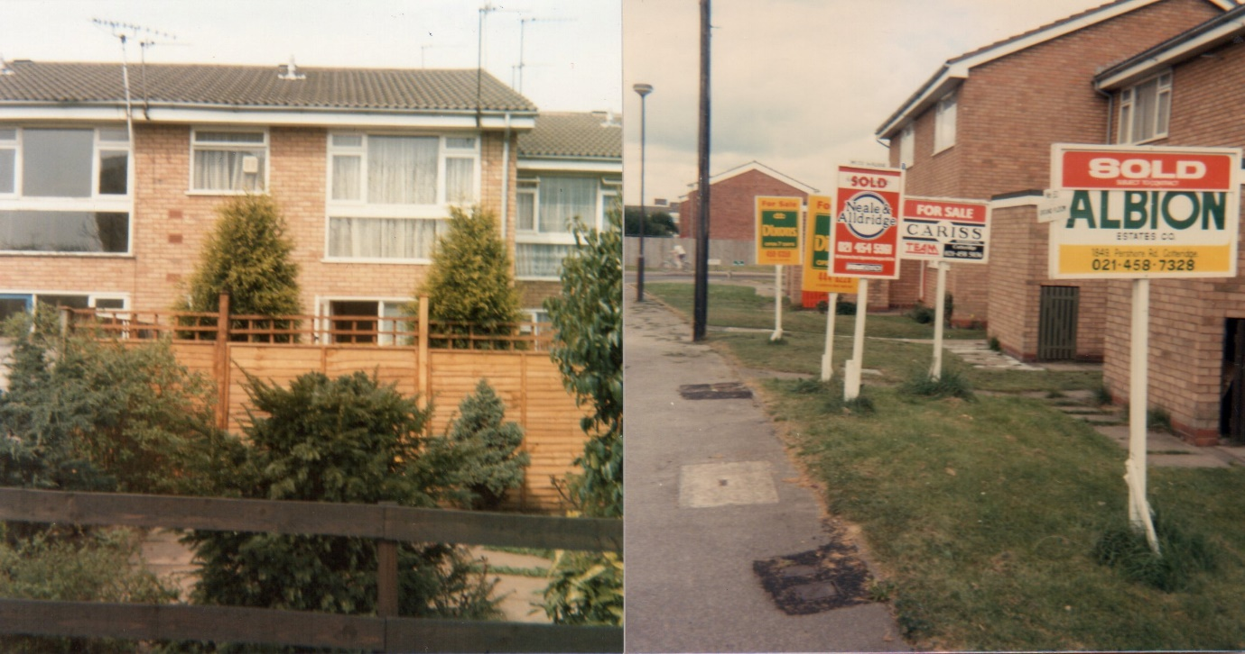
My flat at Dornie Drive, from the back, with garden, a couple of years after I moved in …..and the front, when I put it on the market in 1987. It was advertised in estate-agent-speak as “a deceptively spacious one-bed first floor maisonette suitable for the first-time buyer.” I had been there for 11 years, and it felt like a little palace to me…. but rapidly became too small. My bedroom window is at the top right.

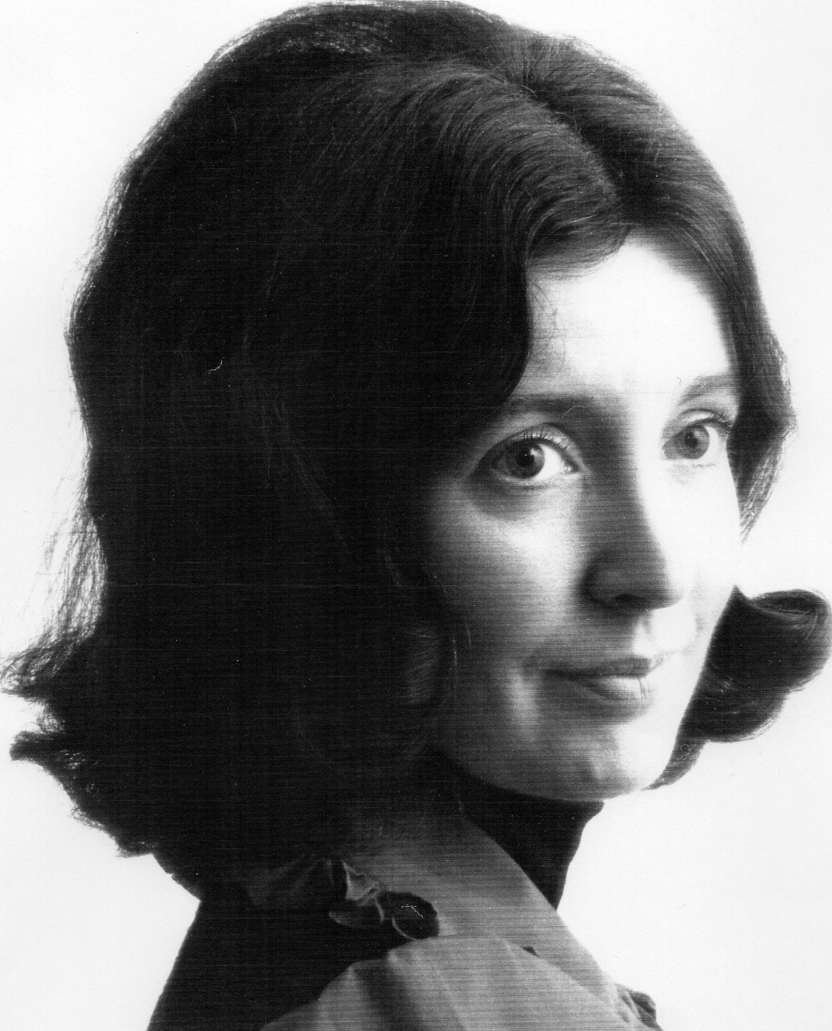
Taken on my 35th Birthday…. 1978

The Swanshurst Job
I was to be here for all of 24 years. I remember the day before I was due to start, I went with Daddy to a dress rehearsal of ‘The Count of Luxemburg’ which he was doing in Lichfield, to try and calm my nerves, which was not totally successful.
It was April 1974, and the whole educational system was on the point of going comprehensive – abandoning the tripartite system (grammar, technical and secondary modern) in favour of all-in schools. I found myself in the bilateral side (tech./sec. mod.) for the term prior to the Big Upheaval, but from the start only the top streams did German, which I was used to from King’s Norton. What a shock all this will be to all the old-school staff back at KN, I thought, and those who had been in the Grammar School at Swanshurst until then. We opened in September with Lower, Middle and Upper Schools, all with all 3 ability bands, but any of us could be sent to teach in any of the 3 buildings, so there was much leg-work involved. I was required occasionally to teach a little junior French, and that could be with any of the 3 streams, and I taught German from scratch to A-level, settling quite well. As before, I was most interested in exam work in the older classes, who were all volunteers.
It seemed that there was General Studies going on in the school, with a team of people teaching some aspect of their own subject to groups which changed around every half term to give exposure to as many different fields as possible. The level of enthusiasm among the staff was not high, as this subject was given to mop up odd free times on people’s timetables, and often staff were at a loss as to how to motivate their students. As I was fizzing with ideas from all the Social Studies I had done at KN, I volunteered to become one of the team and was soon given this opportunity. Many of the other staff thought I was mad… I set up my course on KN lines, making use of all the contacts I had made previously, finding most of them still remembered me from a few years before, with the difference that I myself was responsible for engaging speakers and arranging visits instead of having all this set up by the school Secretary. This was soon done with a few letters and phone calls, and I enjoyed it every bit as much as I had at KN. I was most flattered when some of the A-level Home Economics people were instructed to do my Public Health course, which was directly relevant to their syllabus.
After a while the Head of General Studies was promoted, and I was called in to the Headmistress and told that I was going to become Head of the subject…I did the job free for 3 years and then was given a promotion when one of my German students, whom I had taught from scratch, got into Lincoln College, Oxford. (She eventually emerged with a first-class Honours degree in German, and while we had one other girl who read Geography, my Sally Davies was and is the only one ever to get a first. She finally trained for the ministry and is now operating in at a church in Surrey). I suppose that was the pinnacle of my career, at least in school. As I was so involved with Sixth Form, I moved over to the Sixth Form Centre, the school buildings having meanwhile been reorganised from Lower, Middle and Upper Schools into Lower, Upper and Sixth Form.
There were both A and O-level General Studies exams, so I had to make arrangements for mock exams in these, but what I enjoyed most was the other work I did, for example in the 6th Form my newspaper survey where I would get a day’s batch of all the common dailies and Sunday papers; the students would choose one and look at various aspects of them (balance of news and ads., quality of language, layout and presentation, style of headlines, political bias, value for money and so on, with detailed questions to answer and marks /10 to give for all these (they loved doing that, being usually on the receiving end!) The marks would then be added so that we arrived at the group’s best paper.
It also dawned on me that in a year or two some of them might find themselves sitting on a jury in a Court of Law, and if nobody gave them any legal education, they would be quite at sea. If General Studies didn’t do it, who would…? I had already taken parties to the Law Courts and had various speakers in, so made arrangements for the students to visit the Courts (Magistrates’ Courts, the Assizes, and then the Crown Court), and then fixed for them to go on their own to listen in to whatever interesting cases they could find. ‘Justice must not only be done, it must be seen to be done’, so there is a public gallery in each courtroom for that purpose.

At Christmas of 1982 I met, at the home of a friend who worked at the BBC in Pebble Mill, one John S.W. Taylor, a BBC Director, who it seemed was at a loose end following a break-up. He invited me out, and I spent early 1983 in a most pleasant romantic haze, with an increasingly fast lifestyle to match. Friday nights were usually spent in the BBC bar, and in time I began spending more and more time in his flat not far away. I felt as if I now had 4 different homes: my own, my parents’, where I still went for dinner every day, John’s place and…school. Early that spring we went on an idyllic holiday to the Lake District, followed by outings here, there and everywhere, both locally and further afield. Some of them were working assignments of his, outside broadcasts where I went along with him. Unhappiness had become my default setting since Dieter 20 + years before, and in some ways I found it hard to be happy…I was not used to it…and it has to be said that I knew the dangers…but I had fallen in love again. At Easter we had another lovely trip up to the Moray coast in Scotland, to visit David Rennie, a family friend who had recently retired up there. He lived in a lovely, very Scottish rambling grey stone house with its own bell-tower called Dundarg on a clifftop with his own red sandstone headland and two private beaches on either side, not far from a wee village called New Aberdour. To get there you could either walk along the main road or pick your way over the rocky beach. It was spring, the gorse bushes were in flower and there were tiny daffodils everywhere. I was in paradise again… John and David got on very well, and I had these 2 handsome fellows all to myself! David grew his own vegetables and was in general fairly self-sufficient. He looked after us very well, and we went on some lovely local outings to places like Fraserburgh and Inverness. I had been to Scotland before, but really fell in love with it on this trip, which was to be the first of two. The second was about a year later with John’s work colleague St. John Howell, who was a reporter on ‘Midlands Today’. (Occasionally they used to flash the captions on the screen as a signal to me). That time I had 3 handsome fellas all to myself!

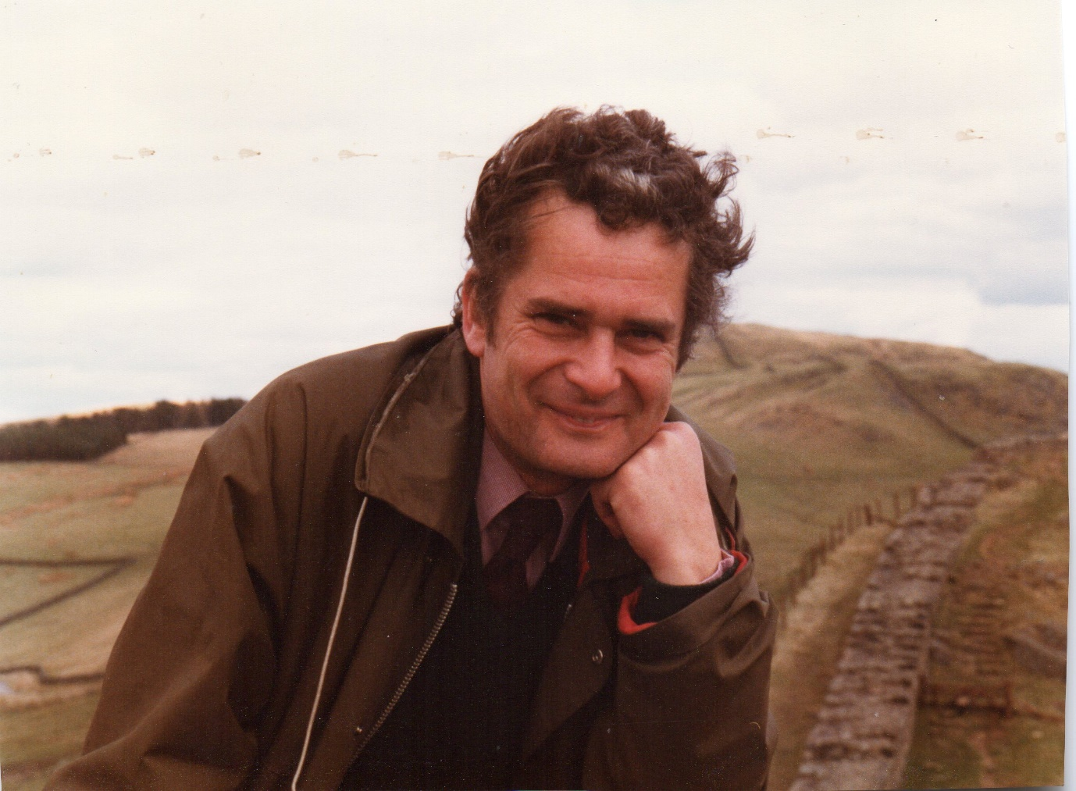
John at Hadrian’s Wall

We had our problems and differences, as John was ‘difficult’ with a temperament like a gala firework display…as well he might have, with a birthday on 5th November. I had to get up at 7.00 to get to school, but he was able to be sociable half the night and did not start until 12.00. I found I was continually tired and could not keep up with all the drinking, and was beginning to notice that John was making me insecure; I felt I fell just short of what he expected….all this went on for 2½ years.
In the summer of 1985 the two of us again planned to go up to David Rennie’s as before. One night in the BBC bar there was a lady who had just returned from France and was prospecting for a BBC job. She obviously spotted John and decided she wanted him (well, so did I, but I could never be so blatant and shameless), and he was clearly taken with her…. A day or two later my phone rang and he told me our trip was off…I was distraught, and would have been even more so had I known what was going to happen next. I felt as if I had lost an arm and a leg, having now become addicted to his company, and I sat up in the window of my flat in Dornie Drive with a bottle of fizz, and wept into the sunset. Shortly afterwards I went round to his place as requested to remove all the items of my property which he had stashed in his porch, with that same feeling of being unwanted, and knowing they were both inside.
I finally consoled myself as best I could by going to Bonn on my own, but was miserable, just as I had been in Freiburg 22 years before. Back home, Barbara, at whose party I had met John at Christmas 1982, was still working in the BBC Newsroom and told me the tale had been going round that he had taken his new lady in my place up to Dundarg, (to my friend!!) and that after some altercation David Rennie had threatened them with his shotgun (kept for shooting predatory animals). I was much relieved when I heard that, although this was true, the threat had only been verbal, though John denied that. Whatever had made David agree to host them under these circumstances….? Maybe they had invited themselves. - They had fled to the Isle of Skye, where…they were married.
I was back where I had been…and had plenty of time to mull over what had gone on. My self-image nosedived, and for months afterwards I did not sleep properly, being in a slough of sheer misery.

Meanwhile apart from comprehensive reorganisation, other changes were looming…O-level was to be replaced by the G.C.S.E., and this meant a lot of revised thinking and retraining on our part – and we were expected to do all this ‘in-service’, another way of saying ‘fit it into your work schedule without expecting any extra time set aside for it.’ I had always hated the amount of work I had to take home right from my King’s Norton days, and here it was the same, and getting worse…evenings and Sundays were always hijacked, and Saturdays taken over by washing, cleaning and housework generally, so that every day was crammed full, and now came the worry of the unknown with all the new criteria. I was already exhausted after that disastrous summer. That autumn term of 1985, to make matters even worse, I was given a class of awkward Year 8 girls who were all demanding instant and constant individual attention, which of course no teacher can give. Most classes got through the ‘teenage bit’ in year 9, but these girls were different, and soon detected a weakness in me which was born of misery and lack of sleep, and exploited it. I loathed their lessons, and had to keep them for 2 years. Friday mornings were not so bad but the last 2 lessons on Tuesday were a nightmare. But I told myself that this job was all I had, and if I were to cave in I would have nothing…so soldiered on until it became clear to me that I had to get help. One or two of the senior management team knew what was happening, and were very good to me, after all I had proved myself with Sally’s success at Oxford….but there were lots of others who did not understand and treated me with casual indifference or even spite, talking about me behind my back. I had a lot of support from Maureen Hillier, one of the Deputy Heads and a great mentor to me, who was a Music specialist and had come to help us at Bournville when we had no pianist. She knew my Dad, who of course was Musical Director and took the rehearsals for which she played, and we would all go over to the Club for a drink afterwards, so I got to know her better than most of the other staff in the school did, and she obviously put the other senior staff in the picture. I always gravitated to mature women as role models, and she was quite wonderful, seeing me through this crisis by inviting me out to theatre productions in Oldbury and elsewhere with herself and husband Danny to avoid my being on my own too much, and generally giving me the time and attention I had never had at home.
Eventually I booked myself on to a depression cure in my 2 weeks’ Easter holiday at a private clinic in Edgbaston, where I learnt how to counter the malaise I was suffering from, and found out what I had been doing wrong all my life. With hindsight, I ought to have done it in term time, but this would only have drawn unwelcome attention to my mental state. – Another thing I did to rehabilitate myself and boost my confidence was to take a Mensa exam…I had often wondered how I would get on with this, and after all, when we were at university we were supposed to be the top 4% of the population….these days I think 50 % of young people go, and there has been a great divide between the traditional ‘Russell Group’ universities and the rest, consisting largely of new universities which had been polytechnics and other colleges. I sometimes joked that even Swanshurst School would soon be calling itself ’the University of Billesley’, the part of Birmingham where it is situated. - At my first attempt I fell just short of the required marks, earning myself a letter saying I had scored highly enough for them to be interested in me and inviting me to take the test again, which I did. This time I was in….so much depends on what hour of the day the test is taken, whether one has slept well the night before and other factors, and the same person can therefore perform differently on different days. I began to realise that I had not given myself enough credit earlier on in my career…I had a jolly good brain in my head! When my mother saw all of this, she decided to try herself…and also got in, whereupon she sent for a lot of their merchandise (T-shirts, medallions, mugs etc.) advertising the fact to the world at large. For me, modesty forbade – the boost to my confidence was enough.
At school meanwhile, other changes were happening alongside the G.C.S.E. upheaval; we had always taken the A-level exam of the Northern Universities Joint Matriculation Board (N.U.J.M.B.), which required a large literature component, but saw that the Associated Examinations Board had a much higher pass rate, and there was a groundswell of opinion that other topics were more relevant to our students for modern life, for example background studies involving things like the German education system, guest workers, recent post-war history, Berlin and the like, so we switched boards. In the summer of 1986 I went on a course with the Goethe Institut in Berlin and learnt all about its history since the end of the war. The city was still divided then, and so the visit we had to the East with all its restrictions was quite exciting. I came home all clued up on Berlin and was able to take it as an AEB topic; we needed two, so I also did the German educational system, in which I had worked for 3 years in the early 70s. I enjoyed teaching for the AEB far more than I had for the JMB, and the results were certainly better.
Hot on the heels of these changes there soon came the National Curriculum, which again meant a load of work having to be fitted in around our general teaching of the timetable. I had to devise a new Scheme of Work for the German department, and found it took me an entire Sunday at home to complete one single chapter of our course book. This innovation was to dog the rest of my school career right until I finished at school in 1997.
One of the specifications of the National Curriculum was ‘equality of opportunity’, which meant that even those girls who had for example only arrived from Hong Kong a week before without any English and were thus in the bottom stream also had to learn French, and take turns to sit in the entrance hall of their building on reception duty like all the others, when I felt that they really ought to be doing English, English, English, not missing the lessons the rest of their class were doing. Teaching the bottom stream French was such a nightmare that a member of the Special Needs team was always drafted in to the lessons to help. I was given this class as my Head said: ‘You have always had the cherry on the cake’, since most of my teaching had been in the top band. There was one delicious year when I had no junior conscripts at all, either in French or German, but all exam and Sixth Form work. One Sixth Form boy from Hong Kong needed an English qualification badly in order to get a place at college to study physics and to avoid spending his life in his parents’ Chinese restaurant, so was sent to me to teach one-to-one. Eventually he passed, and I wish he had stayed in touch, as some of my Sixth Form A-level girls still do. I often wonder how he got on.
Slowly the time slipped by and I lost the difficult class in the summer of 1987. Hurrah!
There was one girl whom, with hindsight I felt I had not been very fair with and who was probably a victim of my unhappiness at this phase in my life. When I retired I wrote her a letter, but of course I could not find her as she had by then left school and has probably got a different surname now. The letter remains sealed up in my letter rack to this day. Maybe she will read this online and get in touch…I hope she will. She will know who she is.
Before I move on from Swanshurst, I must record that in November 1989, of course, the Berlin Wall and Iron Curtain fell, cause for great celebration nearly a year later, when the new German Constitution was established on 3rd October, 1990. We could not believe that, some 28 years after the building of this monstrosity in Berlin, and even longer after the country was divided, it was really true! We celebrated by cutting letters out of A4 paper and hanging the German flag out of my classroom window, albeit still in 2 parts, simply because my room was on 3rd floor, and it was too difficult to tie a single flag safely standing on the windowsill. - All the girls in my classes got a ‘Berliner’ (jam doughnut) that day to celebrate.
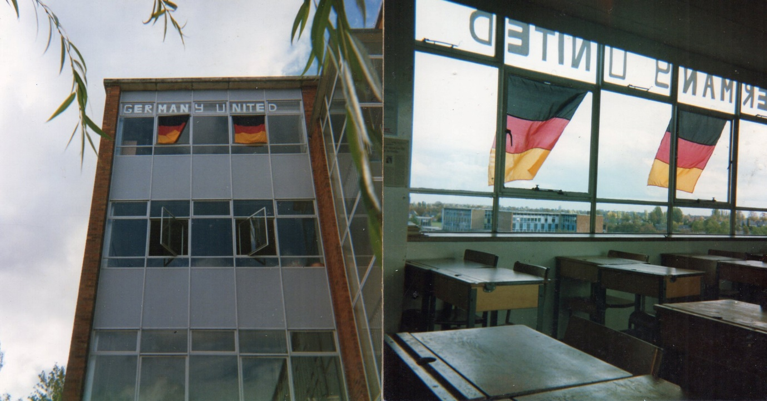

Another House Move
In 1987 I was becoming increasingly aware that my small flat at Dornie Drive was bulging at the seams, and that I needed more space. Although I had envisaged it 11 years before as a permanent home, I was also noticing that the young couples for whom the properties were built were moving on rapidly as they too found the space inadequate, and that the development had the air of a transit camp with fences unmended after storms, and badly maintained gardens, so I decided to look for somewhere larger; I also needed a bigger investment. I have a photo of 5 ‘For Sale‘ signs all lined up outside my property, (it’s on P.40), which told their own story. - I enjoyed househunting, and thought this venture, which is supposed to be one of the most stressful things one can do, would help me to achieve something I had wanted for some time, and in fact for me it was therapeutic. I still felt basically unhappy, (my ‘default setting’) and needed something to lose myself in. For a time I had a deposit on a cottage at a paper mill in Redditch, but I relinquished it because, living alone, I felt happier on the first floor as I had been at Dornie Drive. Finally I found a pleasant apartment here at Regency Drive, which had all the extras I had been looking for, including a garage, and situated in a large and beautiful garden with lots of trees which was and is looked after by the people on the ground floor. Surprisingly it had no maintenance charges (some of the places I saw cost a thousand or two per annum), and it was situated between my parents’ house and King’s Norton Green, so was ideally placed and more affordable than the cottage, which was finally taken over by the previous occupant of my new place – I thus did her househunting for her.
In the following picture, my flat is top left.

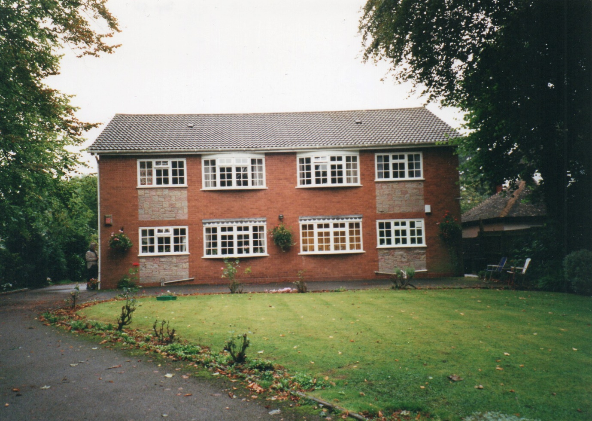
Why am I writing about it in the past tense? I am still here, have made some changes and it is now my ‘forever home’. - In order to secure the sale, I had to be out of Dornie Drive a couple of weeks before I could move into my new place, so my furniture had to go into storage for the duration, and all my smaller effects, of which there were many, cluttered up Daddy’s house until I cleared them all out on 25th August, 1987, the day I moved in. I think around that time my Mum was on one of her numerous trips to Germany. Suddenly I felt as if I were living in a park, with no gangs of rowdy youths going noisily home late on Friday and Saturday nights past my front door….the Regency Drive building stands well back from the road in what I often feel is the nicest front garden in King’s Norton, and the bedrooms are at the back. My own room is slightly smaller than the one I moved out of, so I doubled the space with mirror doors covering the whole of one wall, with all storage space behind, making it feel very spacious, even if it is only an optical illusion! It was wonderful to have central heating after the all-electric Dornie Drive, and the garage means I no longer have to de-ice my car in the winter…I am truly lucky. Gradually I replaced all the windows with double glazing, and had a new front door.
However, it was not long before I found that I had more things to store than I had room for, so I began by having the loft largely boarded and the aperture enlarged and fitted with a pull-down ladder, so that I could get rid of seasonal things like Christmas decorations and suitcases and so on when they were not required. This was fine for the time being, but more was to come, of which I shall write later.

The Wind of Change….
I had done my last show with Bournville in 1986, but saw that things were moving inexorably towards American musicals, which I did not want to do. At that time of course I was still in the aftermath of John S.W.Taylor with my problems at school, retraining for GCSE and struggling with that dreadful class, so pulled out of the Company as a performing member, though I still kept in touch on a regular basis. Meanwhile Daddy was now nearing 70 and getting a bit deaf, though he would never admit it and rejected any suggestion of hearing aids of any kind. He had already given up his companies further afield but always wanted to keep on with Bournville, where he had now been for some 36 years, even though Mum always said ‘you should go before they push you’. Every year at the AGM he was voted back in for the next show and had come to see this as virtually automatic, but his growing handicap had not gone unnoticed by the Company at large, and in 1988, just after he had conducted ‘The Pajama Game’ for them, he was voted out. Unthinkable. During the AGM itself he used to sit in the Bournville Club having a drink until he was sent for to rehearse for the rest of the evening, so I volunteered to go over and tell him gently what had happened…one of the worst things I have ever had to do, as I knew his world would collapse. He took it well while still there, and I remember the then Chairman of the Company coming over, shaking hands with him and thanking him for his 38 years of service….particularly sad was the tubular container someone had made Daddy for his conducting batons, which he had brought with him for when he was called over…
I drove him home and knew exactly how he felt; I watched him going down the steps to the house, baton tube in hand, and felt so very sorry for him. I think we sat up for a while that night before I went to my own place, and had another drink to drown our sorrows. I know it was one of the worst nights of his life, and it was also one of the worst nights of mine.
After that things began to go downhill for him…he was 70-odd and by 75 his deafness had turned to confusion. Since my parents’ retirement in about 1980 they had been on some pleasant trips to Germany, but it now became clear that these would no longer be possible. Neither was he able to continue doing little errands for me while I was at school, such as getting me stamps from the Post Office, or being in at my place when tradesmen needed to call and I was at school. He still played the piano for the children in the Primary School and the Sunday School, now his only musical activities. On Sundays he would walk down to the Green, passing the end of my drive, and I knew he would come at exactly 10.43 a.m., so would stop my school work and wait in the window to wave to him as he went by. Sometimes Teddy would join me…. One day I got home to Vardon Way and found the piano had gone…as he never played it now, they had spoken of getting rid of it before, but I had always resisted. Now I realised I would never hear him play again…
In the run-up to Christmas in 1995 we had a week’s Ofsted inspection in school, which meant I had to perfect all my lesson plans the night before, and I was still going to Vardon Way every evening, meaning that Dad wanted and needed my attention. By then he was past understanding that I had to do my school work and was under extreme stress, and it broke my heart to keep having to tell him so. Things were coming to a head…. That Christmas I did not send out any cards – I could either do Ofsted, or Christmas, but not both…..it was quite some time before I could assure people that I was still breathing.
Mum looked after Daddy at home until it became too much for her, and eventually he moved to a series of care homes, winding up at Moseley Hall Hospital in the Gwen Cannon Unit. It felt very strange not having him at home, but it went on for some 7 years, so we eventually got used to it, and spent those years visiting him often and taking him treats of various kinds. Once we put a keyboard in front of him, but he pushed it away.

Life Goes On…
Meanwhile I was soldiering on at school, and decided that I would like to take on some work as a freelance translator alongside. I always loved this work, which I could do well, and with the EEC it seemed there would be plenty of it, so in 1990 I took the Institute of Linguists’ Diploma in Translation. This was ‘professional development’, so I got the day off and sat in splendid isolation in a classroom at the top of the Sixth Form Centre with all my dictionaries (which are allowed for this exam) and did a 3-hour general paper in the morning, had half an hour off for lunch, then another 2 two-hour papers in the afternoon, by which time I had writer’s cramp writ large. One of my A-level girls got the job of bringing me a cup of coffee, and was amused to see me with steam coming out of my ears doing the exam, when it was usually the other way round! - I eventually passed, after a long wait, with a merit. This, like my Mensa membership, further boosted my confidence.
In 1992 I had the summer term off for a hysterectomy, my first break from work since the age of 22, apart from a few weeks’ unemployment after Oberhausen. I recall having my dictionaries with me and boning up on the German for all the hospital jargon going on around me, and being grateful that cancer had not figured anywhere in my diagnosis. During my recovery I remember going on a few car trips with Mum, to Erddig in Wales and other National Trust places. The freedom made me look forward to being retired….
In the summer of 1995, a very hot, dry year when all the grass had turned yellow, I was sent on a French cultural course in Sèvres, Paris, as I was having to teach ever more French, rather a ‘poor relation’ with me, as I had always been to Germany, but hardly ever to France. I would have been quite happy to go in my school holiday, but the course happened to be in the last 2 weeks of term, so off I went, much to the envy of my colleagues back in School. I did the Dover – Calais crossing for the first time, and went on a hovercraft – ditto, and the journey to Paris was hot…hot…I almost turned round and went back home, thinking how am I going to do any work in this heat? I drove round the Périphérique to find the venue, for which I still feel I deserved a medal – at least!
The course was in a teacher training college, and my room was under the roof….unbearably hot, with cockroaches for companions. I could not even bear to put a sheet over me at night. But the course was good, led by a very cultured gentleman and his wife, both recently retired, who knew all there was to know about their home city. When they saw I had done French as a subsidiary up to my finals, they put me in the top group, where unfortunately I floundered somewhat…. I recall going to Versailles and laboriously composing a postcard to my Head of Department at School, which probably took me longer than any other I’ve ever written…I must not make any mistakes, I thought to myself...and apparently I didn’t!
By 1997 the German in the School was being cut back to accommodate more Spanish as a second foreign language, and also Urdu, which some of our girls spoke at home, so they were able to take GCSE 2 years early, reducing pressure on them later. The School had consisted of about 30%+ Asians when I was new in 1974, but it was the nearest girls’ school to Sparkhill and Sparkbrook, the areas where most Asians lived, and fathers liked their daughters to go to a girls’ school….and by now it was nearer 70%. There were a few boys in the Sixth Form at Swanshurst, but not enough! Our A-level candidates were therefore increasingly choosing to go to a mixed-sex environment for these exams, quite a few Sixth Form Colleges having opened in the area. I would have loved to teach in one of them, but jobs were few and far between. Now all those precious candidates I had spent 4 years with, trying to get an A-level group from them, were deserting me!
Additionally, we were forever being urged to learn the computer, which was being introduced to classroom methodology, and I had no inkling of how they worked, having always been something of a technophobe. Computer lessons that year were on a Monday afternoon after I had had 2 double French classes with juniors (horrors!) and was on my knees. I knew I would not make any progress until I had a computer of my own and time to learn it properly. So, given the option to retire, I decided to jump ship, conscious that I knew exactly what I wanted to do as an alternative. I was 54 and certainly had no intention of sitting at home being an old lady (and still don’t have that today!) I envisaged a future doing something which suited me better, and which gave me the freedom to do what I liked when I liked, and to do lots more theatre……and so it turned out. My only regret was that in that year there was no pension enhancement, where others had had 5 years’ or even 10 years’ worth……but I still managed to pay my mortgage off 4 years early (yippee!) and after all, money is less important than other things.

My ‘Alter Ego’
During my working life I had managed to get holiday jobs in Germany for my A-level girls, usually between the Lower and Upper Sixth, so that they would have the experience under their belts before the A-level exam. Now I felt I would love to do something like that myself, as I had done as a student, so wrote to ask at a Heart Clinic in Seebruck am Chiemsee, where I had sent several girls.
Regretfully I had to leave Daddy for the 6 weeks, but he was being well looked after in Moseley Hall, and I trusted that he would still be there on my return. I knew that as before he would not wish me to put my life ‘on hold’ on his account, and after all, we had no idea how long the present circumstances would last. - I will always recall my feeling of Total Freedom as I set off and drove through London and Dover, listening to my favourite cassettes. I had a night or two in Bonn to see the family and break the journey, then it was off to Seebruck…a long trip, which, with hindsight, I ought to have split over 2 days. Half way I found a swimming pool and managed to get my exercise fix... very welcome after sitting for so long. I finished the journey in total darkness and thought I should never arrive – the road was interminable, and when I arrived, I had difficulty getting anyone to hear the doorbell. They gave me a wee attic bedroom as I expected, and I was glad to see it had its own bathroom. Next day I met the managers and other staff, who were a bit bemused to have a teacher under their roof doing domestic work…but it suited me fine. I was in a lovely new place, doing different work, with different people and speaking a different language, with not a school child nor any books in sight….a Total Tonic - I became Someone Else! Swanshurst seemed very far away.
We had to work from 7 a.m. to about 1 p.m. and for a couple of hours in the late afternoon, so there was time to go on outings or shopping in between…if we were not too tired. I soon became aware of the heat, and the many buzzing insects flying round, and that I had to protect myself from bites at all times outside. Some of the patients left their windows open at night with the lights on, and wondered why they got all sorts of bugs in their rooms… Next day there were always lots which disappeared into our vacuum cleaners. The patients were lovely, and we had fun getting to know them all, and there were super outings locally, like Herrenchiemsee, the Fraueninsel and Bad Reichenhall, where the Reber chocolates are made, and everything is red, a bit like Bournville’s purple back home. I also got to a few concerts in local castles (very atmospheric) and to Bad Tölz, where I recall going to a Glenn Miller concert.
The first year I was there (I worked there 2 summers running) I also got a job for Samena, one of my A-level girls, who was quite ambitious and whose Asian parents were willing to let her come as they knew I was there to keep an eye on her. Together we went on some lovely local trips in my car, and yes, we did remember to speak German, though we did not work closely together. Our manageress was called Karin Englmann, and I always got on well with her.
When a patient departed for home, the room had to be thoroughly cleaned, far more so than for the same patient from day to day - all drawers and wardrobes inside as well as all the usual. (I dread to think what difference the pandemic would have made….) This was ‘Abreise’, a most dreaded word, as everyone knew it took twice as long to do the room as normal. One Sunday, one of my colleagues could not come in and asked if I could do the room for her…that was my Day Off gone west….but I had to agree, and tried to do so with a good grace. Afterwards I took photos, and heaved a sigh of relief when the room passed muster after Karin’s eagle-eyed inspection. I think this was partly why I was accepted back the next year. - On my way home that year came the shock news of Diana’s death in Paris.
In 1998 I was visited in by a gentleman I had met at the house of a friend near Munich…my ‘twin’ Anne Fishburn had invited me over to celebrate our 55th birthday in January. She was born in GB on the day I was born in Berlin, and at uni. we had our 20th celebration together in one of the Halls of Residence. I kept in touch with this person, as he came from Evesham not too far from Birmingham, and that year he came out to Seebruck to ‘have a look at me’. We motored out to a lovely lake in the mountains, the Hintersee across the Austrian border, and there I received a marriage proposal… which I politely declined, with the feeling that I should be selling myself down the river….
The day I left I managed somehow or other to compose a poem in German satirising the daily work we had to do…(I had found out at Swanshurst that I was able to toss off rhyming couplets at the Christmas parties we had, where we drew a name out of a hat, bought a fun gift for the person and put in an anonymous message). But in German….? - My effort in Seebruck went down very well at my leaving party, and I felt quite proud of myself. Here’s what I wrote:
Das Los eines Zimmermädchens (oder: Meine Erfahrungen in der Jander-Klinik)
Ein Zimmermädchen hat’s schon schwer
Und muß sich stets bemühen, sehr
Daß der Patient sich nicht beschwert
Und fröhlich wieder heimwärts fährt.
Morgens erstmal Schlüssel holen,
Wie von der Chefin mir befohlen,
Dann los! Frisch auf und in den Kampf!
Bald pufft mir aus den Ohren Dampf.
Die Arbeit, die ist nie zu Ende,
Da braucht man wirklich zwanzig Hände,
Polieren, wischen, putzen, saugen,
Obwohl die Staubsauger mal nichts taugen
(Eins möcht’ ich gerne wissen, sehr –
Wann macht man sie denn überhaupt leer?)
Boden im Bad mit Eimer und Lappen,
Und dann, wenn man Glück hat, Frühstückshappen.
Hinterher weiter in einem fort,
Mein Gott, das ist ja glatter Mord!
A-B-R-E-I-S-E, da tut mir ja das Wort schon weh.
Ich brauche Behandlung und ‘Visit-matenten’
Genau so sehr wie die kränksten Patienten!
Zuletzt den Wagen wieder hin
Mit weder Müll noch Wäsche drin.
Da geht man nochmal zu der Tonne,
Erfährt mit lauter Freud und Wonne,
Die ist von gestern immer noch voll,
Sodaß man den Müll draufhäufen soll…
Na, fertig! Die Erleichterung ist groß,
Doch bald geht der Trott von vorne los,
Denn kaum ist man am Abend weg,
Da macht die Kundschaft für morgen schon Dreck! Seebruck, im August 1998.

The 3rd year (1999) I applied to go again, but Karin said ‘You’ve already worked for two years running, why don’t you just come and stay?’ so I did. She had a lovely house just down the road in Seebruck, and I had a very pleasant time there, without having to worry about any ‘Abreisen’! I am still in touch by phone, though I have not seen her since that year, but hope still to do so before too long. Meanwhile I have some beautiful photos of the Clinic, which no longer exists, and of the surrounding area, to remind me of a delightful period in my life.
On my return from my 3rd visit, Daddy was still going strong; when I first visited him after my 3rd time in Seebruck, he called me by my childhood nickname…something he had never done since the beginning of his illness. I thanked God with all my heart.
At that time the Millennium was looming, with frightening predictions about the Bug…which came to nothing. When I was younger I used to wonder if I would live long enough to see it…..and here I was, tough as old boots and feeling fighting fit. Not so however my mentor at Swanshurst, Maureen Hillier, who succumbed in 1999 to ovarian cancer at 63; and then Joyce Allis, a great inspiration to me when I was at King’s Norton, both as a pupil and on the staff, collapsed with an aneurism aged 67 in 2000. They both deserved much longer.

Career Reborn
In 1997 I left school with a firm sense of purpose, intending to set myself up as a translator and to learn the computer. Somehow I managed to get an email address and to do a word-processing course, and having my own machine, I learnt by trial and error, with plenty of the latter. My Diploma in Translation meant that I was now a Member of the Chartered Institute of Linguists and could work as a professional translator, and of course as a private tutor, so I set about looking for such work in whatever way I could. I was entitled, doing this, to National Insurance credits, for which I had to sign fortnightly at the Job Centre, and one day met a lady there who asked me if I had ever thought of setting up my own business. ‘I’m just in the process of trying,’ I replied, whereupon she invited me for an interview at Business Link in Aston. It seemed that a series of 10 monthly interviews and jumping through several hoops should qualify me for an Enterprise Award, so I completed this process, setting up a Business Plan, opening a business bank account, having brochures and cards printed (see below), doing market research and putting myself in the Yellow Pages. I had to give the business a name, so settled on ‘Hofmann German Language Services’, and lo and behold, I finally got about £700 towards my start-up costs of some £2K…a feather in my cap.



Suddenly the telephone never stopped ringing, and there began a very pleasant phase in my life where I could take whatever work I wanted and refuse the rest. I was also able to decide my own hours, avoiding the rush hour traffic. I used a corner of my lounge as my administrative nerve centre and travelled round to my students, which gave me a lot of variety…I worked everywhere from an apartment in a converted stately home right down to the back room of a Chinese restaurant, where everything reeked of Chinese food, including my student’s exercise books….and went into some lovely homes. I also taught 3 girls of the Royal Ballet at the Birmingham Hippodrome, one Italian, one French and one Brazilian. To get us going I asked them each to write me an account of how they came to be there, and all 3 wrote that someone, as they were growing up, had told them: forget it, you’ll never be a ballerina…perhaps we all need someone like that to make us grit our teeth and do it regardless.
Part of my work was translation, but though I enjoyed the work, I was looking at the same 4 walls every time, and everyone seemed to want the work done soonest, with much of it having to be specially formatted, so there was much pressure. I decided I would prefer tuition, and taught everyone from little boys who could not punctuate, right through secondary age to A-level, and business people, who were usually very interesting to talk to. Sometimes I had groups of businessmen, though this was less satisfactory as they often had to miss classes, then would fall behind the rest and never really catch up, so I preferred to teach one-to-one. I did a little French but mainly German and also discovered that there is much need for English as a Foreign Language in a place like Birmingham. I live not far from the former Rover works, and taught both English to Germans who were working there, and German to British workers. Then BMW bought up the factory, and were also desperate for an EFL teacher at their new plant in Hams Hall on the eastern side of the city. This was 27 miles one way and further than I wanted to travel, but the agency I was registered with were prepared to pay me petrol, so off I went to Hams Hall. I discovered I had to wear wellingtons, a high-vis jacket and a hard hat, as the building was not yet complete, and I had to pick my way over rubble to reach my temporary classroom. I began with one student and was soon going over 3 days weekly to teach a total of some 10 - 12 . I was spellbound…civilised people, whose English was already very good, teaching whatever I wanted to do with them with nobody breathing down my neck, no cheek, no litter, no chewing gum, no open evenings or parents’ evenings, no in-service training, no exams, marking nor inspections, in short, nothing which makes life so stressful in school. There was a super canteen with a wide variety of lunches. I already had a pension which was about half of my previous salary, and found I could very easily make up the other half with all the work I was doing. Sometimes I found I was paid by so many clients in cash that I did not need to go to the bank for months on end. I was also lucky enough to be able to get a % off a new car….BMWs were rather grander than I needed, but I had a lovely new Rover 25 at that time.
One downside of freelance work is that one has to do an annual Tax Return…at the outset I found this very difficult as I had to claim for business use of my car and a % of my insurance, water, gas and electricity, postage, stationery and so on. I had ‘fun’ working all this out and almost went to an accountant in despair, but persevered, as I would have had to produce all the necessary documents anyway, and it would have been just another bill. Over the years it got easier, and became no problem at all, and it is certainly worth that bit of effort for the free lifestyle. I kept up this work until my early 70s, and concluded that I had a much better business head on me than I had ever given myself credit for. At school I felt I was being kept in my place and that there was not much else I could do…a mindset common to many teachers…but there is a whole world out there, and all you need is the courage to fly free, a bit of determination and something you feel passionate about…infinitely preferable to being beholden to a boss. I made sure my school knew what I was doing: I got me an Enterprise Award…so there!

Tony and the Reunions
On 1st August 2000 a letter dropped through my door from a Tony Ambrosen in Newport, South Wales. I remembered him as one of my Leeds Uni. year group, though I did not have much to do with him there, as he did not come to the same clubs and societies as I did, but of course we all had lectures together. He was trying to trace a Sabine Hofmann, who could only be me….and told me he still had my graduation ticket from July 1964…..a mystery to me…what on earth would he be doing with that? I wrote to him, updating him with what I had done with my life, and we had an initial day out, meeting each other in Ledbury, Herefords., which is about half way between us.
It turned out that on the day we graduated, I had had no pockets in my clothes to put my numbered seat ticket into, and as handbags were discouraged on several counts and he was the nearest gentleman to me with a suit on, I had asked him if he could put it in one of his pockets. It stayed there, and in his wallet, for 36 years...I only had a very dim recollection of all this when he jogged my memory, otherwise I would have totally forgotten it. The yellowed ticket, worn at the corners, which Tony sent me once he knew I was the right person, is now in a small frame in my hall. A verse he wrote to me at the same time is concealed in the back of it. It further transpired that he had recently retired and that his ailing mother had died at about the same time, and so now, after having been frantically busy working double shifts and acting as carer to her, his life was ...a vacuum. We were surprised that we were both still single, and of course this opened up lots of possibilities. On his first trip up to Birmingham to see me, we went on an outing, and on the way back had a break in the King’s Court Hotel on the Alcester Road back into Birmingham, where we counted up how many people we were still in contact with from Leeds…it was about a mere 5. We wondered if we could trace enough of them to mount a Reunion, and as Tony was good on the computer, he said he would do his best. Fast forward to the next summer, and he had found some 30 altogether, including some staff, enough to organise an event, which we held at the Crowne Plaza in Leeds. We were delighted to have one or two even fly the Atlantic to be there, and the first evening, in the hotel bar, was quite surreal – we had thought we would never see any of our former fellow-students again, and here they all were, and we just carried on from where we had left off 37 years before. The Gala Dinner was of course a very special occasion, but as well as that, we made a weekend of it with extra meetings, outings and meals on the other days too. That was Reunion 1, and since then we have had another 7, with No. 9 in Bradford pending in 2022 at the end of the current pandemic, after 2 postponements. Suggestions for the next venue always come from the group at the Dinner, and our record looks like this:
- 2001 Leeds
- 2005 Leeds (Picture below)
- 2007 Dortmund (Leeds’ partner city, where John and Odile Brogden lived; the late John became our ‘official’ photographer, and Odile is now, despite her widowhood, a regular member of the group).
- 2009 Leeds
- 2011 Munich
- 2013 Stratford-on-Avon
- 2016 Weetwood Hall, Leeds
- 2018 Berlin
‘Partners in Crime’ (1)
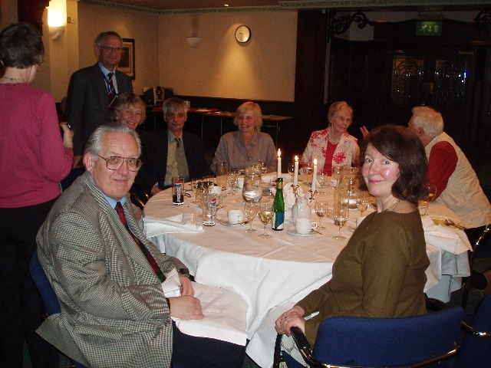
In 2018 for Reunion 8 we drove to Berlin, a protracted journey with a night on the ferry from Harwich – Hoek and two further overnight stays en route, and on arrival I was in such pain from my deteriorating left hip that our hotel got me a doctor’s appointment for a steroid injection, which enabled me to do the necessary sightseeing while we were there. After our reunion, Ellie came to Berlin for a partly overlapping stay, and before her arrival we took one of the flower arrangements from the Reunion to await her in her hotel room. The three of us had a couple of memorable trips out together before Tony and I departed again by car. Unfortunately, on arrival back home, I was back to sq. 1 with my hip, which I had replaced a few weeks later by Ronan Treacy, to me the very best hip surgeon in the world, who had resurfaced my other hip way back in 2004 and for whom I am trying, so far without success, to win a national honour. So far I have not managed it, but I shall not give up. He deserves a Knighthood – at least!

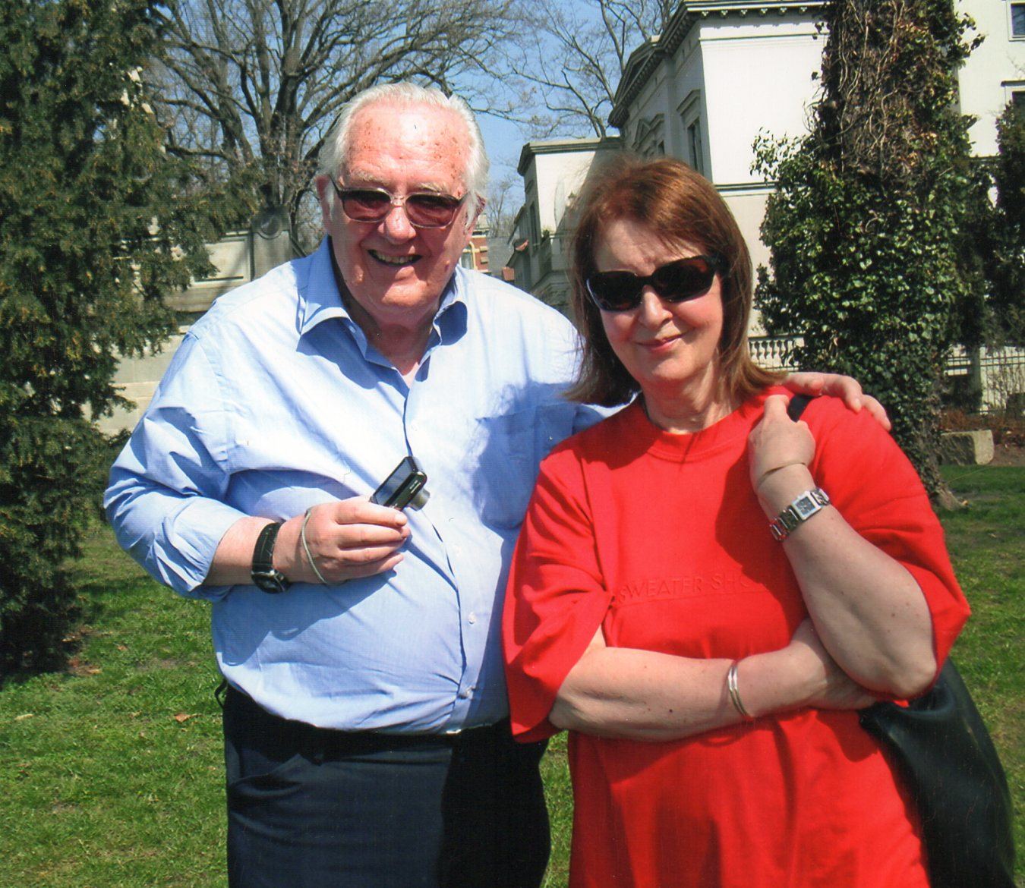
‘Partners in Crime’ (2) …just after Reunion 8, 2018, at Wannsee, Berlin, taken by Ellie

We are told by the Alumni Office that ours are the best-attended and longest-running reunions in the University…a feather in our caps! We usually get between 20 and 30 participants, some flying in from Germany and Jersey as well as from USA and Canada, though it has to be said that numbers are usually greater in UK than in overseas venues. Lots of photos are taken and emails exchanged subsequently, and we always write a report for the University website. Keeping in touch with the group by email has been particularly therapeutic during our recent long months of lockdown. This venture is a lot of work, but very well worth it.
In addition to these reunions, ever since we have been back in touch, Tony and I have had Christmases, birthdays and holidays together, having visited destinations in Britain and elsewhere in Europe far too numerous to mention, both on long holidays and on days out. For Christmases we have usually been on a hotel break and for birthday lunches the huge Celtic Manor Golfing Hotel is not far from Tony’s. His vacuum disappeared long ago! We are in constant touch by email and phone.
Since reunions had meanwhile become a way of life, I also decided to organise one for ex-members of Bournville Light Opera, as someone had said “We only ever see each other at funerals”. Being just for some 20 people for a lunch, this was a relative doddle, and so far we have held 2; I am sure we shall do more. I also organise a monthly lunch for some 15 retired Swanshurst staff, and still go to an annual reunion of ex-King’s Norton colleagues.

God Rest Their Souls (1)
In February of 2002, Our Daddy took a turn for the worse…we knew this had to happen at some stage, and had been used to not having him at home for the 8 or so years that he had been in homes and hospitals. We visited him on a very regular basis, taking him lots of treats and generally making life as comfortable as possible for him; now he was 83 and sinking fast. It was still a shock when, having got home from seeing him at Moseley Hall Hospital late on the night of 20th February, a phone call came saying that he had breathed his last not long after I left. I had dreaded this for years, but we finally had to accept it. We had the funeral at St. Nicolas’, King’s Norton, followed by cremation at Redditch, where we found the atmosphere less hectic than that at Lodge Hill, with its conveyor-belt procedure and one party waiting for the previous one to move out before they could move in. I drove up to Leeds the previous day to fetch his elder sister Marie, who was 10 when he was born and now was coming to his funeral……I know I would have regretted it had I not made the effort. She stayed at Vardon Way for 2 or 3 days, then Mum took her back to Yorks. - At Redditch we had the whole place to ourselves. It was a very musical occasion as befitted Our Daddy, who had never talked much about what he wanted for eternity; he only once said ‘They’ve got a place for me at King’s Norton’…so that was what happened. For his coffin we agreed he should have white carnations, just as he used to wear in his buttonhole to conduct his orchestras.
On the evening of his cremation, I had a dress rehearsal for ‘Salad Days’ with Crossed Keys Operatic Society at the Old Rep, and thought that this was an appropriate thing to do, as Daddy had conducted this show for other companies, so knew it well. His cremation stone states, under his name, ‘He Loved His Music’, and he did. Among the things I have which remind me of him are the silver salver and 2 goblets which were presented to him at Bournville when he had completed 25 years with the Light Opera, on the Saturday night after ‘Lilac Time’ in 1976, and the diamond ring given back to him by a previous fiancée after the war, which Mum wore for years until they decided to give it to me when I was 23. And then there is Teddy…
Daddy got me Teddy when I was home from Germany either in the summer of 1971 or 72. He is a big orange and white bear and I absolutely fell in love with him, taking him with me whenever I went on holiday as I could not (and still cannot) bear to be parted from him. My constant companion, one might say, and most definitely my desert-island luxury item… Dad and I used to put him on each other’s pillow when the other wasn’t looking…’he must have snook’, we used to say. On my journeys to and from Germany he was strapped into the passenger seat and the border officials used to ask ‘You have a passport for the bear?’ I suppose I was lucky he was not cut open to see if he contained any prohibited goods, but then he was far too innocent for that. He does lovely cuddles and therefore gets quite grubby, so he has a bath about once every 10 years. This he does not enjoy...after being washed in top-quality Teddy-shampoo and rinsed several times, he has to be hung up in a plastic bag with a hole cut in the bottom for the water to drain out, then to lie on a towel in the bath until he is completely dry, which takes about 3 weeks. These days he still sits by the side of my pillow at night with Boxi, a toy monkey, who is his best pal. I suppose they replace the pets many people have, but my premises are not suitable for these. My animals don’t make a noise, a mess or any demands, and remind me of Daddy, so they suit me quite well and I gladly give them house room…happiness is Teddy-shaped!
“You don’t stop playing because you’re getting old, you get old because you stop playing.”
What am I going to do with them? I’d rather take them into my coffin with me than leave them with someone who does not love them as I do.
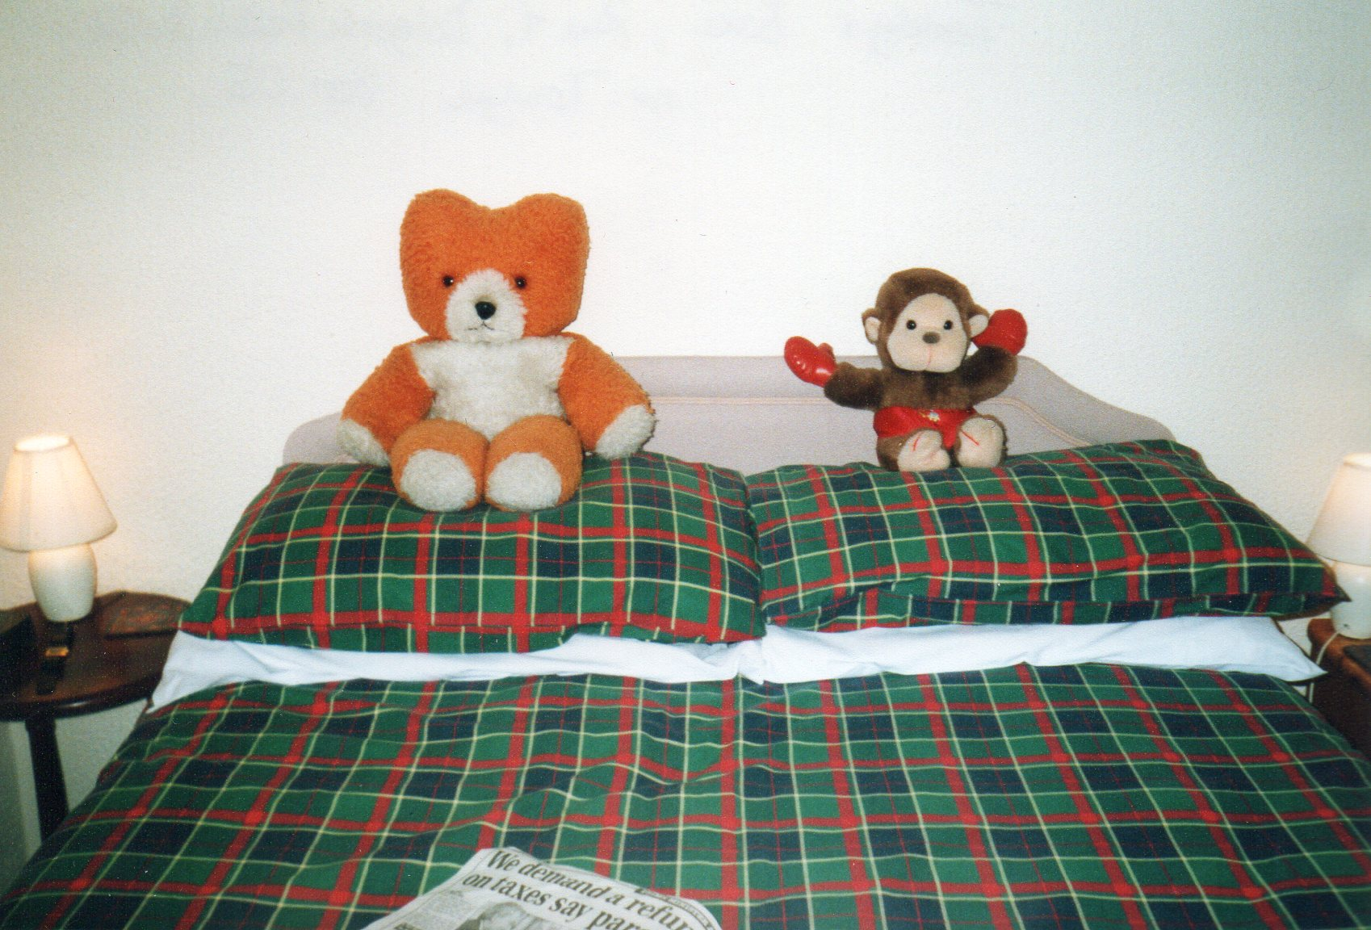
Two of my best pals on holiday at the Dolgoch Falls Hotel, Mid-Wales, in 2005

Dad was excessively strict with us as children, but later he and I spent a lot of time together and became really good pals. He once said: “You’ve been a good girl to me.” In all my ups and downs he was a constant, and was the person I loved most. Home was where he was. It was through him that I got to love music, and he taught me, at hundreds of rehearsals, much of the music I sang on stage. In my hall I have a life-sized photo of him, my favourite one. I feel his influence far more around me every day at home than ever I do in the graveyard, and recall all the things he used to say in different situations. Often, when something out of the ordinary happened, for years afterwards I still thought ‘I must tell Daddy’…, only to remember that he wasn’t there any more – where he was there is a yawning gap. I still think I could not have been fonder of my own father than I was of him. I shall love him for ever……and it all began with a toffee apple and a drive in his jeep…… My regrets are that he never understood that I had set up my own business, and that he never knew I took up the violin…he would have been delighted.

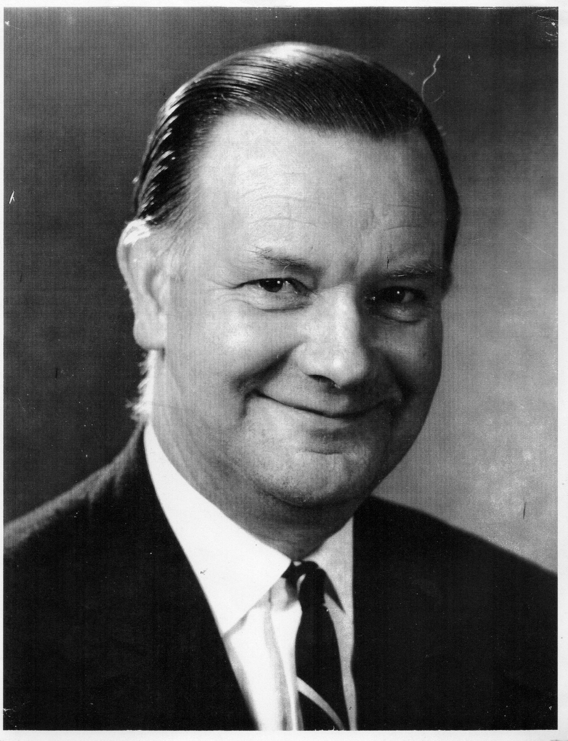
Daddy….my favourite picture.

God rest Their Souls (2) Auntie Marie (always pronounced ‘Marry’)
As I wrote above, she was 10 when Baby Jack was born and apparently said, in her broad Yorkshire accent: ‘I don’t want a new baby brother…I’ve enough to do with looking after Bob’. (Bob was the previous new baby…) However, she got to love him, of course, and whenever we went up to Middleton (South Leeds), looked after us all very well, cooking a fabulous Yorkshire lunch for us and the rest of the family up there (Mabel, Bob and Peggy) when we got back from the Woodman. Her husband Jim, a retired policeman, had died in the dreadful winter of 1963, on the same day as Mabel’s husband Bernard, and I went to their double funeral at Upper & Lower Wortley Cemetery, as I was at that time a student in Leeds. (They were both heavy smokers, and the Clean Air Act had not yet happened…) Marie had therefore been a widow for many years and was lonely from time to time, so sometimes came down for Christmas, and I used to ring her often and go up for the occasional weekend to take her out. On my arrival on Friday night there was always a slap-up meal waiting for me with Yorkshire pudding to start with, and this was the real McCoy, not like the pale imitations found in most restaurants. Then there was a lovely lamb or beef dinner with good old English trifle for pud, and our subsequent coffee was always laced with rum. Marie had always been very hospitable.
On Saturday afternoon we went out to perhaps York or Harrogate, or National Trust Houses, stately homes and museums, where she showed an insatiable curiosity…sometimes I could hardly keep up with her. Then on Sundays we would go out for an elegant lunch, before I eventually had to return home to go to school on Monday, unless it was in the holidays. There is hardly a Big House in Yorks. which we did not visit, and not only there… around that time, after the Windsor Castle fire, Buckingham Palace had just opened to the public, and I was determined she was going there to look round while she still could…Mum & I took her on a day bus trip, which included Windsor Castle, an unexpected bonus. Hurrah!
This went on until, inevitably, time caught up with her, and her very kind neighbours John and Sheila Stephenson did more and more to look after her. Though I was on paper as her next of kin, I was obviously not able to supervise her shopping and generally see that she was all right, so was glad of their help. But after a long stay in hospital, it was clear that she was not able to live solo at home any more, so we arranged for her to come down to King’s Norton so that we could visit her often. Had we left her in a home up in Yorks., John and Sheila would have still felt obliged to worry about her, and she would forget us, (Mum & me) seeing us perhaps only a couple of times a year, so we found her a suitable care home, luckily very near us, where we could see her two or three times a week. I went up on the train and had to go and pack everything she needed for the rest of her life, as the house was going to be sold, a very sad but necessary job, and I recall taking lots of photos in the house to remember it...then off to the Hospital in a taxi with several sacks of belongings to pick her up and drive in an ambulance, specially laid on, down to King’s Norton. That was in May of 2003, when all the rape fields were in flower…Marie, having seen nothing but hospital walls for 3 months, was spellbound, and I was pleased to be able to look out of the windows instead of having to concentrate on driving.
She settled in quite well, but at 96 I don’t think she really understood that she was not in Yorks. any more. We had some good sessions with her remembering times gone by (she used to tell us of her wartime experiences when she was a midwife going round Yorkshire on her motor bike in the snow) and having a good laugh, and considerable energy went into trying to get financial justice for her from the NHS, which, after a protracted struggle, we eventually did. There was also her house to be sold, and Social Services allowed me, as family, to remove any items I wished to keep before the rest was dispersed to charities. Again, a sad process, but I knew she would prefer me to keep as many items as possible before the rest was scattered to the 4 winds. She had a lovely home, and excellent taste. A few items were also given to John and Sheila next door, and to other friends of hers.
In September of 2006, when she was just 4 months short of her 100th birthday, news of her passing came early one morning when I was about to depart on a Danube River Cruise with Tony. We were advised to ‘put her on ice’ and go regardless, and on return had to send her up the M1 in her coffin, as she had a space awaiting her alongside her late husband Jim. We had her service at the local church in Town Street, Middleton, south Leeds, where Daddy had learnt to play the organ, the service being taken by the Rev. Robin Paterson, and she was laid to rest wearing her best navy-blue lacy dress. Sheila and John provided us with a wake at their house. It was a great pity she did not see her century, but we were glad we had done all in our power to make her last years as comfortable as possible. She led a good life…. God Rest Her Soul.

A Big Win
Meanwhile in the spring of 2004 I had my crumbling right hip replaced; when I was a student in Leeds in my final year, I had had a heavy fall on the steep stairs between the first and second floors of my digs, giving me a bruise the size of a tennis ball…..I must have split the cartilage capsule, resulting in pain which got gradually worse over the next 4 decades. After the operation I learnt to walk again and was able to go on holiday fairly normally by September - the pain had gone! I nominated my brilliant surgeon for the knighthood I felt he deserved, but that year all the honours went to lollipop ladies, fish shop owners and the like, so justice was not done.
That year too, the BBC ran a competition for heritage buildings in need of funds, the second in the ‘Restoration’ series. Our medieval buildings on King’s Norton Green (the Saracen’s Head and the Old Grammar School) were entered, voting came from members of the public nationally, and the final took place at Hampton Court one evening that summer. A group of us went down by bus, and, totally unexpectedly …won, to the tune of some £3 million, mainly from the Heritage Lottery Fund. We were treated to an al fresco supper in a remote part of Henry VIII’s garden and generally fêted, driving home through the night still in a state of total disbelief, subsequently shared by everyone else in the KN community also. There began feverish negotiations and preparations for the improvements to the buildings, and courses for the guides who would eventually show the increasing number of visitors round when the renovated buildings reopened – I was one of these guides, and made detailed notes on the two buildings, which of course needed memorising. I also researched the history of the Church, as most people coming to the renovated parts would probably want to see that too, though it would not be open as often.
The old, crumbling Victorian part of the Saracen’s Head was demolished, but before any new structures could be put on it, the ground had to be excavated archaeologically while the going was good…who knew how long it would be before that could happen again? Some interesting historical items were found, most importantly a stillborn baby’s body dating from around 1300, which was properly buried near the west door of the church in December 2010. God rest its little soul.
The win and the excavations were widely reported in the papers and on radio and television; lots of meetings, lectures and information sessions were held; books were written by historical experts and archivists, in short, a big fuss was made as we geared up for the reopening. We trainees followed tours by the people who seemed to be in charge, though I still do not know what in particular qualified them for this; my impression was that they made the tour too short, glossing over all the fascinating detail which in my experience the visitors really wanted to hear. When we got going, my own tours were much longer, and I know that my guests really enjoyed them. I too loved doing this work; had we not won the money, I would probably have applied to do some voluntary work for the National Trust, but this was fascinating and met my need very well – and it was on my doorstep. In the Tudor Merchants’ House/Saracen’s Head ( I always hated the new name of St Nicolas’ Place and refuse to use it) there was a new café next to a souvenir and card shop in time-honoured tradition, and eventually all tour guides were required to learn the till and work in the shop; I loved sitting on reception, very pleasant work, but drew the line at being a shop assistant after all the historical training we had done, and there was never any proper till-training, so, having done the tours for some 6 years, I eventually pulled out. I had plenty of other things to fill my time. I could still do tours of both buildings and the church today if I were to reread my notes, but life moves on….
One other thing which annoyed me was that I had spent all my teenage years raising money to build the new Parish Hall at the far end of Birdcage Walk, and suddenly the news came that it was to be demolished and the land sold so that the proceeds could be ploughed into the Saracen’s Head. This duly happened and now a new McCarthy and Stone building occupies the site. However, the additional money soon ran out, and the Saracen’s Head was up for sale for some considerable time, as the maintenance costs are unsustainable. We need someone with enough wealth to buy the building and still let us use it for community purposes, and such people are thin on the ground. The euphoria of the win evaporated in little more than a decade, and the win itself was for restoration, not maintenance. We have the buildings restored, but that is only half of the story; latterly a year’s funding for 2021 -2 has come from a few local ‘Business Support Networks’ and some help from the Northfield Community Partnership has been agreed, though it is anyone’s guess how long that will be able to continue for, and now we are also struggling with the funds for repair of the Church, but repair it we must.

A Hangover from World War II
In the summer of 2000 I had been with Mum to her home town of Merseburg. It was my first visit there and I was interested to see the house on the banks of the Saale where she was born and all the places where she went as she grew up, including her school. As a schoolgirl she had had a different colour velvet cap for every year, and we took these back with us for the school’s archive. I was quite relieved at this, as otherwise I should have been stuck with them on her demise; this really was the best place for them. We visited the castle, where a raven has been held captive ever since the Middle Ages; the legend goes that a man was executed for stealing the bishop’s ring, which was later found in a raven’s nest. This unfortunate bird was in a very small cage, not much bigger than a telephone box, in the Castle courtyard, and soon found its way on to the town’s coat of arms. When I revisited Merseburg some years later with Tony, a net had been thrown over a part of the courtyard so that the bird had more room to spread its wings, though it was still not free to fly away.
In Merseburg Mum & I also visited the Walter-Bauer-Archive. This quite well-known writer was the first cousin of my maternal grandmother and her twin, and would probably have been more famous if he had not emigrated to Canada half way through his career. I still have some writings of his (Mum corresponded with him for a while), which I feel I should deposit at the Archive in due course.
Not far away is the small spa town of Bad Kösen, where my paternal grandmother grew up, and we visited the great villa where she used to live….it was in a bad state of repair, having been confiscated by the Russians as a private house at the end of the war; they had converted it into flats, but had done very little maintenance on it. A Greek guest worker had been given the job of caretaker, and he lived in a tent in the garden. He let us go in, and we went up to the top floor (it was a 3-storey building), where, seeing a door with skull and crossbones on it, we fled rapidly back downstairs.
The ‘Wende,’ the reunification of 1990, meant that the authorities were now trying to restore all these confiscated properties to their rightful owners, who were expected to repair and maintain them; they were visible everywhere with peeling paint and in dire need of restoration, in great contrast to all the other buildings newly renovated since 1990. My Aunt Barbara had made an attempt to get the villa back into the family which had just failed owing to lack of documentation, and back in Bonn she told me that all the family, including herself, had refused to accept the will passing this edifice on to them, obviously as they regarded it as a liability, not an asset – it would cost them. The authorities, however, had not chased Ellie and me with it, as we lived in England, and as I was conveniently in Germany that September, unlike Ellie, and could speak German, unlike Ellie, Barbara asked me to go into Bonn to her solicitor’s office and take on responsibility for it…a Big Ask…how did I know what I was taking on….? I had worked very hard for my financial security, and this building, for all I knew, could bankrupt me…. However, my family in Bonn had always given me lots of hospitality, and I knew I was indebted to them to some extent, so I felt pressured, and therefore, off I went into Bonn, in trepidation…..the solicitor had once been Mayor of Bonn, and got quite grumpy with me when I hesitated over this huge and unknown commitment…he gave me an hour and a half to read the documents through, all in German legal jargon – and then expected me to sign on the dotted line with his metaphorical gun at my head. With hindsight I ought to have asked him for longer, but finally signed under the pressure from both him and Barbara, and went home on the train back to Tannenbusch thinking ‘What have I done?’
As soon as I put my head round the door, Barbara asked me ‘Hast du unterschrieben?’ (‘Have you signed?’) She did not care about my long-term future, only about getting the proceeds of the house, when she too had refused the will. (She had also, it has to be said, misappropriated funds left to Ellie and me in our grandmother’s will, by giving them to her own children, as she was executor. I still do not know how she got away with it).
Thereafter the Bonn solicitor presumably mounted another claim on the Kösen villa, and 2 years later a letter arrived stating that that too had failed. I heaved a sigh and thought ah well, the Kösen authorities will see to it, pull it down perhaps and build garages or something on the site.
For 6 years then I lived in a fool’s paradise…. Until in 2008 a letter dropped through my door from the Bauamt in Naumburg , not far from Kösen, saying please would I get the windows of this house boarded up and the ground floor secured, as drug users and so on were gaining access and doing damage. All hell broke loose……if they injured themselves I would be liable……I tried to find the local Yellow Pages on the Net to search for firms who might be able to help…difficult by remote control. I rang my cousin Klaus (Barbara’s son) about it, who told me that meanwhile there was a neighbour in Kösen who was interested in buying the house, one Herr Briesemeister…..I rang him, and he confirmed he wanted to buy it, also telling me not to worry, he and his pal would do the boarding up for me…gratis…. That was of course a huge relief and a step in the right direction, but not a permanent solution…the house would obviously continue to deteriorate, and I had to find a proper solution, or else I would never sleep at night. This business was already beginning to take its toll….and went on…and on….
Klaus told me he would help me to find a solicitor specialising in the Law of Inheritance; however I am pretty certain that his wife Marina put her foot down, fearing that they would have to pay some of the costs if they got involved, because I never heard a word on the subject from Klaus again.
I finally contacted the Law Society in London who put me in touch with a firm in Prenzlauer Berg, Berlin, and its Herr Höhmann, wo turned out to be quite wonderful….I had to send him a sum of money first to give him the green light, but he got going and frequently sent me all sorts of legal documents which I did not really understand, but no matter, the whole business was in hand.
Even so, I still felt as if I were sliding down a razor blade and was not sleeping properly, so asked him to recommend me a firm to insure myself against 3rd party claims, which he duly did. It cost me an extra 180 euros per year, but it was certainly worth it for the peace of mind. Now I just had to send regular amounts over to Berlin until such time as everything was resolved.
It turned out to be Herr Höhmann’s longest-running case, taking from 2008 to 2013 before everything was done & dusted. He had to follow through numerous relevant wills since 1945, asked me very many questions about obscure relatives whose existence I was not even aware of, ascertained that several children had died in infancy, and that their next sibling had been given the same Christian name, all very confusing for him. Mum might have been able to help, but was at the time in terminal decline. In September of 2010, not long after her demise, Tony and I went to Berlin on holiday, and called in to see him. I was glad Tony was there, as he later recalled things Höhmann had said which I did not. We also went to Kösen to see the villa again, which by now was totally obscured on the ground floor, overgrown by new trees and bushes, and actually met Herr Briesemeister, who was still interested in the property, but told us he had fallen out with the pal who helped to board up the windows. It was apparently over money, so he could no longer afford the purchase. In the end the building was bought by another neighbour, a lady, but back home quite a lot later I still had to give a signature to final documents, together with Ellie, who, like me, had not refused the original will. At first we thought we’d have to go to Berlin to do this, then it seemed we could do it in London, and finally a convenient German Consul emerged near Coventry, so Ellie and I met in town and got the train out together to the Eon office where she worked. We signed on the dotted line, and the job was finally done. From a small amount left over at the solicitor’s, I sent Herr Briesemeister 500 Euros for his initial trouble in boarding up the ground floor, but the value of the house was to be virtually swallowed up by its demolition costs. It had cost me 9000 Euros, so my debt to the family for all their hospitality over the years was well and truly paid. I subsequently had the pleasure of telling Klaus that everything was resolved, that I had been very willing to take this on for the family – and had survived.

Mother
‘Honour thy father and thy mother’, the Good Book admonishes us, but some of what Annemarie did was not very honourable, as I have already made clear. However, one only gets one mother, and she was not all bad. At least she had got us through the War alive. - Ellie, having been married, was naturally busy with her own family, so inevitably, the onus of looking after Mum as she grew older fell to me.
She was always quite hopeless with money, which just seemed to slip through her fingers, often spent on frivolous things rather than what should be the priorities. When Our Daddy died in 2002, she lost his pension, which she had benefited from while he had a free place in hospital, and looked for ways to make up the difference. Now a widow again, she applied to the German authorities for a German war widow’s pension to be paid for the period before she had remarried, and the period since Dad’s departure, but for long years heard absolutely nothing from them, and told me one day that she had virtually given up hoping. I urged her to be patient after the effort she had put into the application and the long wait. Meanwhile, she was deteriorating mentally and began to try making up her shortfall by answering the inevitable scam letters which drop through the door: “You have won £20,000; please forward us a ‘release fee’ so that we can verify your identity and send you your winnings.” If one responds, one gets added to a ’suckers’ list’, and one’s address is circulated to lots of other similar outfits, all trying to con their victims. Very soon, more and more letters arrived, and were put into black plastic sacks; Mum would answer half a dozen a day and post them…or ask me to do so. Her home help Pat Pradey knew about all this and we discussed ways of countering what was going on; once or twice Mum was convinced that a deputation of representatives was coming to the house to bring her her winnings, and got the house ready to entertain them……I once took her into town to the Trading Standards people, who said that as these outfits were all abroad, they were beyond the reach of the British authorities, so there was little they could do. They tried to persuade her that she was playing into the hands of scammers, but this went in one ear and out of the other…. Several times, when this type of scam was featured on television, I made her listen to the report, but the activity went on, and soon we could hardly move in the house for sacks of letters. The trouble was that every envelope contained her name and address, which I did not want to put into the recycling, so each one had to be opened and her particulars removed. I sat for hours on end doing this, for some years………………. In order to keep their victims ‘sweet’ and playing ball, they would send Mum cheap gifts, often of jewellery, in particular pendants on fine chains and other items, which she would leave lying all over the house.
Soon I began to open the few daily letters she had answered and which were left for me to post, and if there was a bank note inside I would put it back into her handbag. A cheque would be torn to pieces or shredded, a damage limitation exercise if ever there was. Eventually I got so exasperated that I would reply to the letters enclosing only their correspondence to us, writing on it ‘STOP SENDING’, and posting it back to them without any stamps, in the hope that, as they were all abroad, they would get a hefty bill for the postage, which might deter them….I even resorted to telling them that she was now deceased, so desperate did I become. At any moment, I thought, there will be a report on the Midlands News that someone is posting vast quantities of letters without stamps…. but fortunately this never happened.
All this time I was sleeping at my own place but going round every day to see all was well with Mutti, so spent most evenings with her if I was free. As she had a whole range of pills and could no longer be sure of taking them as prescribed, I stayed till her bedtime and did the necessary, then had to wait until she was settled in bed before I could lock her in and then go home. Very often I fell asleep in the chair while waiting…. sometimes I would think all was well and be on the point of departing, when suddenly she would come poddling down the stairs again…. go to bed, Mum, I can’t go home myself until you’re settled…. My sleep was therefore split into 2 parts: half in the chair at Mum’s and the other half in bed at home.
One day I got home and found she had had a letter from the German Pension Authority in Berlin, awarding her the hoped-for backdated widow’s pension, quite a considerable sum of money. Had she received it some years sooner, it would have been very rapidly spent, but now she no longer had the steam to go out shopping, so most of it sat in her bank account at Barclays. I had to run this and needed on several occasions to go to her branch, and got very angry with them as it seemed that whenever I went, they wasted my time, losing vital documents and having to ask me for a duplicate, for example, so I swore that once I could extricate myself from them, I would never again touch them with a bargepole. - Since I was Mum’s Attorney, I felt duty bound to do the right thing as regards her income tax, so duly declared the German money to the HMRC. - Subsequently an A4-size parcel arrived at my address, which I mistook for something I had sent for from a catalogue, and I opened it to find 6 backdated Tax Returns…horrors! I spent much of one summer allocating her widow’s pension money to the correct year, with the help of the pensions office in Berlin…I also had to contact her German banks from when she had worked over there to calculate her interest payments and so on, and had to take into account her British teacher’s and state pensions, all a total ongoing nightmare. Fortunately I was able to ring Berlin and elsewhere in Germany free on my British telephone bundle. Slowly I ground out these 6 documents and heaved a huge sigh as I sent them all off.
Mum was still driving at this time, and then came her doctor’s recommendation that she should stop, as she was becoming a danger to both herself and to others. This went down like the proverbial lead balloon, and I spirited away her car keys, only to find that she had spare bunches, so I put the steering lock on the car and hid the keys. Eventually she realised that this was the best thing, and, thank heaven, sold the car herself without coercion. Thereafter other strange things went on….Mum would ring taxi firms and ask them to take her to her house in Redditch….which did not exist. Once she asked them to take her to a cashpoint, and had all her money stolen by the taxi-driver. Then she was found by the police wandering on King’s Norton Station, obviously unaware of what she was doing. One Christmas she rigged up a star of coloured paper round a bulb in the front bedroom window, which I had to dismantle immediately before the house caught fire….. After her 90th birthday in May 2008 I took her to Bonn, and at the hotel she got up in the middle of the night and started knocking on people’s doors on our corridor. It was all a constant worry.
One day in January of 2009 she collapsed at the top of the stairs, and this became the event which meant she was to move permanently into a home. I had already taken her to see a few places, and she had agreed that she could happily live in one in Northfield, where she got talking to a lovely old German man. However, at the crucial time there was no longer a space for her, so she moved into a ‘sister’ home not far away, fortunately without objections, and once settled there, decided not to move again. The home allowed her to get a satellite dish fixed outside her room, so that she could still watch German TV, and I also took her some Christmas decorations in. Packing her things had been a sad but necessary affair – she took some of her gold jewellery with her, but once in the home, it soon disappeared. I kept her wedding ring back, as I knew that would also go if left carelessly lying around, and she was upset about not being able to wear it in the home, but I was not going to let that follow the rest – it was a classic case of having to be cruel to be kind, along with a series of similar incidents.
It was winter at that time, and we had to go back once again later for all her summer clothes; I was acutely aware that this would be her last visit to the house. Regular visits to the home followed, and I would often take her out in the car for meals or other outings. Many of her companions in the home never got taken anywhere, and most people thought Mum was very lucky to get taken out so much. I was simply doing whatever I could.
Meanwhile, by summer the house had to be cleared and sold… News gets about that a house is empty, and in order to make break-ins less likely as the house was still full of all our things, I decided to clear it out in the small hours, so that anyone could see a light on and that there was someone inside. Fortunately, in my old age, I sleep less than I used to, so I would begin at about 10.00 at night and come home to the dawn chorus, then sleeping for my few hours. Occasionally Ellie & Don would come round to help, and I was particularly grateful to Ellie for agreeing to sort out the Sewing Drawer, a dreadful tangle of, scraps of material, reels of cotton, pins, needles, hooks, eyes, press studs, buttons, ribbon, braid, darning wool etc. etc., which had never been disentangled in the 35 years since we had moved from the prefab…..Ellie made out of it all quite a useable sewing kit. Don also worked wonders on the nightmare of disentangling all the fine chains and jewellery which the scam merchants had sent Mum to keep her sending them money…. and putting them all in tiny plastic bags to keep them separate. That all went with the sewing kit to the charity shop.
This was inevitably a task that was fraught with memories, but it had to be done. Some items we kept, but of course space was a problem and we had both meanwhile got fully equipped places of our own. At the time I was thinking of moving to somewhere with a 3rd bedroom, so did not immediately get rid of excess furniture, but stored it in Hinckley in my niece Susie’s garage, which she assured me was dry enough, and I paid her a storage fee, which I preferred to give to her than to a storage firm. A removal lorry took it over there, and also took other items for resale or clearance. Thus I said a sad goodbye to the bed base I had slept on since arriving from Berlin when I was 4, and numerous other items which were surplus to requirements, watching the lorry depart until it was out of sight. I recall also all the ironmongery which we put at the top of the steps for the salvage people to collect.
The house had been rented until I persuaded our parents that they would be paying less in mortgage fees than they were in rent. Daddy was never property-minded and never thought in the long term, so was sceptical, though he did finally see the logic, and Mum saw it through, taking out a mortgage when they were both 70-ish. It was to run for 15 years before the capital would be payable, and they assumed that by then they would both have passed on, and that the capital would be covered by the sale. However, Mum was still very much alive at 85, and the repayment date was approaching. … at the time she had not got adequate funds to cover the capital, and, as my 2 mortgage policies had matured, I paid this off for her in return for a Deed of Gift which would, on the sale, get me my money back.
As at Auntie Marie’s, I took lots of photos of the house in and out, after a hot and strenuous
day cleaning it all together with the help of Pat, the home help, who had been so good with the letters. She was much saddened by Mum’s demise, and asked for a wooden owl which she had always admired when offered whatever she wanted of the remaining property. - That evening, I went to the swimming pool to cool off after all the physical effort.
We found a buyer, and regarded the proceeds of the house as compensation for 26+ years in the
prefab. I recall how bereft I felt on handing over the keys…. The lady said I’d be welcome to visit any
time I liked…. I thanked her, but knew very well that I would rather remember the place as it was
than see it taken over by someone else, and have never been there since, only driving past on my
way elsewhere occasionally. I used to have 4 ‘homes’; then John’s had gone, school had gone, and
now Vardon Way had gone; Regency Drive was now my only focus.

Mutti died in her room at the home on 28th June 2010 at the age of 92, and I was with her for her last 20 minutes, then, when her life had ebbed away, I sat with her for an hour or so, remembering… as I drive past the home these days, I always look at the windows of her bedroom.
As for Our Daddy, we held her funeral at Redditch Crematorium, with the wake at the Westmead Hotel. I wanted her to wear her floaty summer dress, but on looking in her wardrobe at the home, found that it had disappeared…and so had several other items of her clothing. I felt too wrung out to make a fuss by then.
For some 6 months I had been batted between the Eye Hospital and the Dermatology Unit at Selly Oak Hospital, having had diagnosed a basal cell carcinoma on my eyelid, as well as one on my nose. (These are due to sun damage, and do not spread cancer round the body, but need excising). The latter was easily treated with a dry ice spray, but that on my eyelid was not so easy…half of the lid had to be cut away and spare skin from elsewhere grafted on. I had finally been given a date at the beginning of July, and when the hospital knew my mother had just died, they asked if I wanted to put the operation off. No, I said, I have already waited for 6 months to be given a date….and meanwhile the carcinomas were growing. I had the first part of the op. on one day under general anaesthetic, and woke to find a huge dressing over my eye so that I could not see what they had done…then the graft followed on the next day, with another anaesthetic…
Back home I had to arrange the funeral, and my reading eye was out of action under the dressing, so I had to squint through a magnifying glass to read all the phone numbers I had to ring to notify people, and went to the funeral a week later with a black eye as if I’d done a few rounds with Mike Tyson. It took time, but the surgeon did an excellent job, and nobody these days would ever know what had happened. If that was to be my only brush with cancer, I thought, then I’m jolly lucky.
Later on Mum’s ashes were buried with Dad’s in King’s Norton churchyard. Under her name, it says: ‘She loved Life’, together with a Runic symbol of life which they had put on my birth announcement in 1943. We bought the plot for all 3 of us; I am still deliberating what I should have written under my name when the time comes. “She loved in vain” sounds too negative… perhaps something else will suggest itself in the time I have left. It needs to begin with ‘She loved ...’ to match the other two. Her Teddy?
My relationship with Mum had always been difficult…a child soon knows where it stands on its mother’s (or anyone else’s) list of priorities. My own feeling is that if you bring a child into the world you have to put it first, and to make it feel unwanted is totally unforgiveable. And there were, as I have written, times before I was independent when I felt in the way, a nuisance. (Some poor children in recent TV programmes have been told by their mothers that they wished they had aborted them…this seems to me as the very ultimate betrayal….) At least we did not have that, but what we had was bad enough. Praise or encouragement never came, confidence was never built, we were not read to, nor taught how to cook/sew/knit, nor about sex, which always seemed to embarrass our mother, nor how to be circumspect and tactful in our dealings with others. It was all left to the primary school, and chance. The result, at least in my case, was an insecure and inhibited girl who felt socially inept, inferior and unhappy in her own skin. It is possible, if not likely, that this was one of the causes of the failed relationships which gave me so much heartache later, especially the first one. I have never known what it is to feel completely happy, and regret all the time I spent being so miserable.
If one is on the receiving end of this kind of treatment from parents and never taught any real social graces at home, one can only look around elsewhere for inspiration and to see How It Is Done. I know some in their 60s and 70s who still have not managed to learn this, but hope that I was not one of them…at any rate I now have at long last the feeling that I overcame my demons, got there in the end and that I have turned into the sort of well-adjusted person I always wanted to be. - One day towards the end of her life, I asked Mutti if she thought my father Paul Gerhardt would have been pleased with me…? After a second or two of reflection… “Yes,” she said. Praise indeed.
That same year, in October, my brother-in-law Don, Ellie’s husband, also died. He succumbed to lung cancer, leaving her a widow. Their daughter Sue, my niece, was living in Hinckley, Leics. with her daughter Jasmine, and Don and Ellie had thoughts of moving out there to be nearer them, something which Ellie finally did on her own. I like to think it was good therapy for her. - Previously surrounded by family here in KN, I was now entirely alone.

Of Love
I have written of the two individuals I fell seriously in love with; for me, romantic love, on the one hand, inevitably brings sorrow, certainly not any lasting happiness, and on the other has crept up on me unexpectedly, inappropriately and inconveniently. Others I have thought I could fall for were for various reasons unattainable, and my feelings had to be put into cold storage and ultimately abandoned. Looking around, I saw that many married couples were not particularly happy, and over time it occurred to me that I was probably better off single as a ‘free agent’ than married to someone for the sake of it. I used to look on from the sidelines at all those in that position with a degree of bemusement, and found that they seemed to envy me my freedom.
Certainly I could never have brought children into the world to bring up solo; a husband had to come first, and as one gets older, suitable candidates get ever thinner on the ground. In any case I have never been the ‘mumsy’ kind; I was closely involved in the upbringing of Ellie’s children, Sue and Steve, and had seen enough of children at school. I do not miss having a mother-in-law, nor being called ‘Grandma’ - !
Things would probably have been different if I had met the right person, but after a decade or two it didn’t seem to matter any more, and in any case, there are lots of lovable people around to lavish one’s affection on in a non-romantic sense, which is much more reliable than the other kind, if much less heady, and I can still find magic in some of these relationships.
I have to admit that there is a certain amount of misandry in me…there are some wonderful men, but many others disgust me, and I think of all the missing fathers who leave their ex-partners to cope on their own with their children…delighted to be regarded as a ‘Jack-the-lad’, and sometimes forcing themselves on to unwilling partners. Who do they think they are? I have always felt that there were far more presentable women in the world than there ever were men.
The LGBT brigade are now being accepted everywhere, but I have no interest in them, nor approval of them. For me God decides on our gender, end of story. Some would probably call me homophobic, but phobia is fear, and I am certainly not afraid of anyone under that heading, just not interested in them and their concerns, any more than I am interested in tattoos and body piercings, both of which I regard as vulgar turn-offs, regardless of what is fashionable.

My Home Revamped
After some 15 years of having to look after the three family elderly who fell to my lot, my parents and Marie, I had my freedom, also from school, so for the first time ever had both time and money to do as I pleased. I decided I wanted to do lots of shows, which I did, (see appended list), but was also becoming aware that I needed more space than I had at Regency Drive, where the spare bedroom was ‘the size of a postage stamp’…I needed a study-cum-library as well, and my computer monopolised the only dining-type table I had. I knew that to have a loft conversion, one needed a fixed staircase, but dismissed this idea as I felt there was just no room for one. So, once the dust had settled after the departure of Mutti, I decided to go househunting to see what else was available and what I could find. I was also looking for better air quality than we have here in King’s Norton, though it is true that there are many places worse off in that regard than KN, which is right on the edge of Birmingham. I must have visited, in the early part of 2011, some dozen properties, mainly apartments above the ground floor, where I felt safer, but soon became disillusioned, as they all had huge annual management charges, where here we have none, and cost up to twice as much as I would get for here, as I found from a valuation at the time, and were certainly less pleasant than here. Some were leasehold, a problem we do not have here either, as we did a collective lease extension of 999 years (a ’virtual freehold’) some years ago, and for some I would have had to do gardening, which here is done by the people on the ground floor. I therefore resigned myself to ‘sitting tight’ here and counting my blessings for the time being. That phase, however, did not last long; very soon I saw an A-board outside a neighbour’s house advertising ‘Mainpride Lofts’, with a telephone no. I may as well ask about a conversion, I thought, and since the neighbours were people I vaguely knew, asked them how satisfied they were with this firm’s handiwork. They gave very positive feedback and let me go in and look at what they had had done previously, and what they were having done at the time. I rang the firm and got a representative round, who said um and ah, and told me that, yes, a fixed staircase would be possible…I had underestimated these builders. However, we would have to wait for planning permission first, something which took until September that year, but which ultimately turned out to be unnecessary, as all that would be visible from the outside were 2 Velux windows at the back, flush with the roof. Murphy’s Law….. – I was delighted that I was after all going to hang on to my flat with all its advantages, and save the bother and expense of solicitors, removal men, new carpets and curtains everywhere and a new address, which I would need to send round to everyone, so really got the best of both worlds.
I had lived with a horrid turquoise bathroom for 24 years, so now was my chance to replace it with something more to my liking, but the main point of it all was to make an extra bedroom in the roof space. In a flat or apartment with everything on one floor, the loft is naturally bigger than in a house on 2 floors with the bedrooms above the lounge and kitchen, and the plan was to move my bath to space made from former built-in cupboards to make way for the new stairs, and to build, as well as the new bedroom, a large storage cupboard on each side of it, one for books and one as an airing cupboard, also containing an additional WC and hand basin; a shower would have been nice, but there was too little headroom.
In order to make everything possible, I had to move out for a couple of months into Judy & Ian’s flat next door, which luckily happened to be vacant at the time, taking with me several items of furniture and everything out of my loft…filled with lots of stuff from Vardon Way and Marie’s house in Leeds, as well as a lot of my own things like worksheets and books from school, family documents etc. etc. All this had to be carried down the stairs, across the front and up the other stairs, so it was all a huge operation.
I felt things were really moving when the scaffolding arrived on 1st September, and had been told everything would be finished in 6-8 weeks, but in fact it took until Christmas before the scaffolding was removed, and even then, there was still a lot of plastering and carpentry to be done, plus all the decorating; in the end, it was April 2012 before everything was thoroughly decluttered, rebuilt, renovated, sorted out and redecorated comme il faut – at a total cost of some £50K.
The builders were a jolly bunch with whom I got on well, but there were times, in good old builders’ lackadaisical tradition, when they did not turn up, neither did they ring and say so, so I just got on with all my sorting in the other flat; I also needed to shop for a new bathroom suite, and later for wallpaper and new carpets for the hall, stairs and landing and for the new bedroom. On the days when the chaps did come, they would ring my bell next door, I would throw the keys out of the window for them to start, and when washed and dressed, go round to my kitchen where I still kept all my food. It was strange living with one foot in both places. The mess was quite unholy, and is recorded on photographs, but I expected this; after all, ‘you can’t make an omelette without breaking eggs,’ as the saying goes.
All this chaos meant that I could not put Tony up for Christmas, where he usually spends one night on our way up to Harrogate or wherever, so that year we met each other half way - I picked him up from the train at Worcester’s Foregate Station, and we went to a nearby hotel, where the 4-day package was quite pleasant; however we were both ill and coughing badly.
Through January to April, the remaining jobs slowly got done, and everything left in the other flat after my sort-out got carried back. I had got rid of a lot of surplus items at various sales for Tinkers Farm Opera, happy to know where some of Marie’s items were finding a good home, and much went to the charity shop.
Around this time I also decided to have a go at renovating the Piano Stool….Mutti had had it in the bedroom, its lid/seat was badly stained and the wooden handles were caked with hairspray. I took the lid off and that went to the upholsterer together with my sofa, which was having a new seat, and in the Saracen’s Head second hand bookshop I found a volume on restoring furniture. This said ’you won’t want to do this, but first get some steel wool and scour off any caked-on dirt….’ and then recommended a mix of linseed oil, white spirit and vinegar, to be well rubbed into the remaining smooth surface.…it worked beautifully, and when the lid came back, the whole thing looked better than I had ever seen it before, with a lovely satiny finish to the wood. I wished I had done it in time for Daddy to see…it was the stool on which he learnt to play the piano as a little boy, and now stands in my bedroom, full of my socks! I rather hope it may wind up in the church eventually, being used as a piano stool again.
Some of the furniture I had stored at Sue’s in Hinckley from the prefab and Vardon Way had to go as it was too big to get up the stairs to the new loft room, and had to be replaced by rather more modern and suitable items, but much was kept, and I also took Ellie’s old fridge-freezer, which arrived on the same lorry-load from Leics. I wound up with a beautifully ballast-free home, in which maximum use was made of all the available space, and in which there was not a trace of the currently oh-so-fashionable battleship grey. The previous small bedroom is now a dining room, study, library, teaching room, recording studio and temporary depository for all manner of items needing to be kept handy but out of the way, a very useful extra space, and though the new loft room is more suited to midgets than giants, guests still have more room than before. As for me, I have more room to myself than 4 of us had in the prefab. Now all I had to do, after all the months of upheaval, was enjoy it…I did, and still do!
The Violin
Many years ago I went to Chatsworth, and there, on a door, was a trompe l’oeil violin, looking very real, but turning out to be painted on. I have always found a violin to be a thing of beauty, and fancied the idea of having one on my wall when I was at Dornie Drive. So our Daddy got me a second-hand one, rather the worse for ill-treatment and without any strings; I sent for a rough and ready set of these and for 35 years it looked wonderful as an ornament on the wall in my lounge. It is a Verini, with a date of 1897 on the label visible inside, and the oldest item I have. I used to think that one day, perhaps when I retired, I might get it properly restored, and after my building alterations I decided to take it to Moseley Violins, where I was told it would cost some £500 to restore, but was well worth it, ‘and then it would be begging to be played,’ so I went ahead with the restoration, and was further recommended to insure it for a large sum….. - I found a young man willing to take me on, despite my advanced age of 69, and 2½ years later passed Grade 1. Hard work…the practice was quite tyrannical and gobbled up vast quantities of time (and quite a lot of money!) and I do not know how people fit in an instrument alongside school or a job...but of course they are usually a lot younger, and I wished I had started sooner. My teacher moved away after this exam, and I found a young lady to see me through to Grade 2, but it took me all of another 4 years owing to interruptions for shows and holidays away…I felt I must hold the record for the longest gap ever between the 2 Grades. (I was told that little Chinese toddlers do it in 2 years…) The second exam was traumatic as I had a major computer breakdown on my mind, squirrels in my loft with builders coming the same day to repair a gap in the roof, and had not slept the night before…hardly all conducive to doing my best! I still cannot believe that once I had the nerve to play a solo as an ‘adult beginner’ at a charity concert run by my friend Una Byrchmore, who had been Head of Music at Swanshurst……but I have a picture to prove it! As I write, I have hardly touched the instrument for 18 months owing to the Pandemic, and doubt if I will ever play seriously, but I do not regret the time I spent on it; I only wish our Daddy had known I was doing it…maybe he did…?
Concert in a Care Home; on the right, the late Una Byrchmore.
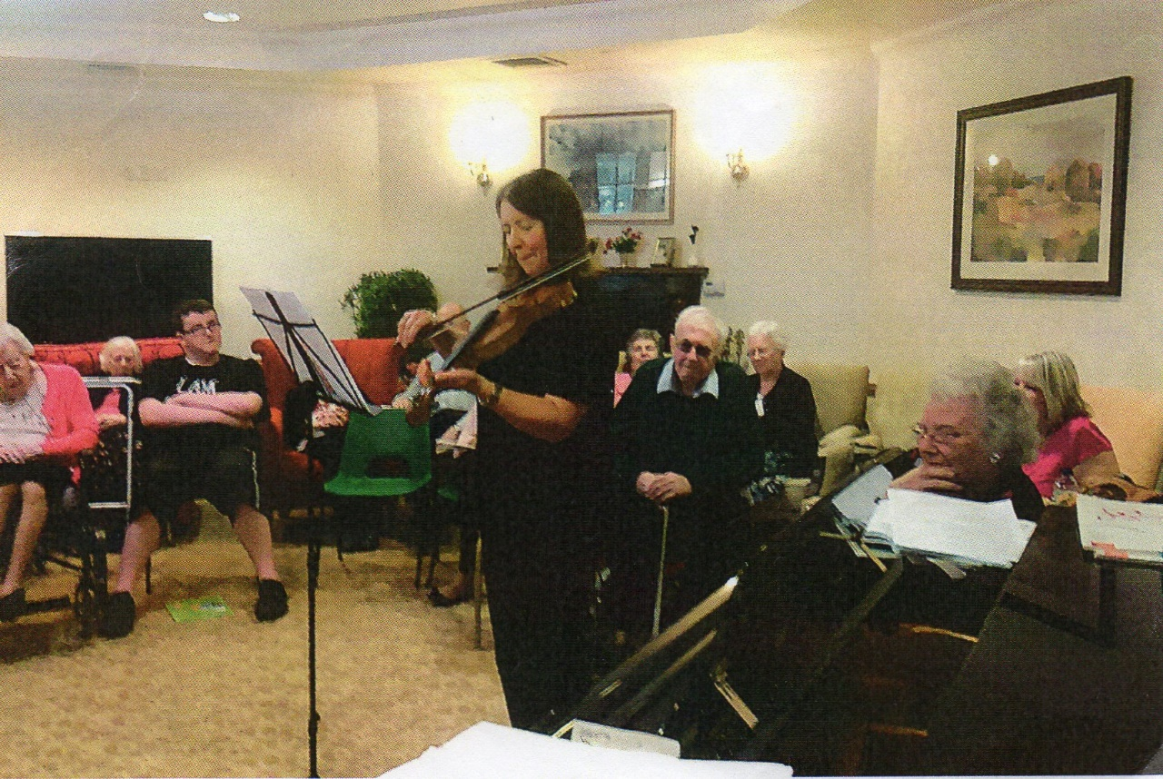

The Decline and Demise of Doris
After our Aunt Barbara, our father’s younger sister, had drunk and smoked herself to death, Doris was left on her own in Bonn, and suddenly we lost her from our radar…there was no reply on the phone, nor by letter, and nobody knew where she had gone. Eventually we found her in a local care home, to which she had been spirited away as she was now incapable of living on her own, being in her late 90s; she had gambled her last. - In 2013 I took Ellie over to see her, as it had been decades since the two had met, and we had quite a pleasant time living in the Hotel Römerhof, just round the corner from Haus Rosental, the home in question. We spent many happy hours there in its Café over coffee and cake, reminiscing about times gone by and relatives departed; I also recall dead-heading the roses in the garden, and joining in with some of the occupational therapy.
Two years later, in November 2015, Doris was 100, and we both went over again to celebrate her Birthday in style along with the management of the Home, getting her a lovely flower arrangement and a big teddy bear, whom she christened ‘Simon’ after one of her occupational therapists. A little girl recited her a suitable poem, she got letters from several government and local administrative departments and there was a general party atmosphere for the Occasion…with only one cloud on the horizon… Klaus and Marina had never replied to our enquiry as to whether they were coming up from Neuburg/Donau, neither had they nor Gudrun in Spain sent so much as a card…
We knew at that time that it was likely we would have to return for the inevitable before long – and it happened a few months later in March 2016, when I was involved in rehearsals and another show, and was required at home. The policy in the care home was to cremate the bodies at once to save storage fees, and as this had already happened to Doris, I was told on the phone that there was no rush and that we could come over and do the funeral at our convenience. There was still no input whatsoever from Klaus & Co., who seemed therefore content to let us have to fix the funeral by remote control from GB, and so it was. Ellie and I went over in May, had one day to organise flowers and arrangements at the Nordfriedhof, and then it was the day of the ceremony – the burial of the ashes. There was one lady from the home, Doris’ lady solicitor, with whom I had briefly corresponded, and the two of us. We had not booked a wake anywhere as we did not know the locality well enough, nor how many of us there would be, but we four wound up in a very pleasant café not far away, getting to know each other a little over coffee and cake. So we had seen Doris off, on a very small scale, but none the less sincerely. She was basically good. God Rest Her Soul.
The following day we went back to the home to sort out her remaining effects, and we had just one day to do a trip out together in the car (I took Ellie to the Kahler Asten) before setting off back to Birmingham via Hoek of Holland and Harwich. Back in England we broke the journey at Lavenham in Suffolk with all its half-timbered medieval buildings.
Doris was my last foothold in my homeland and therefore represented the end of an era; I now have to rely on hotels when I visit.

St. Nicolas’ Church
I think it was a brightly-coloured book of church calendar stamps when I was a very little girl which made me agree to go to the Sunday School in the Saracen’s Head; this led in time to the Junior Church in St. Nicolas’, taken by the Rev. Edward Ashford, (whom we thought was God himself), and then on to the Bible Class in the Old Grammar School, with Mrs Joyce Banbury. Inevitably this continuity was interrupted by my departure to Leeds at 18, and my attendance was very patchy thereafter, not because I had stopped believing in God, but because there was so much all competing for my attention, and a career to launch, attitudes to be laid and a sense of identity to establish. Then I was in Germany for 3 years and I just lost the habit of going regularly.
I started going to services again around the time when Daddy died in 2002, feeling very strange at first, but persevering and finally becoming a regular attender. I knew that he, as my godfather, would want me to do this. I found things had changed considerably – the old B.C.P. (Book of Common Prayer) services had been replaced by modernised versions which were unfamiliar, and much to my disappointment, the hymns were mainly new ones which I did not know (and which I still feel are not a patch on the older Victorian ones we had sung in school, from our ‘Songs of Praise’). As I enjoy singing, I found this frustrating, and still do.
Gradually I got to know more people, both clergy and parishioners, and found myself being asked to read lessons and do other jobs for which volunteers are required. Thus I have delivered magazines, dusted the window-ledges, arranged Easter and Christmas flowers, served coffee, washed dishes, the childen’s lego and wax-filled candlesticks, taken empty cartons to the recycling plant, made up keyrings for children going to new schools, participated in various courses, written articles for the magazine, been a welcomer and steward at services, helped at baptisms and so on, as well as what I have already outlined in the wake of the Restoration win in 2004. As I write I am supporting the curate responsible for the regeneration and development of Druids Heath Estate, and trying to launch a new Choir there as a part of this. In a church like St. Nicolas’, there are 1001 jobs which depend on volunteers, so most of these activities will no doubt continue for the rest of my life, and who knows what else I might wind up doing…I have long felt like part of the furniture and fittings, or, to put it differently, an ‘ecclesiastical dogsbody’…delighted to help.
With the building of all the new council estates, the daughter churches of Hawkesley and Immanuel were established, but I always felt too much tied to the Big Church on the Green which is Home to me because of my long association with it, and because of Daddy’s. He is part of the history of King’s Norton, and I guess I am becoming a part of it too.

Into the Present
With that, we have come more or less up to the present date. In 2012 Doug Smith, M.B.E., former History master at Swanshurst, filmed an interview with me as part of his ‘Living History’ project, the questions being asked by girls from the school. This was all about the end of W.W.II, my early life in Berlin and our move to Britain. (It runs about 18 mins. Highlight, then press ctrl and click. You may have to copy this link out and enter it elsewhere. There is an underscore before the final zero).
https://m.youtube.com/watch?v=cd7QsvNK1_0

In August 2019, with Brexit looming, I was granted Settled Status in GB. I would have liked to apply for British nationality to run as dual with my German, which I do not want to give up, but understand that Germany does not allow this with countries not in the E.C., so intend to just remain German.
Prior to the Pandemic, which began around January 2020, a typical week of my life ran as follows:
Monday morning: Aerobics class, evening rehearsal at Astwood Bank, Redditch.
Tuesday: Aerobics again, evening Swimming at Northfield Pool, then Harborne while Northfield was being rebuilt.
Wednesday: Hairdresser’s. When I was younger Mutti used to cut my hair, but later I got fed up of having it short and curly, so let it grow and began having it straightened, which I like much better.
Thursday evening: rehearsal with Tinkers Farm; other companies’ rehearsal evenings varied and could be any night.
Friday: once-monthly lunch with ex-colleagues from Swanshurst, in various pubs; latterly at the rather more rarefied Moseley Golf Club. Otherwise Druids Heath for prayers over lunchtime.
Saturday: Domestic jobs and correspondence, which also have to be fitted in on other days around everything else. Afternoon: Gemini Choir in Barnt Green, occasional concerts.
Sunday: 6.00 Service, paperwork, emails, domestic jobs, which are never-ending.
Health has always been a priority; I have never drunk to excess, never smoked and have always tried to keep my weight down by healthy eating. ‘You are what you eat’, and cannot expect to feel good if you fill yourself with junk food. As mentioned above I have always done plenty of exercise, partly because it was necessary after my hip operations of 2004 and 2018, but also as it lifts mood, aids sleep and ‘oils’ the joints.
However, I am not immune from all ailments; a couple of years ago I was found to be heading for Diabetes Type 2 and was sent on a preventive course, learning quite a lot of useful things about the effect of different foods on the human body, and in December 2020 I was afflicted with what turned out to be I.B.S., and which I thought I would never get rid of. Fortunately I have managed to get this under control, more with natural items I have found myself rather than what was prescribed for me, and its silver lining has been the loss of a stone in weight, making walking, swimming and the stairs easier. Never did I think I would ever hear a doctor telling me to put weight on -!!

The Pandemic
We would never have believed 18 months ago what was going to happen to the world in 2020. We saw people on TV wearing masks in the Far East, which we had seen before, but never thought this plague would creep round the globe to affect us!
In the early part of the year I was rehearsing a production of ‘Orpheus in the Underworld’ at Redditch, and we were very lucky to just be able to complete the week before the barriers came down; the audiences were already beginning to show that they were reluctant to visit places with large numbers of people. Suddenly the unthinkable happened and we were all put under ‘house arrest’ except for essential trips to the shops and for exercise and medical treatment. This was Lockdown, and the novelty very quickly wore off. Only essential key workers were allowed to go to work, with the rest working from home and schoolchildren having to be taught by their parents, putting them under extreme pressure, only a few going to school if there was nobody to take care of them. How on earth parents were to fulfil all these roles I have no idea, especially if they had several children of different ages and were living at the top of a tower block….
Many workers lost their jobs and some were put on furlough, being paid a part of their usual wages, but not knowing when or if they would be summoned back to work. I very soon realised that being retired, I had very many blessings to count, with none of these problems, no elderly relatives to care for and with my income unaffected. However, there were many small problems to be solved, which sound very trivial by comparison, such as when and where to shop, with many people ‘panic buying’ and TV News showing supermarkets with empty shelves…fortunately, their assurances that there was enough of everything for everyone soon turned out to be true, and one had only to decide where to go and when. I soon discovered that supermarkets are beautifully empty in the evening, and topped up my normal shopping with some delivered ready meals. Wiping everything down with a disinfected cloth before putting it all away became something of a chore…and petered out some months later!
Hairdressers were closed so it became a DIY activity, with varying results, and it was amusing to see on television that people had either done their own cutting, or not bothered at all, with the inevitably shaggy results, not to mention the grey roots! I managed an inch off the bottom all round, and became quite good with the blow brush until I could get back to Sam, my trusty hairdresser. I also saved quite a lot of money – fine for me, but not so good for her.
Fortunately my teeth were stable throughout, so I did not need to extract my own with pliers, as seemed to be happening in some places where people could not get an NHS appointment. Horrors!
Prescriptions and G.P. consultations were available by telephone, and washing, usually taken to the coinwash, either went to my nearby laundry at great expense, or was put into my neighbour Jackie’s washing machine. (Being on the first floor I am terrified of a leaking machine ruining the décor in the flat below, so have never had one). There was most definitely a feeling of wanting to help each other as much as we could, and people encountered on walks were suddenly far more sociable than they had ever been before, probably owing to their enforced isolation at home, despite the constant need for social distancing.
Being ‘confined to barracks’ meant that it was easy to feel housebound with detrimental effects on both physical and mental health, and we were urged to go out for exercise, to begin with just locally. Daily, government representatives would come on to the tv screen and intone the current figures for deaths and hospital admissions, and of course overkill about the Pandemic soon crowded out all mention of Brexit in the news. Yes, the novelty was definitely wearing off…. but everyone everywhere was willing to clap all the selfless NHS and key workers from their doorsteps every Thursday evening at 8.00. I did so from my kitchen window, and could hear the applause and a cacophony of wooden spoons on saucepans too from all the neighbours.
Local walks became a daily necessity, but all the possibilities were soon exhausted, and so we were all glad when dispensation came for us to drive out a short way to local beauty spots and to walk from there. Prior to that I had had to take the car out for odd runs to nowhere in particular, usually in the dark, to turn the engine over and generally keep the car drivable. Now the weather was often beautiful and the A-Z was invaluable for finding green spaces; we are very lucky in this regard here in south Birmingham. With far fewer cars on the road than normally, the air was fresh and filled with exquisite birdsong, now very audible without so much traffic noise.
My most memorable walk, and one which set the tone for many others, was one blustery, cold and cloudy Sunday in May, when I thought I’d try my luck at King’s Norton Golf Course. I had intended to ask for permission to do a walk there, but there was not a soul about anywhere… and the golf season had not begun, so I decided to help myself to a walk regardless…I can always own up later and ask if I was allowed, I thought to myself. (Later, I did). It was quite spiritual…. just me, the wind and the clouds, and acres of lovely grass with beautiful trees… and not a single soul. Plenty of time to commune with Nature and the Almighty, and to contemplate what was happening to us all so unexpectedly, with no idea of how it would all end. Certainly I did not expect to be still in Lockdown a year and more later!
There followed very many other walks in various parks, golf courses and gardens, which kept me feeling mentally and physically fit…I listed them all, and most enjoyed the ones where I had not been before. Then I would come home ravenous, cook myself a nice dinner and relax for the evening, feeling great and thinking how lucky I was. - Never have I done so much shoe-cleaning, and washing masks has become rather a chore, continuing to this day, and who knows for how much longer?
Many people of my age, it seemed, were lonely in Lockdown, but I was far too well-connected by phone, computer, television and radio, and sometimes found I had far more communications than I could cope with, as several people rang to keep in touch as they knew I lived alone, which of course was good of them. I also knew of some who had been housebound even before the Pandemic began, and felt I should at least keep in touch with them by phone just to assure them that they had not been forgotten. Our Daddy used to call this ‘doing one’s social service’.
My most important piece of social service however was closer to home: in December 2019 Ellie had been due for a hip operation, which was then postponed as she needed another ailment to be cleared up first; this did not happen before Lockdown closed in, and when I next saw her in June, she was in pain struggling to get about on a stick and also in a state mentally, wondering when she would ever get her operation, since the NHS was fully occupied with Covid. I drove home that day from Burbage thinking we must do something before she deteriorates further, and rang my own surgeon, Mr Ronan Treacy, but discovered he was busy helping out with other urgent surgery, his private list ‘on hold’. Try again in a couple of weeks, I was told. - By then he was starting consultations again, and we got Ellie a date just a week later at the end of July; on that day he gave her 24th August as an operation date, a far better outcome than we were expecting.
I went over to Ellie’s before the op., and took her the funds I had promised her towards the considerable cost, and we progressed slowly and painfully to the bank in Hinckley to set everything up. She was still sceptical, expecting to be told again at the ‘pre-op’ that she was not yet fit for the surgery, but everything finally went ahead and she came through it all very well, Covid notwithstanding, at the Priory Hospital, where there was an emergency unit in case anything went wrong. Nothing did, and her recovery back at home went smoothly with the very patient attentions of Sue, not far away in Hinckley. Steve, her brother, came up from Bristol for a few days to take the pressure off her with her very stressful job. I went over one day at this time, as permitted by Covid regulations, and the next time I went, Ellie had made an excellent recovery and was now able to walk and go out shopping independently, the hip working excellently and the op also having seen off her back pain. – This was probably the nicest thing that happened during Lockdown - I was very happy to be able to help.
I have not mentioned that Jasmine, Sue’s daughter and only child, decided at about 20 that she was going off to Australia…solo… much to Sue’s concern and that of the family generally. She did so, and I can only imagine what Sue must have gone through around that time. But all seemed to go well out in Oz, and the next time we saw Jasmine a couple of years later, she had a nice young man called Luke in tow. They remained here for a year or two and then returned, and of course Sue was and still is planning to go out to see them…only to be thwarted for the foreseeable future by all the travel restrictions due to Covid. Meanwhile, she keeps in daily touch via Skype/webcam.
Postponements in general are a feature of Lockdown: Tony and I were planning our Reunion 9 in Bradford in April 2020, 2 years after No. 8 in Berlin. When this looked impossible, we settled with the Hotel on April 2021, only to have to postpone again until April 2022. - A holiday on the south coast, booked originally for October 2020, also had to be put off and is now scheduled for September 2021, and our Christmas 2020 break in Harrogate had to be postponed until Christmas 2021. Now, in June 2021, everyone is tired of having their wings clipped and desperate to get away.
Tony and I, both living alone, decided to form a Social Bubble, and as ‘bubblemates’, were allowed to do things which others weren’t. Matters were complicated by the fact that he lives in Wales, which had different restrictions in place from those in England. To make quite sure we were only doing what we were allowed, I regularly went onto the relevant government and BBC websites to check up, as very confusing and contradictory information was coming over the airwaves. For long weeks we wondered what we should be allowed to do for Christmas, as the goalposts seemed to be constantly moving, and after all the to and fro, we were finally given only 25th December to visit anyone, with those not in any bubble being told to ‘stay local’.
I whizzed down to Tony in Newport in the morning in wonderful sunshine and with a great feeling of liberty, even if it was to be only of short duration. On board was a frozen Christmas lunch with all the trimmings, which got sorted out on arrival, the chicken crown timed to be ready at 3-ish, leaving plenty of time for catching up, opening parcels and starters. This meal extended into early evening by the time we had had our dessert and coffee, with me taking my usual after-dinner nap to be fit for the drive back, starting just after 10.00, with Classic FM paying lovely Christmas music to entertain me on the way home. Law-abiding as I am, I arrived back as per the regulations on the dot of midnight.
At this time I had had about a week of tummy trouble which was not responding to any of the usual medication, and was frightened of a disaster on the journey, so had starved myself the previous day…I need not have worried…all was well, at least for that day. However, the malady continued, and by Easter Monday, when we did a rerun of my trip but minus the Christmas presents, I found that I had lost 7kg in weight and was looking decidedly scrawny….
Some tests in February at the Priory had revealed nothing seriously wrong, which was a relief, but the elephant was still in the room…. after all that, I was given a loose diagnosis of ‘age-related I.B.S.’, and the remedies I found myself have been far more effective than anything I was given on prescription. - During this time I was glad of the assistance of my ex-neighbour from Dornie Drive, Alistair, who obligingly brought me my Saturday newspaper with its vital TV listings magazine for several weeks, as I was not ready to go down to the Green myself to get it before it sold out.
Despite my malaise, walks continued as ever, though obviously I did less during the winter with its bad weather and short hours of daylight. In general I felt very well and still do, in fact, full of the joys of life.
I had been supporting St.Nicolas’ prayers for the Druids Heath estate on Friday lunchtimes, and one day met Sue Welland, who had lost her job and was somewhat depressed. Not long afterwards I invited her to come for a walk with me straight after our prayers, which turned out to be the first of many…. we repeated many of the walks I had previously done on my own, and found lots of new ones too. I noticed how much shorter each walk seemed with company, and as we walked, we generally put the world to rights, getting to know each other quite well. I soon noticed that the exercise was having a decidedly beneficial effect on Sue, as well as myself.
A year ago, I was saying, not with very much confidence, that I was pinning my hopes for the Pandemic on a speedy vaccine; but it actually happened! Soon we were all being urged to have our first jab, mine being on 23rd January (oldies first). I walked to the Health Centre and back through glorious snow and sunshine, making it my Daily Walk. - My birthday shortly afterwards was spent flower-arranging and answering the phone, and on a new hairdo with the blow brush, so that it was tea-time before I got round to opening any of my numerous cards. - The 2nd jab happened in April, and I was relieved to know I had at least some, if not total, protection from the virus.
In the latter part of 2020 Kai Thierbach had arrived in Britain to take up the German Lutheran Pastorate for our area after a patchy period of interregnum; I felt he deserved our support, as I had supported his predecessors, and with St Nicolas’ services being partly on Facebook which I do not subscribe to, beat a path to his first Birmingham service. Thereafter the Pandemic scuppered everything and, like so many other concerns, the Lutheran Church had to rely on Zoom. Technology has never been my strong point, but my computer expert got me a small gadget which enabled me to join in successfully, and the rest is history! Kai ran an Advent calendar each evening in December, asking for volunteers to do a ‘little door’, and soon I had contributed 3 evenings on Advent and Epiphany, later doing an interview with Kai and his wife Helen, and writing an article about him and the German Church for the Parish Magazine. Then there were an online Communion, Easter zooms, and a Friday evening one which has continued weekly. After all this, it was surreal to meet Kai again in person recently for only the 2nd time, and I look forward to showing him and Helen round our medieval buildings in King’s Norton very soon.
Now, in early June 2021, things are continuing to loosen up, and I have already had very welcome days out to visit Ellie, pick up my much-overdue Christmas presents and have a lovely Italian meal with her at her local Pesto’s. We also got to the Botanical Gardens to celebrate her 80th Birthday. Tony and I managed to fit in our joint Birthday lunch in the Celtic Manor, postponed from Jan./Feb., I went for a day out at Hanbury Hall, N.T., the first for a very long time, with friends from Astwood Bank, and to a lunch at Moseley Golf Club with my former colleagues. All of these things would have been unremarkable 18 months ago, but now seem like absolute treats. As I write, our predicted ‘freedom day’ on 21st June is under threat, and we can only hope that we are not once again locked down with clipped wings.

The Future
In 2017 I completed a Lasting Power of Attorney, then a Funeral Plan and finally a Will. This present document was talked about a lot but was always postponed as there was too much Life getting in the way, and finally, after over a year of Lockdown, I’ve completed it in little over a month, so can heave a sigh… I now have to add the photographs and documents, proofread it, reprint it, rewrite the index, back it up and then deposit it wherever I think best for posterity/the family.
I’m hoping that my next prompting engagement will materialise; it is scheduled for late July and is to prompt Donizetti’s opera ‘Don Pasquale’ at the Midland Arts Centre. Just after that I have a ticket for the Country Landowners’ National Game Fair, an event which I have normally been to annually since my BBC years in the mid- 80s, and which is a jolly good Day Out in the fresh air, run by the Country Landowners’ Association. This has been put off from last year.
Tony and I very much hope that our September holiday on the south coast will materialise, also Christmas in Harrogate and Reunion 9 in Bradford in April 22.
Meanwhile my ‘new’ book cupboard upstairs has accumulated vast quantities of A4 papers of various kinds which need sorting (or else pity the poor person who has to tidy up after me on my demise….) such as those from Mutti, Marie, the house in Bad Kösen and financial items. In the course of this I intend to extract all our family papers and photographs from the Hofmanns, the Eckhardts with author Walter Bauer (as previously mentioned, first cousin of my maternal grandmother with an archive in Merseburg/Saale, where Mutti was born and grew up) and from the Myers family in Yorkshire, so that all of these are not wasted but get handed down the generations, since so much work and effort has gone into them.
Foreign travel is still difficult post Pandemic, but I need to get to Merseburg with the family papers, which will have to wait until 2022. Sadly, I have no foothold in Germany now, and have to stay in hotels. My nephew Steve, Sue’s brother, is interested in the Hofmann papers, and the remains of the Myers family in Wakefield will get all their items. - For the rest, I hope to do many more shows, probably as prompt rather than on stage, and sing in lots of concerts; I am sure I still have a few Reunions in me, including more for the former Bournville Light Opera Section and for retired Swanshurst staff. I shall try to read more (not as easy as it was before I needed reading glasses!), continue all my church activities, aerobics and swimming, and of course walks. Perhaps I’ll even do a bit more violin…. The demon Technology rears its ugly head all too often, and so far I have resisted the ubiquitous ‘handy’/mobile phone, but can see the day coming when I shall have to get one in order to conform to modern requirements, though I really have no inclination to spend my remaining time gawping into one of these things like the rest of the population. I fear that I fitted much better into the 20th century than I ever will into the 21st…..
Apart from that, my aim is to be the best I can and as useful and helpful to others as possible, and though all too often life seems to be one long series of disappointments, to enjoy it and count my numerous blessings.
I am lucky to be very healthy and feel I still have one or two decades in front of me; if Oma Hofmann and her daughter, Doris, my aunt, can live to 100, then so can I… so I will end for now with the hopeful phrase
” To be continued ”!

Sabine Hofmann 9th June, 2021

